Using the Internet
K Huszcza / R Wilson
Information Services, Feb 2000

The Internet is a global network of computers linked together by phone lines that enables information to be exchanged between computers anywhere in the world.

Access to information on the Internet can be gained using Netscape Communicator. Netscape Communicator is browser software which allows you to search and retrieve information. Information can be in various forms, text, graphics, audio and video files. Audio and video files can only be downloaded if your computer is capable of handling these files.

Loading Netscape

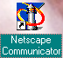
Selecting the Netscape Communicator icon with the mouse and double clicking on it will load the program. The home page for the Institute of Education is loaded first.
Web site address
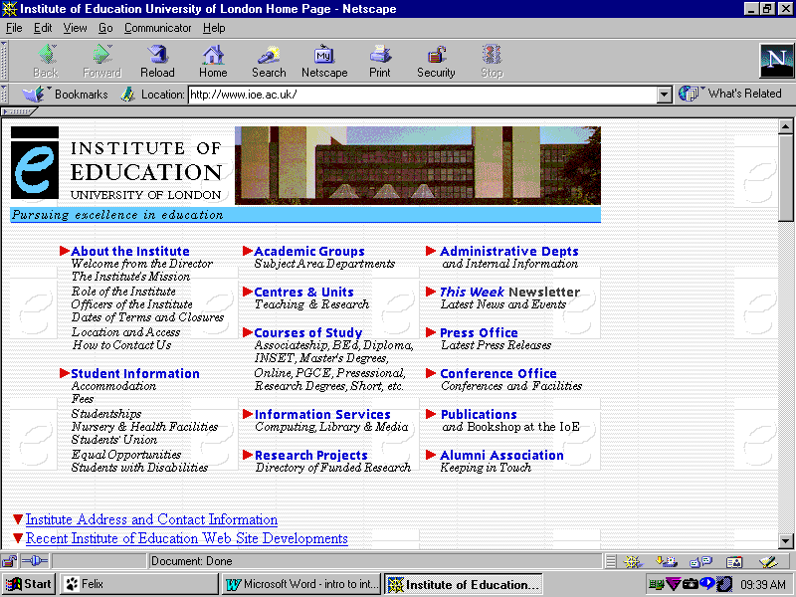
Toolbar Buttons
Activate Netscape features most commonly used

e.g.
go back to previous page, reload page,
go to home page,
print
Hypertext links
Clicking on these links will take you to another page
Status bar
Gives information on the progress of your request

The World Wide Web can be described as the multimedia section of the Internet as it gives you pictures and sounds in addition to a vast array of textual information. It makes information available in Hypertext format. Each page has hypertext links to other related pages. The links are the sections of text which are underlined and in colour, usually blue. Links may also be assigned to graphics. Clicking on these sections activates the link to the page.

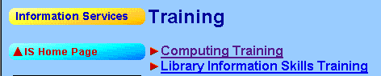
You can identify whether text or a graphic is a link by hovering your mouse over the text and looking for the hand symbol.

Accessing Other Pages

To access other pages there are 2 options:

- Use a Search Engine
- Enter the unique reference for the location of the information

1. Using a Search Engine

A search engine is a service on the Web that helps you find what you are looking for. You provide key words and the search engine comes up with a list of Web sites that contain them.

One way of loading a search engine is to click on the Search button on Netscape's toolbar and a new page will load which provides a space for you to type in the Keyword or group of keywords for your search.
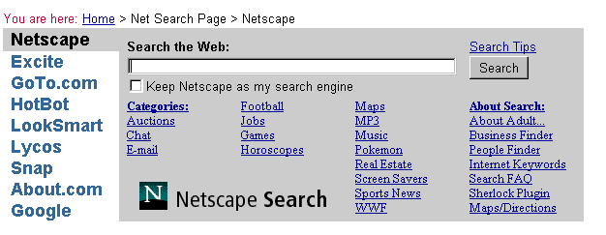
The Search Tips link will take you to a page leading to useful tips for entering keywords as the search criteria for various different search engines

The outcome of a search can be overwhelming as it can provide many thousand web sites as a result of the search. There are ways of narrowing your search. You can access information on how to do this by clicking on the Search Tips link. There is a useful summary of search engines and the methods used to narrow your search for each at the end of this document.

Each search engine may provide different results so is worth trying more than one and comparing results.

2. Entering the unique reference for the location of the information

Each web page has a unique address for its location. These addresses are sometimes referred to as URLs which stands for Uniform Resource Locator.

For example http://www.ncet.org.uk will open the National Council for Educational Technology (NCET) home page.

You can either type the address for a location in the Location window at the top of any web page and then press the Return key on your keyboard

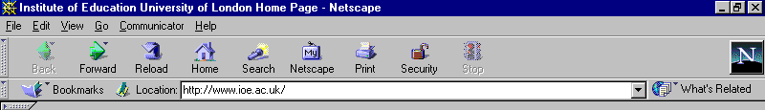
Or,

You can select Open Page from the File menu to call up the following dialogue box:
(The shortcut for this is to press CONT + O on the keyboard)
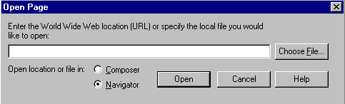
Type in the URL or address you require and then click the Open button.

Either method will initiate the browser to attempt to make a connection to your chosen location. The connection may be made in seconds or it may take up to a few minutes. The length of time that a page takes to load depends on where it is coming from and the content of the page. Mainly text loads faster than a page which is mostly graphics. The Status bar at the bottom of the screen gives information on the progress of the transfer of data. A page with graphics will take longer to load. The text will load first followed by the graphics. It is possible to click on a hypertext link and move to the next page before the graphics are fully loaded

When attempting to make a connection to a location an error message may appear.

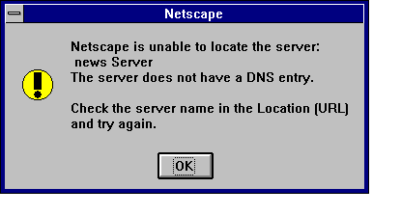
This indicates that the server issuing the page may be temporarily shut down or too busy with other connections to handle your request. It is always worth trying again but make sure the address is correct if you have entered the location

Back/Forward/Home

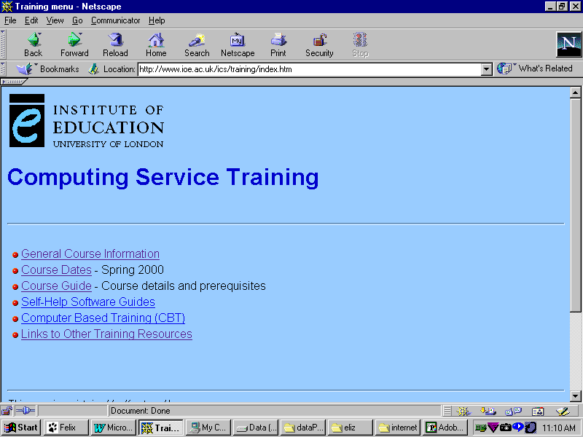
Clicking on the links within each page, either underlined text or graphic links will load further pages of information. You can navigate back to previous pages and then forward again to the present page using the Back and Forward buttons on the toolbar.
Clicking on the Home button on the toolbar will always take you back to the Institute of Education Home Page.

Bookmarks

Pages which you have found useful can have their locations saved as a bookmark. These pages can then be subsequently loaded from the bookmark, this is useful when you have found information by progressing through many links between pages.
To bookmark a page click on the Bookmark button on the toolbar or select Bookmark from the Communicator menu.

The following dropdown menu will appear:
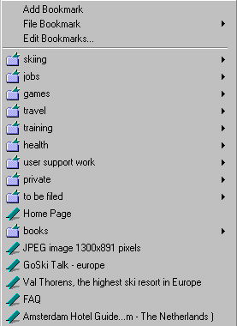
Add Bookmark
will add the current web page to the list of bookmarks

File Bookmark
will give you the chance to file away the new bookmark in a folder which you have previously created

Edit Bookmark
will give you the chance to edit any of the bookmarks or create bookmark folders

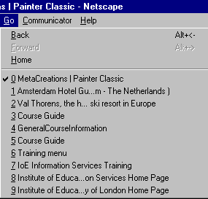
Using Go

Go is a useful facility as it gives you a history of the pages already loaded as a list. It is then possible to revisit a page by selecting from the list without retracing your way back through all the links.

To use, click on Go in the menu bar and select which location you wish to go to next.

Printing

An option to print pages is available in Netscape. However you may find that some information will print successfully while others pages will not. This depends on the capability of the printer to handle commands from the Netscape software.

Print by either selecting Print button on the toolbar or by selecting Print from the File menu. The latter method will give you the chance to select how many pages you wish to print.

Saving Text Files

Pages can be saved as text files which can then be opened by word processing programs and be printed or edited.

Only the text on the page is saved, any other media on the page is not saved.
Click on the Save as command from the File menu. Select Plain Text (*.txt) from the Save File as Type option and then enter a filename, including the .txt extension. The file can be saved as the default type Source (*.htm) but this will display Hypertext codes when loaded into a word processing program. The saved .htm file can be loaded in Netscape using the Open File command in the File menu. Information can then be looked at off-line which can be a cheaper option, particularly at home or in schools.

Copying Text
Hold down the mouse button in the content area and drag to select portions of text. Then select Copy from the Edit menu to copy this selection to the clipboard. The copied section can be pasted from the clipboard into a word processing file.

Saving Graphic Files

Graphics files can be saved in jpeg (only using Internet Explorer) or gif formats to any drive or a floppy disk. These are standard formats for digitised images and the file format used to store the image will be given when you save the file. Once saved to a drive the graphic file can then be opened in a graphics program or inserted into a word processing or desktop publishing file.

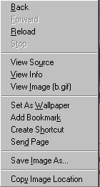
To save a graphic :

- move the mouse pointer inside the graphics image area.
- right-click the graphic and the following shortcut menu will appear:
- Select Save Image As
- In the Save As dialogue box select the location you wish to save the file to and change the name of the file if necessary.

Saving Video Clips

Video clips can be saved as avi, mov mpeg or files. To show graphics or play video clips you need to use software such as Quicktime which includes Picture Viewer and Movie Player or they can be assembled in a multimedia presentation using a program such as HyperStudio.

Useful Internet Pages for Education

NCET: (National Council for Educational Technology) is involved in a number of projects which aim to encourage the use of Information and Communications Technology in education. Their home page is located at
http://www.ncet.org.uk

NCET: NCET's Internet publication Highways for Learning: the Internet for schools and colleges is written for classroom teachers and managers in schools and colleges. It is available in text form on the Web.
http://www.ncet.org.uk/publications/highways/

DfEE: The Department for Education and Employment has a comprehensive web site with all the latest government education papers, which can be downloaded.
http://www.dfee.gov.uk

BECTa: British Educational Communications and Technology Agency. This site includes a wide range of ICT information, projects and resources. There is also access to the National Grid For Learning (NGFL) and the Virtual Teachers Centre.
http://www.becta.org.uk

OFSTED: The government inspection body site where all school inspection reports are published. This is useful for researching placement schools or potential employers.
http://www.ofsted.gov.uk

NGFL: This recent Government initiative aims to have all schools connected to the Internet by 2002, thereby creating a National Grid for Learning. This web site is a collection of resources brought together by the Government.
http://www.ngfl.gov.uk

BBC: This is a useful internet starting point as there is a list of useful sites and links for each subject. A short description is given so you have a flavour of what might be available. Use the BBC Bitesize revision site to test your own GCSE subject knowledge!
http://www.bbc.co.uk/education

The Institute of Education: Information about courses, facilities and help for students is on our web site.
http://www.ioe.co.uk

PGCE Support: There is a Web site within the Institute site specifically for PGCE Students.
http://www.ioe.ac.uk/ics/pgceictresources

TTA: This site gives information about all recent Teacher Training Agency initiatives, policies and documents.
http://www.teach-tta.gov.uk

Campus World: Communications projects and on-line resources for education
http://www.campus.bt.com

Schools Online: Project to support the development of curriculum materials in Science and Languages
http://sol.ultralab.anglia.ac.uk/pages/schools_online/

Media Site: Provides access to International newspapers, magazines and broadcast material.
http://www.potter.net/mediasite

Research Machines: This site has RM’s Internet for Learning pages which provide thousands of links for a wide range of curriculum topics. Most of the information is only available to subscribers to RM’s service. The Eduweb section provides links to UK schools who have Web pages. Links to many other educational organisations and professional bodies are also provided as well as a classroom forum for teachers
http://www.rmplc.co.uk

TONIC The Online Netskills Interactive Course
To take you further you can access an on-line structured course on using the Internet which has been developed for UK higher education at
http://www.netskilss.ac.uk/TONIC

Search Engine Summary
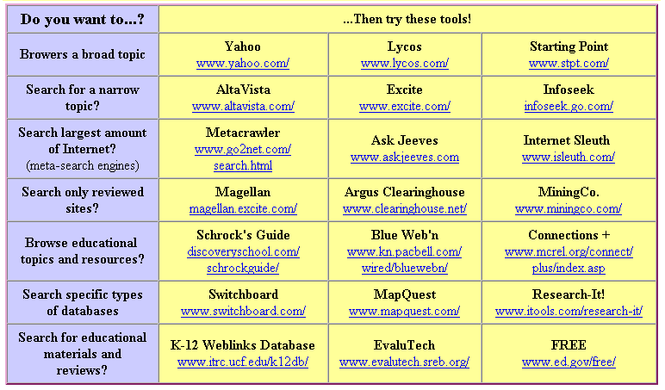
Try searching for a topic using at least three different search engines and compare your results.
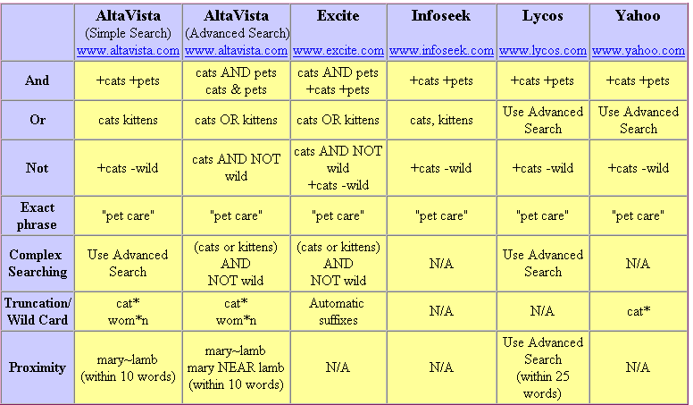
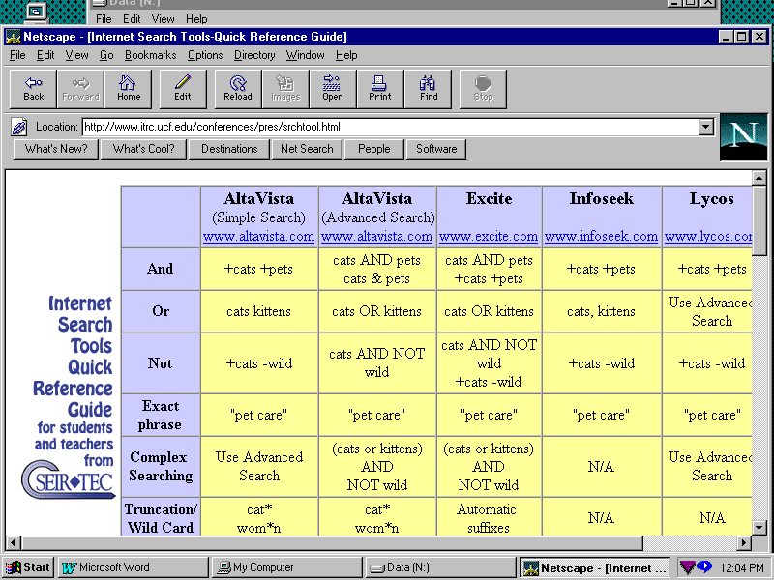
Thanks to :
SEIR*TEC for this very useful table from their webpage www.itrc.ucf.edu/conferences/pres/srchtool.html

Thanks to :
SEIR*TEC for this very useful table from their webpage www.itrc.ucf.edu/conferences/pres/srchtool.html

