 | 

Happy Computers Essentials Guide to
Microsoft Excel 97 for Windows 95

Copy This Manual!

This course guide is produced for the Happy Computers “Excel 97” course.
For all your computer training needs, contact:

Happy Computers
St James House
10 Rosebery Avenue
London EC1R 4TD
Bookings: 0171 278 5596
E-mail: happy@happy.co.uk

Copies of this guide can be obtained from Happy Computers, fully bound, at a cost of £15 each, or £10 for extra copies for organisations who have booked courses.

Happy Computers allows this guide to be copied, provided the name and phone number of Happy Computers remains on the copies.

Contents
Getting Started In Excel
About This Manual
Starting and Exiting Excel?
The Excel Screen
The Mouse Icons
What Are All Those Pictures All Over The Screen?
Using the Mouse
The Right Mouse Button
The Office Assistant
Basic Principles
Cursor Movement & Functions Keys
Selecting Cells
Selecting Columns & Rows
Basic Text & Number Entry
Correcting Mistakes
Undo & Redo - A Licence To Make Mistakes!
Using AUTOFILL To Make Copying Easy!
Erasing Cells
Getting Excel To Do Your Calculations!
Adding Up Numbers With The SUM Function
Using AUTOSUM For Quick SUM's
Principle: Always Include Blank Line in SUM()
Percentages
Other Functions That You Can Use
The Paste Function
Inserting & Deleting Rows and Columns
Saving Your WorkBook
More Options In Saving
Opening, Creating and Closing Workbooks
Managing Files in the Open Dialog Box
Moving And Copying Things
Copying Formulas
Absolute Cell References & F4
The Golden Rule Of Good Spreadsheet Design
Never Put A Number In A Formula
Principle: Calculate in One Direction
Principle: Check your Spreadsheet
Using Sheets In A Workbook
Making It Look Good
Changing The Look Of Your Text & Numbers
Aligning Text & Numbers
Other Options In Aligning Text & Numbers
Changing The Font (The Typeface)
Changing The Look Of Numbers
Making Columns Wider & Rows Taller
Dates & Times
Adding Lines And Borders
Adding Colour And Shading
Use AUTOFORMAT for instant style!
Conditional Formatting
Removing & Copying Formatting
Seeing More Of The Worksheet On Screen
Printing
Basic Printing
Print Preview: So What Will It Look Like On Paper?
Page Setup
Making The Printed Output Look Good
Headers & Footers
Creating Charts
Charts: With the Chart Wizard
Working With A Chart If It Is Inserted As An Object In A Sheet
Using The Chart Toolbar
Changing Your Chart After Creating It
Formatting Your Chart
Printing A Chart
Charts: Two Dimensional or Three Dimensional?
Charts to Display Trends
Charts to Display Proportions
Charts to Display Trends & Proportions
Making Your Spreadsheet Easier To Use
Two Useful Design Rules
Grouping Sheets
Creating Formulas That Link Worksheets & Workbooks
Adding Comments To Your Worksheet
Adding A Post-It Type Comment
Creating Range Names
Using Named Ranges
Protecting Your Work
Protecting A File
Using The Toolbars
Spreadsheet Templates
Excel Spreadsheet Information In Word
Appendix
Error Messages
Selected List of Functions
Full List Of Functions (Alphabetical)
Glossary
Index

Getting Started In Excel

Objectives:

By the end of this section you will be able to:

- Start and Exit from Excel
- Recognise the different parts of the Excel spreadsheet
- Recognise the different mouse icons
- Use the right mouse button
- Use the Office Assistant

About This Manual
This manual has been written by Happy Computers for the Excel 97 courses. It is meant as a learning tool for use during the course and a way of exploring further elements of Excel after the course. It is not a replacement to the huge manuals that come with Excel, but rather a step by step guide to the most useful features.

Write Your Own Manual!
There are sections in this manual that are left blank and it is intended that you should fill these in during the course. Use lots of colour and make it fun, that way it's easier to remember. The manual is only printed on one side of paper so you have plenty of space to make lots of your own notes.

Step by Step Instructions
There are sections within the manual that are step by step guides. These use the following style

Things you should do are here A description of what's happening is here
Click On File The File Menu will drop down
Click On Print Preview The Print Preview Box will appear
Each step by step section is self contained, you should not need to refer to another part of the manual to get it to work.

Let Us Know What You Think
We are always searching for ways to improve our service, and are very keen to hear you thoughts on any aspects of this manual, or indeed, any part of Happy Computers!

Starting and Exiting Excel?

Starting Excel 97
Click on the Start Button The Start menu appears
Click on Programs The Programs menu will appear
Click on Microsoft Excel Excel will start

Exiting Excel 97
Click on the File Menu
Choose Exit
or
Click on the cross on the top right corner of the screen -

The Excel Screen

What Does What And Where?
Excel looks like this. Throughout the course you can mark in the names of certain areas of the screen so that you can build up your own personal reference about what does what! A more detailed look at the toolbar is on the next page

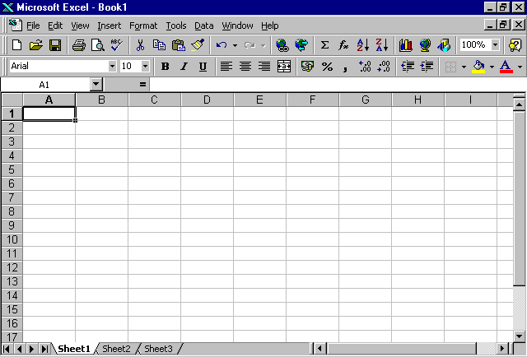

The Mouse Icons

The mouse icon changes according to where it is on the screen. This is because it performs different functions depending on where it is on-screen. The most common ones in Excel are:

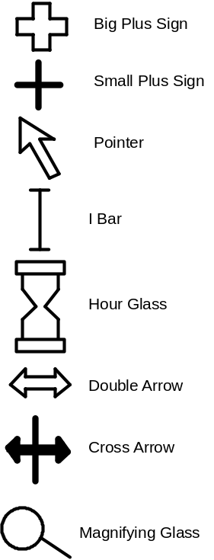

Fill in your own description of these icons as the course progresses.

What Are All Those Pictures All Over The Screen?

The Standard Toolbar

New Format Painter Sort Ascending
Open Undo Sort Descending
Save Redo Chart Wizard
Print Insert Hyperlink Map
Print Preview Web toolbar Drawing
Spelling AutoSum Zoom
Cut Paste function Office Assistant
Copy
Paste

The Formatting Toolbar

Font Right align Increase indent
Font size Merge and Center Borders
Bold Percentage Fill colour
Italics Comma Font colour
Underline Increase decimal
Left align Decrease decimal
Centre Decrease indent

Tool Tips
You don’t have to remember what all the buttons do. You can use ToolTips.

Move the mouse cursor over the tool for a second and a ToolTip will pop up and a description will appear on the status bar at the bottom of the screen

Using the Mouse
Excel is designed around the 'mouse'. This is a small piece of plastic, with between one and three buttons, which rolls around the desk. As it rolls the mouse 'icon' moves around the screen.

Normally it is the LEFT MOUSE BUTTON that you press to make things happen.

The mouse is designed to make using a computer more in line with how people think. Once you are used to it, a mouse can enable remarkable speed and ease of use. The main mouse actions are:

Point and Click Roll the mouse around the desk until the icon is at the required place on screen. (Either the required cell or the required menu option.) Click the left-hand button to select.

Point and double-click Click on an option quickly twice to call up that option without having to click on OK.

Click and Drag To define a range, or re-size a window, you must click at the required point and drag the mouse, without releasing your finger, across as desired.

Drag and Drop You can move parts of your worksheet about the page by clicking on the edge of the selected area, holding down the mouse button, dragging to a new location then 'dropping' the item on to the new place. (Is this mouse droppings!!?)

Using the Keyboard instead of the Mouse
It is generally easier with a mouse, but it is possible to perform nearly all the functions in Excel using only the keyboard. Use the arrow keys to move the cursor box around the worksheet.

Selecting Menus: Note which letter is underlined in the required option. Hold down the ALT key (towards bottom left of keyboard) and press this letter.

Selecting Menu Options: Press letter which is underlined in option that you want.

Dialogue Boxes: Press TAB to move between different selections in Dialogue Boxes.

The Right Mouse Button
Many of the things described in this manual can also be performed in another way. One of the most useful is the Short-Cut menu. This provides quick access to some menu commands, and is especially useful for:

- Formatting Numbers, and Text
- Cut & Pasting
- Inserting & Deleting Rows & Columns
- Adding Patterns and Borders
- Showing Toolbars
- Inserting comments
- Formatting cells

Using The Short-Cut Menu
Click the right mouse button while the cursor is over a selected area or part of the screen

The options on the short-cut menu will change depending on what you are doing at the time so selecting a row or column will give you the option to change row height or column width, for example.

The Office Assistant

What Does It Do?
The Office Assistant watches what you are doing and then...

- Gives you a particular tip once during a Microsoft Excel session.
- Helps you to search for help in Microsoft Excel.

Using The Office Assistant
Click on the Office Assistant icon
The Office Assistant Box will be displayed

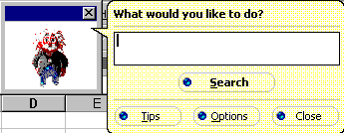
Type your question into the entry box
Press Search.
Click on the appropriate bullet.

Scrolling Through Your Tips
Click on the Office Assistant icon
Click on the Tips button
Click on the Back or Forward buttons to scroll through your tips.
Click on Close to close the tips box.

Closing The Office Assistant
Click on Close to hide the Office Assistant box
Click on the x to shut down the Office Assistant

Basic Principles

Objectives:

By the end of this section you will be able to:

- Move around your spreadsheet using the scroll-bars, cursor keys, and keyboard shortcuts
- Select cells, columns and rows
- Enter text and numbers
- Correct mistakes
- Undo & Redo
- Copy numbers, text and formulas using autofill
- Erase cells
- Use formulas to get Excel to do your calculations
- Use percentages
- Use the sum function, and the autosum function to add up lists of numbers
- Use other functions, such as finding the average of a list of numbers using the Paste Function
- Insert and delete rows and columns
- Create, open, save and close workbooks
- Work with more than one workbook at a time
- Move and copy text and figures using cut, copy and paste and drag and drop.
- Use Absolute cell references
- Apply good spreadsheet design
- Re-name and move worksheets

Cursor Movement & Functions Keys

Movement Keys

↑ Up one cell
↓ Down one cell
← Left one cell
→ Right one cell
CTRL-→ Last entry (to right) in current series
CTRL-← First entry (to left) in current series.
HOME Left-most cell (A column) of current Row
END & HOME Move to bottom-right cell of current worksheet.
CTRL-HOME Move to cell A1
CTRL-END Move to bottom-right cell of current worksheet
PgUp Moves cursor up one screen
PgDn Move cursor down one screen

Deletion & Cancellation Keys
DEL Blanks a cell (with confirmation) / Deletes current character on entry line
Backspace Blanks a cell (without confirmation) / Deletes previous character on entry line
ALT-Backspace Undo
CTRL-Z Undo
ESC Cancels last command selected

Selection Keys
SHIFT-→ Extend selection to the right
SHIFT-← Extend selection to the left
SHIFT-↓ Extend selection downwards
SHIFT-↑ Extend selection upwards

Format Keys
CTRL-B Bold
CTRL-I Italic
CTRL-U Underline
CTRL-1 Format Cells dialogue box

Function Keys
F1 Help
SHIFT F1 Context sensitive help
F2 Edit Formula or Text in a cell
F3 List Names
F4 Put the dollar signs in (absolute cell references)
F5 Go To
F6 Next Pane
F9 Calculate Now (if on manual re-calculation)
F10 Activate menus (in case you haven't got a mouse)
F11 New Chart
F12 Save As..
CTRL-F6 Next worksheet

Arithmetic Symbols
+ Addition
- Subtraction
* Multiplication
/ Division
^ Exponent
% Percentage

Windows Keys
ALT-F4 Exit the program (i.e. Excel)
CTRL-X Cut to the clipboard
CTRL-C Copy to the clipboard
CTRL-V Paste from the clipboard

Precedence of Calculation
Calculations are not simply done form left to right. Below is the order in which all calculations are performed.

Priority | Symbol | Explanation
1 | () | Anything in brackets is done before anything outside the brackets is even considered
2 | ^ | Raises a number by an order of magnitude: raises it to the power of something else  e.g. X²
3 | * / | Multiply and divide are on the same level. Whichever is furthest left in a formula is therefore done first.
4 | + - | Plus and minus are on the same level as above.

The acronym for this is BODMAS

Brackets Order Divide Multiply Add Subtract

Selecting Cells

Selecting A Single Cell
Click on the cell The cell will have a dark outline around it and it's contents will be displayed on the entry line

Selecting A Range Of Cells
Click and drag over the range to select

Selecting A Range Of Cells That Are Not Next To Each Other
Select the first cell(s) The cell will be highlighted
Hold down the CTRL key and click on the second cell

You can use this method to select lots of cells or ranges of cells that are not next to each other.

De-selecting An Area
Click elsewhere on the screen.

Adjusting A Selection
After making a selection you may want to adjust it (perhaps you selected too many or not enough cells)

Hold down the SHIFT key on the keyboard
Click to adjust the selection

Selecting Columns & Rows

Selecting A Row Or Column
Click on the ROW NUMBER or COLUMN LETTER (not the cell)

Selecting More Than One Row
Click on the first ROW NUMBER or COLUMN LETTER and drag to the last

Selecting Rows And Columns Not Next To Each Other
Click on the first ROW NUMBER or COLUMN LETTER
Hold Down the CTRL key on the keyboard
Click on the next ROW NUMBER or COLUMN LETTER
And So on...

Selecting The Whole Worksheet
Click on the square at the top left of the screen Shown below
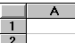

Basic Text & Number Entry
Anything that you type will appear in the 3rd line of the screen, the 'Formula Bar', as well as in the cell itself. (A green tick and a red cross also appear on the Entry Line to indicate that you have changed this entry.)

Press the Return key (the large key to the right of the keyboard, with 'Enter' or a bent arrow on it) when you have finished entering for that cell. (The tick and cross will then disappear.)

Cursor Movement
Use the four arrow keys on the keyboard (↑↓→←) to move the cursor around the screen. Note that the cell address is shown in the Name Box on the Formula Bar

Entering Numbers

In Excel any number or formula is termed a 'value'. To enter it into a cell:

Select Cell Click mouse on cell where number is to appear

125 Type in number. It will appear in the cell and on the Entry Line next to the cell address. (A Tick and cross appear beside it.)

Press Return Or click on the tick

Entering Text
In Excel any text (combinations including any characters that are not numbers or calculation symbols) is termed a 'label'. These are normally used as headings or side-headings on tables.

Select Cell Select cell where label is to appear

Type Text Type in text of label. It will appear in the cell and on the Entry Line. (The tick and cross appear beside it.)

Press Return Or click on the tick

Correcting Mistakes

Replacing The Contents Of A Cell
Select the cell
Type the new contents
Press Return Or click on the tick
Or press an arrow key on the keyboard

Correcting The Contents Of Cells
Double-click on the cell Or Press F2
Or Click in the Entry Line

Make the changes you want

Use arrow keys, DEL and Backspace to alter cell contents.

Press Return Or click on the tick

Undo
If you make a mistake and change a cell you didn’t mean to- or accidently delete a whole range of cells- Excel has a really useful way of undoing any damage.

Click on the Undo button Or CTRL + Z
Or Edit Menu : Undo

Repeating Your Last Action
You can repeat the last action you did (such as typing in something or formatting)

Click on the Redo button or press F4

Undo & Redo - A Licence To Make Mistakes!
Excel 97 provides 16 levels of undo and redo. This means that you can not only undo the last thing you did (as in other programs) but the one before that and before that and so on up to 16 levels. Not only that, if you undo something that you did not mean to then you can redo up to 16 levels of undo.

Redo Last Single Undo
Redo up to 16 undos
Undo up to 16 actions
Undo Last Single Action

Undoing The Last Thing You Did
Click on the Undo button Shown above
Or
CTRL-Z

Redoing The Last Thing You Undid!
Click on the Redo Button Shown above
Or
CTRL-Y

Undoing Up To 16 Actions
Click on the down arrow next to the undo button (a list will drop down)
Use the scroll bar to scroll to the last action you want to undo
Click on the action

- To cancel the drop down list while it’s still displayed click on the undo icon again or click away from the drop down list.
- If you undo say 8 actions, then all 8 actions are undone in one go, you can’t pick out a single action from the list to undo (unless it’s the first)

Redoing Up To 16 Things You Undid!
Click on the down arrow next to the redo button (a list will drop down)
Use the scroll bar to scroll to the last action you want to redo
Click on the action

Using AUTOFILL To Make Copying Easy!
Excel provides a very powerful and quick way of copying formulas and text. This is called AUTOFILL.
You know when you can perform an AUTOFILL because the cursor changes to a 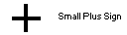as you move it over the tiny black box at bottom right corner of the selected cell, as pictured here.

Autofill To Copy Text & Numbers
Select the cell to copy Click & Drag with the mouse to do this
Move the mouse to the bottom-right corner Your cursor will change to a small plus sign (pictured above)
Click and drag to highlight where to copy to
Release the mouse button The text will be copied and adjusted if necessary.

Excel will actually do something clever if you copy the word Jan. to other cells. It will work out that you are creating a series of months and will fill in Feb., March, April, automatically for you. Try it and see what happens.
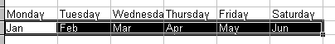

Autofill with More Than One Cell
Highlight two cells in a series (such as dates a week apart) and Autofill will continue that series:
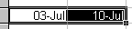

Creating Your Own AutoFill Lists
You can create a custom fill series:

Click on the Tools Menu, then options
Click on the Custom List Tab
Select New List in the Custom lists box
Type the Entries in the list entries box, beginning with the first entry
Press Enter after each entry
Click on Add When Finished
Click OK

AutoFill To Copy Formulas
Select the cell to copy Click & Drag with the mouse to do this
Move the mouse over the bottom-right corner Your cursor will change to a small plus sign (pictured above)
Click and drag to highlight where to copy to
Release the mouse button The formulas will be copied and adjusted automatically.

AutoFill With The Right Mouse Button
Instead of dragging the AutoFill handle with the left mouse button you can use the right mouse button. When you let go you will be presented with a menu of options that you can pick from (such as creating growth trends)

Erasing Cells

Erasing The Contents Of Cells
You can blank the contents of any cell:

Select Cell(s) to be blanked
Press Delete on the keyboard

Erasing The Formats From A Cell Or Range Of Cells
Select Cell(s) to be blanked
Click on Edit Menu The menu will drop down
Click on Delete
Click on Formats

Undo
If you make a mistake and change a cell you didn't mean to - or accidentally delete a whole range of cells - Excel has a really useful way of undoing any damage.

Click on the Undo button Or CTRL + Z, or Edit Menu : Undo

Getting Excel To Do Your Calculations!
The power of worksheets comes from the ability to set up formulas in cells, and to re-calculate when figures change.

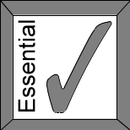Start A Formula With The Equals Sign

You should always start a formula in Excel with the equals sign so that Excel knows it is a formula and not just text to be displayed

Entering a Formula
Select the cell where the result of the formula is to appear
Type =
Enter formula It appears in the formula bar and the result in the cell.
Press Return Or click on the tick

Entering A Formula By Pointing
You don't need to write in the cell references. Simply point to them instead.

Select Cell where result of calculation is to appear
= Type =
Click on first cell.
+ Type +
Click on next cell
Press Return Or click on the tick

Pointing can be used on all formulas instead of typing them in.

Arithmetic Symbols
+ Addition
- Subtraction
* Multiplication
/ Division
^ Exponent
% Percentage

Precedence of Calculation
Calculations are not simply done form left to right. Below is the order in which all calculations are performed.

Priority | Symbol | Explanation
1 | () | Anything in brackets is done before anything outside the brackets is even considered
2 | ^ | Raises a number by an order of magnitude: raises it to the power of something else  e.g. X²
3 | * / | Multiply and divide are on the same level. Whichever is furthest left in a formula is therefore done first.
4 | + - | Plus and minus are on the same level as above.

The acronym for this is BODMAS

Brackets Order Divide Multiply Add Subtract

Adding Up Numbers With The SUM Function

Summing A Row Or Column
The SUM function adds a range of numbers.

Select Cell where result is to appear
=SUM(

Type first cell reference e.g. C3

Type a colon :

Type or select second cell reference e.g. C6

Press Return
Or click on the tick

Excel Puts The Final Bracket In For You!
You don’t have to type the final bracket in the =SUM(C3.C6) function, Excel will do it for you when you press return

Summing By Pointing
Select Cell Select Cell where result is to appear
=SUM(

Click and drag over the figures to add

Press Return
Or click on the tick

Always Include Up To One Line Before The Total In A Sum Range

See “Principle: Always Include Blank Line in SUM()”

Using AUTOSUM For Quick SUM's

Using AutoSum
When you use AutoSum Excel will make a guess at what you wanted to add up and put the SUM() calculation on the entry line. The figures to be added up will be surrounded by a flashing dotted line.

Select the cell where you want the result to appear.
Click on the AUTOSUM icon

Check to see that Excel has guessed correctly by looking at the flashing dotted line

Press Return Or click on the tick

The result will appear in the cell.

What If Excel Guess is Wrong?
If the numbers highlighted are not the ones you want to add up:

Use the mouse to highlight the correct cells before you press return (or click on the tick).

Some Tips For AutoSum

Selecting The Cells First
If you select the cells that you want to add and the blank cell where you want the total to be, then click on the AutoSum icon, Excel will not need to guess what you want to add up and will create the correct formula first time.

Use AutoSum To Create Lots Of Formulas
If your data is in a table type layout you can highlight all the figures, together with the blank cells that will contain the SUM formulas and click on the AutoSum icon. Excel will create all the SUM formulas in one go!

AutoSum Can Create Grand Totals Too
If you select a range that includes some totals, and the blank cell where you want the grand total to be, then click on AutoSum, then Excel will create a SUM formula that adds up the totals and ignores other figures.

Principle: Always Include Blank Line in SUM()
When adding a row or column of figures using =SUM() , you should follow this rule.

Always Have A Blank Row Between The Last Item And The SUM Formula And Make Sure It Is Included In The SUM range.

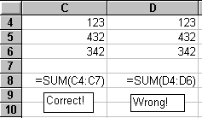

The is because if you insert extra rows, and add some more figures, the first formula will automatically adjust and add up the new figures correctly. The second formula (the wrong one), will not and the total will not change, therefore making your spreadsheet incorrect, forcing you to re-enter the formula.

Percentages
Two forms of percentages are commonly calculated:

• A percentage of a number i.e. 5% of 25
• One number as a percentage of another i.e. 25 as a percent of 125

What is a Percentage?
Remember that 'Per Cent' means literally per hundred.

Thus 15% is 15 per hundred or 15/100 (0.15)

Displaying a Number as a Percentage
Select cell that you want to change
Click on % symbol in Formula Bar e.g. 0.75 will now display as 75%

Alternatively you can simply type in 75%.
Excel will store the number as 0.75 and display it as 75%.

Finding A Percentage Of A Given Number
e.g. What is 10% of £18,000?

 | A | B
1 | Salary | £18,000
2 | % Increase | 10%
3 | Actual Increase | =b1*b2 (1,800)
4 | Total Salary | =b1+b3 (19,800)

What each Cell Reference means...

Cell Reference B3 Calculating the increase, 10% multiplied by 18,000
Cell Reference B4 Adding the increase to the Salary

Finding One Number As A Percentage Of Another
e.g. What percentage is the number 15 of the number 125?
To get one number in a cell as a percentage of a number in another cell, divide the first cell by the second cell.

 | A | B | C
1 | Expenditure | Actual | Percentage of Total
2 | Clothes | £15 | =b2/b6 (0.12)
3 | Food | £85 | =b3/b6 (0.68)
4 | Travel | £25 | =b4/b6 (0.20)
5
6 | Total | £125

Table of Percentages and Decimals

Percentages | Decimal
1% | 0.01
5% | 0.05
10% | 0.1
15% | 0.15
17.5% | 0.175
20% | 0.2
50% | 0.5
99% | 0.99
100% | 1.0

Other Functions That You Can Use

Statistical Functions
There are over 150 other functions that can be applied in Excel. See the Appendix for a complete list. Some of the useful ones include:

=AVERAGE(range) Average of numbers in a range of cells
=COUNT(range) Count of number of values in a range of cells
=MAX(range) Maximum value in a range of cells
=MIN(range) Minimum value in a range of cells

The IF Function - Getting Conditional Answers
You can use the =IF function to give different results depending on the circumstances. For example a salesman may receive a bonus if his sales reach a certain value.

The =IF function takes the following format:

=IF(THIS IS TRUE, PUT THIS IN THE CELL, OTHERWISE PUT THIS IN THE CELL)
So here's an example:

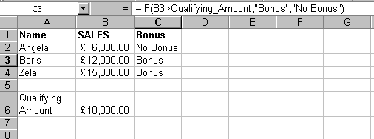

The formula in cell C3 (shown on the entry line above) is saying:

IF B3 (BORIS’ SALES) IS GREATER THAN THE QUALIFYING AMOUNT THEN PUT THE WORD “BONUS” INTO CELL C3 OTHERWISE PUT THE WORDS “NO BONUS” IN THE CELL.

Text
If you want text to appear as one of the results (as in the above example) you must put the text in quotes.

Use The Paste Function
The Paste Function makes it easy to use the functions that are available in Excel- See Paste Function

The Paste Function

Using The Paste Function
Select the cell where the function is to go
Click on the Paste Function Icon A dialog box appears

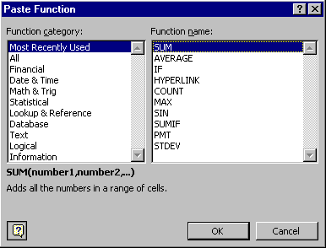
Select a function from the Function Category
list on the left.

Select the function you want from those listed
on the right.
Click OK A dialog box will appear giving a description of the function you have chosen

For example the Average function

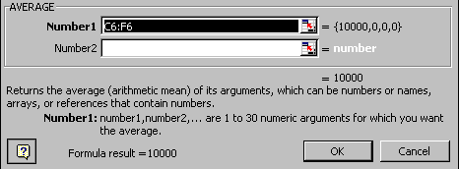

The information you need to enter in each box will depend on the function chosen.

Enter the information into the first box.
Click into the next box (if applicable) and enter the information.
Do the same for any other boxes (if applicable)
Click OK

Easy Entering of Cell Ranges
Click on the to stop the paste function dialog box getting in the way. Select you range and click on to get back to the paste function dialog box.

Inserting & Deleting Rows and Columns

Inserting A Row
Select any cell below the place you want to insert a row
Click on Insert Menu The menu will drop down
Click on Rows

Inserting a Column
Select any cell to the right of the place you want to insert a column
Click on Insert Menu The menu will drop down
Click on Columns

Inserting Several Rows Or Columns
Click & drag over number of rows or columns to be inserted
Click on Insert Menu The menu will drop down
Click on Rows or Columns

Deleting Rows And Columns
You can use this option to delete rows or columns but take care that you do not delete cell with information you need.

Highlight range Highlight range covering row numbers to be deleted
Click On Edit The Edit Menu will drop down
Click On Delete The dialog box will appear
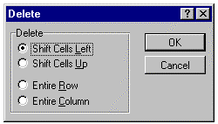

Select Entire Row or Entire Column
Click OK

Using the Right Mouse Button

Select the Rows or Columns that you wish to insert or delete
Release your mouse button
Right Click over the Selection
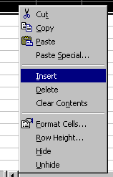
Choose Insert or Delete The selected row(s) or column(s) will be inserted or deleted

Saving Your WorkBook

Saving A Workbook for the First Time
Click on the Save icon Shown below (top left of the screen)

The following dialog box will appear

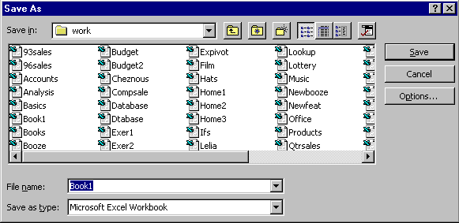

Type in the name of the document (up to 255 characters long).
Change the folder to save the file to, if required
Click Save or press Return

Saving a WorkBook Again after Changes
Click on the Save icon Shown below (It's at the top left of the screen)

The Workbook will be saved without further prompts.

More Options In Saving

Creating a Copy of a WorkBook using Save As
Click on File The File Menu will drop down
Click on Save As The Save As box will appear (shown above)
Type in a new name for the document
Select the folder to save the file to if required
Click Save Or press Return

You may be prompted for Document Properties (Depending on how Word has been set up on your computer). If so enter the necessary information and click OK.

Changing Where WorkBooks Are Normally Saved
Click On Tools Menu The menu will drop down
Click On Options The dialog box will appear

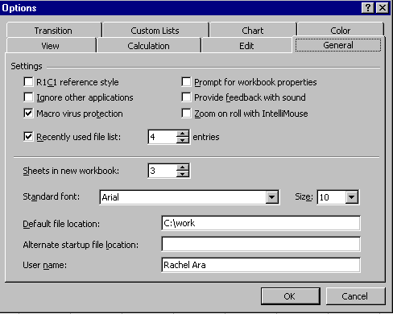

Click on the General tab
Click into the box next to the Default file location
Type in the Default file location for your Workbooks
Click OK

Creating a Folder in the Save Dialog Box
In the Save Dialog box using the Save in Drop-Down list change to the drive or folder that will be the parent of the new folder.
Click on the Create New Folder button
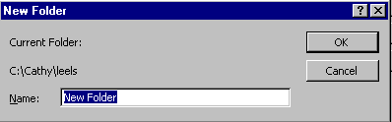
Type a name for the folder
Click OK

Opening, Creating and Closing Workbooks

Opening Saved Documents
Click On The Open Document Icon Shown Below (It's at the top left of the screen)

The following will appear

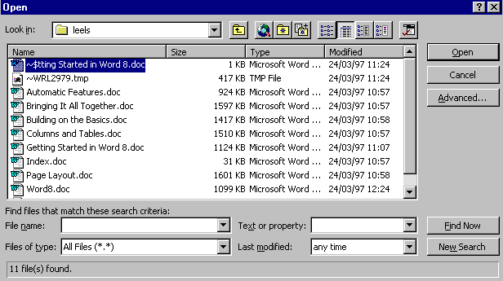

Change the folder if required
Click on the name of the file to open It will be highlighted
Click Open

You Can Open More Than One Workbook At A Time
You can select and open as many files as you want in one go. To select more than one file, use either the shift key and click on the first then the last file, or the CTRL key and click on files individually. Alternatively, you can drag around the files to select a block.

Opening One Of The Last Files You Used
- The File menu in Excel will display the last four files you have used. Simply click on the one you want to open
- The menu Documents Option in Windows, will display the last 15 files you have used in any application. Again simply, click the name of the file you want to open it

Creating New Workbooks
Click On the New File Icon Shown Below (It's at the top left of the screen)

A new blank document will be created

Closing Workbooks That Are Open
Click on File The File Menu will drop down
Click on Close The workbook will close

If the Workbook needs to be saved you will be prompted to do so.

Managing Files in the Open Dialog Box

Changing the View of your Files in the Open Dialog Box
Click on Open
Use the buttons shown below to change the view of your files

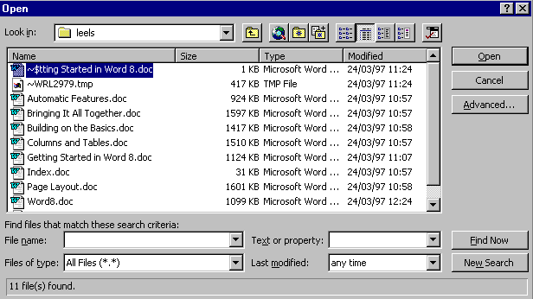

The Default view is List. This shows the name of your files in alphabetical order. Other views are:

Details | Shows Name of file, Size, type and date last modified
Properties | Shows properties for the selected file
Preview | Gives preview of selected file

Sorting Files
In the Open dialog box click the Command and Settings button
Choose Sorting from the pull down menu
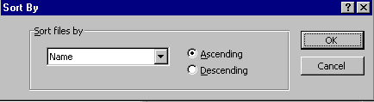
In the Sort files by drop down list specify a sorting options - Name, Size, Types of File or Last Modified
Choose whether you wish the files to be displayed in Ascending or Descending order.
Click OK

Managing Files (In the File Open Dialog)
Click the Open File button or File Menu: Open

Find the files or folders you want to work with (see previous pages)
Click on the file to change with the right mouse button
From the pull down menu click on the option required

Selecting Files
One File | Click on that file
Files that are next to each other in a list | Click on the first file and release your mouse pointer. Now hold down your SHIFT key and click on the last file in the list. All files in-between will be selected.
Files that are not next to each other in a list | Click on the first file and release your mouse pointer. Now hold down your CTRL key and click on the other file you wish to select and so on.

Copying Files Using the Open Dialog Box
In the Open Dialog box select the file(s) you wish to copy
Right-click over the file(s)
From the pull down menu choose copy
Using the Look in drop-down list choose the drive or folder you wish to copy to
Right click again and choose paste

Moving Files
In the Open Dialog box select the file(s) you wish to move
Right-click over the file
From the pull down menu choose cut
Using the Look in drop-down list choose the drive or folder you wish to move to
Right click again and choose paste

Deleting Files
In the open dialog box select the file(s) you wish to delete
Right click over the file
Choose delete from the pull down menu The file will go to the Recycle Bin

True Delete (Avoiding the Recycle Bin)
In the open Dialog box select the file(s) you wish to delete
Right click over the file
Keeping your SHIFT key held down choose delete from the pull down menu
(The file will be deleted)

Renaming a File
In the Open Dialog Box select the file you wish to rename
Right-click over that file
From the pull down menu choose rename
Type the new name and press Enter The file will have a new name

Copying File(s) to the Floppy Disk
In the Open Dialog box select the file(s) you wish to copy to the floppy disk
Right-click over the file(s)
From the pull down menu choose Send to and then 3 1/2 floppy

Favourites
You use the Favourites folder to store shortcuts to files and folders of interest. You can use a shortcut for quick access to the file without having to remember where the file is located.

To add a file or folder to the Favourites folder…
Select the file or folder you want a shortcut for
Click and then click Add Selected Item To Favourites.
To add a shortcut to the folder selected in the Look In box, click Add 'Look In' Folder To Favourites.

To open a favourite file or folder…

Click and then double-click the shortcut or the filename or folder name.

Access the Web in the Open Dialog Box

Click on the Web Toolbar icon You will be connected to your internet browser

Moving And Copying Things

Moving Selections With Drag And Drop
Select range to be moved
Move the cursor to the edge of the highlighted range The cursor will change to an arrow
Click and drag to the new location

Copying Selections With Drag And Drop
Select range to be copied
Move the cursor to the edge of the highlighted range The cursor will change to an arrow
Hold down the CTRL key
Click and drag to the second location

Copy Selections With Cut And Paste
Select range to be copied
Click on Copy Icon
Select top left of range to copy to
Press Return
Or click on Paste Icon

Moving Selections With Cut And Paste
Select range to be moved
Click on Cut Icon
Select top left of range to move to
Press Return
Or click on Paste Icon

Using the Right Mouse Button
Select the Range to be moved or copied
Release your mouse button
Right click over the selected range a pull down menu will appear
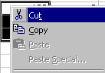
Select Cut (if you are moving) or Copy (if you are copying)
Right click where you want the selection to appear a pull down menu will appear
Click on Paste

Copying Formulas
When you copy formulas like =SUM(B3.E3) to other places on your worksheet, Excel automatically adjusts them so that they add up the correct figures.

An Explanation Of Copying Formulas
Any cell references in formulas are adjusted as they are copied: If the formula =SUM(B3:B9) is copied from B10 to C10 and D10 it will become SUM(C3:C9) and SUM(D3:D9).

 | A | B | C | D
9
10 | Total | SUM(B3:B9) | SUM(C3:C9) | SUM(D3:D9)

Example: The result of copying the formula in cell B10 to C10. The cell references are adjusted.

AutoFill to Copy Formulas
Select the area or cell to copy
Move the mouse to the tiny black square Its at the bottom right corner of the selected area. Your cursor will change to a small plus sign
Click and drag to highlight where to copy to
Release the mouse button The formulas will be copied and adjusted automatically.

See Also

“Using AUTOFILL To Make Copying Easy!”
“Moving And Copying Things”

Absolute Cell References & F4
Normally when cell references are copied, they are adjusted (as described in “Copying Formulas” - page 49). Sometimes you will want this reference to stay fixed. (For instance, when the interest rate is stored in one cell, and is to be used in all formulas.)

To keep a cell reference fixed, insert a $ sign before it in the formula.

Relative Cell Reference | d5*c2
Absolute Cell Reference | d5*$c$2

Thus if a formula in D9 reads d5*$c$1, when copied to E9 it will read e5*$c$1, still referring to the same C1 cell.
Insert the $ (Absolute Cell Reference ) sign by tapping the F4 key at the top of your keyboard!!

Creating A Formula With Absolute Cell References.
Select cell where the result of the formula is to appear
Type =
Select or type in first cell reference Does this cell reference need to be fixed?
Press the F4 key to put the dollars in
Type the maths bit such as + or *
Select or type in next cell reference Does this cell reference need to be fixed?
Press the F4 key to put the dollars in if needed
And so on until you have created your formula
Press Return Or click on the tick

Changing An Existing Formula To Use Absolute Cell References (Putting The Dollar Signs In)
Double-click on the cell to change
(it contains the formula you want to make absolute)
Move flashing cursor to cell reference to change
Press the F4 key to put the dollars in
Move flashing cursor to next cell reference to change If needed
Press the F4 key to put the dollars in if needed
Press Return Or click on the tick

What Happens If You Hit F4 More Than Once

The first time you hit F4 when entering or editing a formula two dollar signs are put in, but if you hit it again Excel actually cycles through the following:

Original cell reference | F4 - first time | F4 - second time | F4 - third time | F4 - fourth time (back to the start)
B4 | $B$4 | B$4 | $B4 | B4
None of the cell reference is fixed | Both column and row references are fixed | Only the row reference if fixed | Only the column reference is fixed | None of the cell reference is fixed
RELATIVE CELL REFERENCE | ABSOLUTE CELL REFERENCES | MIXED CELL REFERENCES | MIXED CELL REFERENCES | RELATIVE CELL REFERENCE

Mixed Cell References

As you have seen Cell References can be absolute, but they can also be relative, which is without the dollar ($) sign and even a mixture of both! An example of mixed cell references is $A1 or A$1. $A1 refers to column A regardless of the position of the cell containing the formula. The 1 refers to the cell containing the formula.

The Golden Rule Of Good Spreadsheet Design

Never Put A Number In A Formula
You should put a reference to a cell that contains the number rather than the number itself. This has many benefits - see the example below for an explanation.

An Example

Although this loan formula will produce the right answer, and will fill across to February and March, it is bad practice because it is impossible to know what the figure 24 represents, and to change it we have to go and edit the formula every time.

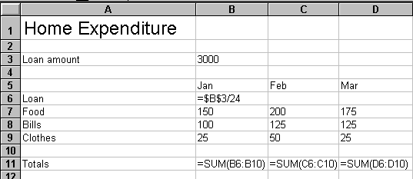

To make this spreadsheet much more readable and easy to change we should do the following :

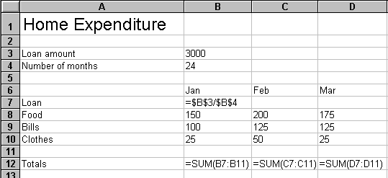

Using a separate cell for the number of months the loan will be repaid over (which is 24) gives you much more flexibility. For example taking the loan to 48 months will meaning changing a single cell.

Figures buried in a formula are harder to spot and understand.

Principle: Calculate in One Direction

Calculate from Above & from the Left

Clean, well-designed spreadsheets calculated downwards and to the right (from above and from the left). This makes them easy to follow and avoids circular calculations.

If formulas loop back on themselves, it is difficult to work out what is going on, if corrections are needed.

Avoid Circular References

Circular references are where one cell uses a formula that is dependent on its own value. The effects can be variable (it could, for instance, increase a value in a cell every time a re-calculation is done) but they are definitely best avoided.

You can avoid any possibility of a circular reference by ensuring formulae only refer to cells iabove this one in this column, or in any column to the left.

The following table is an example of a circular formula, where the calculations loop back on each other. While in balance it is fine. But if one of the figures is changed, it takes several re-calculations to get them back into balance.

Doing it Wrong: A Circular Formula

Calculating the bonus the wrong way (as below) means the total depends on the bonus, which depends on the total and so on. The calculation is never finished. (Circular references are often more complicated than this.)
 | A | B | B
1 | Bonus % | 10%
2
3 |  | Displayed | Formula
4 | Salaries | 15,000 | 40,000
5 | Expenses | 8,000 | 8,000
6 | London Wtg. | 2,000 | 2,000
7 | Bonus | 2,500 | =b9*b1
8
9 | Total | 27,500 | =sum(b3:b8)

Excel Tells You If You Have a Circular Reference

The error message ‘Cannot Resolve Circular References’ should appear if you create a circular reference. In addition the message ‘Circular:’ will appear on the bottom line, with one of the problem cells identified.

Principle: Check your Spreadsheet

Always Check Your Spreadsheet By Hand!!
This may seem to defeat the point of a spreadsheet, but it is ESSENTIAL. Just because your spreadsheet is on a computer and looks nice and tidy doesn't mean that it is correct!!

Mistakes can easily arise through:
A Saying to Remember

“To err is human ... but for a real cock-up you need a computer.”

- Figures being entered incorrectly
- Formulas being typed incorrectly
- New information being typed in, that doesn't get included in existing formulas

Follow a two stage checking process:

1 - Do the results make sense? If they are nowhere near where you expected them to be, trace why not in the spreadsheet.
2 - Check the figures by hand (or , at least, by calculator)

Build in Automatic Error Checking

It is possible to build in an element of automatic error checking, to warn you of some errors.

If a table results in totals at the right-hand side and totals at the bottom (such as in a monthly cash-flow over a year), there are two ways of getting the grand total at the bottom right-hand side: Summing either the column of totals or the row of totals.

SO: Enter formula to do both (in adjoining cells) and compare the results. If they are not exactly the same, there is an error in your table.

Using Sheets In A Workbook

About Sheets
The default workbook opens with 3 worksheets, named Sheet1 through Sheet 3. The sheet names appear on tabs at the bottom of the workbook window. By clicking on the tabs you can move from sheet to sheet within a workbook. The tab of the active sheet is always bold.

A workbook can contain one sheet or as many as 255 sheets. You can:

- Insert and delete sheets
- Rename the sheets with names up to 31 characters in length
- Copy or move sheets within the workbook, or to another workbook
- Hide sheets within the workbook

If you point to a sheet tab and click the right mouse button, a shortcut menu of commands for sheets appears.

A workbook can have six different types of sheets:

- Worksheet
- Chart sheet
- Visual Basic module
- Dialog
- Microsoft Excel 4.0 macro sheet
- Microsoft Excel 4.0 international macro sheet

Moving Through Sheets
Click on the tab you want
or
Use the buttons to scroll to the sheet you want then click on the tab
or
CTRL + PgUp for the previous page and CTRL + PgDn for the next

Naming Sheets
Double-click on the tab
Type the name for the Sheet and press return

Moving Sheets
Click and drag the tab to the new location

Copying A Sheet
Hold down the CTRL key on the keyboard
Drag the tab to a new location to make a copy of that sheet.

Seeing More Or Less Tabs
Drag the divider between the tabs and the scroll bar

Deleting A Sheet
Right Click on the tab (a short cut menu will pop up)
Click on delete (a dialog box will appear)
Click OK to confirm the deletion
or
Edit Menu : Delete Sheet
Click OK to confirm the deletion

Making It Look Good

Objectives

By the end of this session you will be able to:-

- Change the alignment, font and style of numbers
- Adjust the width and height of rows and columns
- Insert the date and time
- Apply borders and shading to your spreadsheet
- Use Autoformat to give your spreadsheet an automatic design
- Remove and copy formatting
- Use the zoom control to see more of your spreadsheet

Changing The Look Of Your Text & Numbers
Excel provides some very powerful ways of making your worksheet look superb. Impress your friends, relatives, boss, customers, you name it, with high professional output!

Making It Bold
Select the cells to make bold
Click on the Bold icon

If you want to remove the Bolding, click on the icon again with the cells selected

Making It Italic
Select the cells to make Italic
Click on the Italic icon

If you want to remove the Italic, click on the icon again with the cells selected

Changing The Font (The Typeface)
Select the cells to change
Click on the downward arrow next to the font list
Select a font from the list that drops down

Changing The Size
Select the cells to change
Click on the downward arrow next to the font size list
Select a font size from the list that drops down (the bigger the number the bigger the size)

The Fonts And Sizes Available Can Vary From Machine To Machine

- Depending on the machine you are using, different fonts may be available.
- Some fonts are not able to display in many sizes

Aligning Text & Numbers

Aligning Text or Numbers Within A Cell
You can align your text or numbers within a cell so that they are on the left, in the centre, or on the right, like the picture below:

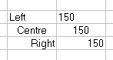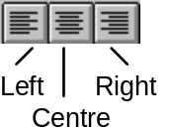

Here's how you do it:

Select the cells you want to change
Click on the appropriate icon Shown above

Centring Text or Numbers Across Columns
This is useful to centre a heading across a table for instance.

Select the cell to centre and the range to centre across (See Below)
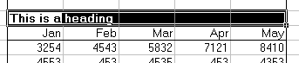

Click on the merge and centre icon

The result will be thus:

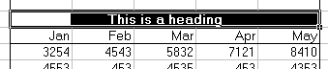

Other Options In Aligning Text & Numbers

Other Options
Select the cell(s) to change
Click on Format The Format menu will drop down
Click on Cells
Click on the Alignment Tab
Select the changes you wish to make
Click OK

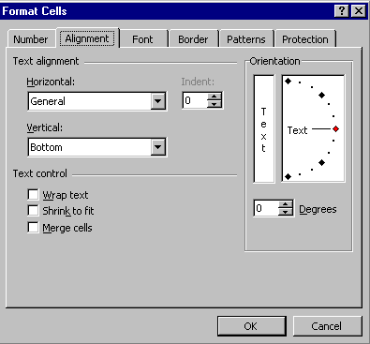

Short Cuts To The Format Cells Box
Select the cells to change then...
CTRL + 1 or
Click the Right Mouse Button And Select Format Cells From The Pop-up Menu

Wrapping Text Within a Cell

If you have a lot of text to enter in a cell, you may wish to wrap it onto more than one line:
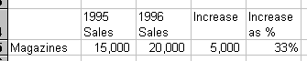
Select cell
Format Menu: Cells
Click on ‘Wrap Text’
OK

Merging Cells

Select the Cells to Merge
Click on the Format menu and Cells
Choose the Alignment tab
Check the Merged cell check box so that there is cross in it.
Click OK

Changing the Orientation
This is useful for labels for tables that you produce



To get the above effect:

Select the cells
Click on the Format menu and choose Cells
Click on the Alignment tab
Under the Alignment section drag the text line to the required angle. (For the above example choose 45°).
Click OK

Changing The Font (The Typeface)

Changing The Font In Detail
Select the cell(s) to change
Click on Format The Format menu will drop down
Click on Cells
Click on the Font Tab
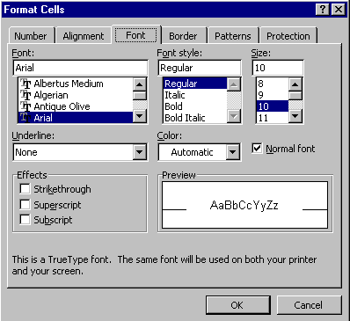

Select the Font Name, Style, Size, Colour, and Effects to your liking. (A preview is displayed)
Click on OK The changes will be made

Changing To The Normal Font
If you want to go back to the normal font (the one Excel started with) for a particular part of your spreadsheet)

Select the cell(s) to change
Click on Format The Format menu will drop down
Click on Cells
Click on Font Tab
Click on Normal Font so there is a tick next to it
Click OK
Short Cuts To The Format Cells Box
Select the cells to change then...
CTRL + 1 or
Click the Right Mouse Button And Select Format Cells From The Pop-up Menu

See Also

“Changing The Font (The Typeface)” - page 58

Changing The Look Of Numbers

Quick Changes To The Number Format
Clicking on this button will increase the number of decimal points displayed
Select the cells to change
Click on the following icons to make the change
Clicking on this button will decrease the number of decimal points displayed

Click here to add the currency sign (£)

Click here to make the numbers display as percentages (0.75 would display as 75%)
Click here to automatically add commas for numbers in the 1,000’s

Displaying a Number with Commas
Select cell(s)
Click on comma button

Displaying a Number with Commas and No Decimal Places
Select cell(s)
Click on comma button Number is displayed with two decimal places
Click on Reduce decimal places Number is displayed with one decimal place
Click on Reduce decimal places Number is displayed with no decimal places

Displaying a Number as a Percentage
Click on cell(s)
Click on % button 0.75 will display as 75%

Changing The Look Of Numbers With The Format Cells Box
Select the cell(s) to change
Click on Format The Format menu will drop down
Click on Cells
Click on The Number Tab
Click on the Category you want i.e. currency, number; percentage
Click on the code that you want An example will display next to ‘Sample’
Click OK
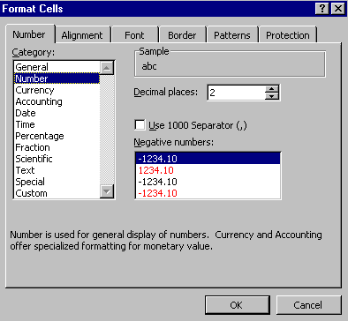

Short Cuts To The Format Cells Box
Select the cells to change then...
CTRL + 1 or
Click the Right Mouse Button And Select Format Cells From The Pop-up Menu

Displaying Negative Numbers in Brackets
Accountants often want to display negative numbers in brackets (instead of pre-ceded by a minus). To achieve this, you will have to customise a number format:

Select cell(s) Select the cell(s) to change
Click on Format The Format menu will drop down
Click on Cells
Click on The Number Tab The Number tab will come to the front
Click on Custom
Click in Type box
Scroll down the list on the right until you find the option
£#,##0:[Red]-£#,##0
Select it
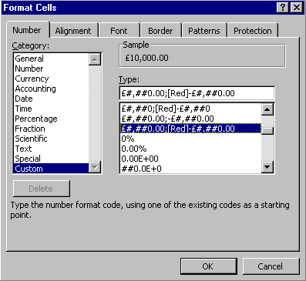

Click OK

What Do The Codes Mean?
The codes are not immediately obvious, but if you take them one step at a time they do make sense.

Here are some examples:

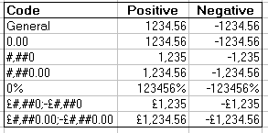

Making Columns Wider & Rows Taller

Making A Column Wide Enough To Fit Everything In
Move the cursor over the column letter
Move the cursor right until it changes to a cross arrow (shown below)

Double click The Column will automatically adjust

Making A Row Tall Enough To Fit Everything In
Move the cursor over the row number
Move the cursor down until it changes to a cross arrow (shown below)

Double click The row will automatically adjust

Adjusting The Row Or Column Manually
Move the cursor over the row number or column letter
Move the cursor down or right until it changes to a cross arrow
 or
Click and drag to adjust

Adjusting More Than One Row Or Column At A Time
Select the row or columns
Move the cursor down or right until it changes to a cross arrow
or
Click and drag to adjust

Adjusting All Columns And Rows
Select the whole spreadsheet Click on the square shown below

Move the cursor down or right until it changes to a cross arrow
or
Click and drag or
Double click to adjust

Dates & Times

Date Stamping the Worksheet
The NOW( ) function can be used to 'date stamp' a worksheet. Not only will it insert the date, but it will update every time you use or print the worksheet.

Select cell
Click on cell to contain date stamp
Type the formula “=NOW( )” Without the “”
Or Use Paste Function for the function
Press Return Or click on the tick

Changing the Date Format
The date and time will now be placed in the cell. To change the look of this:

Format Menu: Cells
Click on Number Tab The Number box will appear
Click on 'Date' (or 'Time') in 'Category' column
Click on date format required
Click on 'OK'

Pre-defined Date & Time Formats
In Excel you don't have to use a special format. Dates and times typed in any of the following formats are allowed:

m/d/yy 12/24/95
d-mmm-yy 24-Dec-95
d-mmm 24-Dec
mmm-yy Dec-95
h:mm AM/PM 9:45 PM
h:mm:ss AM/PM 9:45:15 PM
h:mm 21:45
h:mm:ss 21:45:15
m/d/yy h:mm 12/24/95 21:45

Date Shortcut: For Fixed Dates
You can insert the date in the correct format quickly with the following keys.

CTRL ; The date is inserted in the current cell.

NOTE : This will insert the date, not the date code. This means that tomorrow when you look at the worksheet it will still have today's date in (which might be what you want!)

Adding Lines And Borders

Adding Borders To A Range Quickly
Select the cells to put an outline border around
Click on the downward arrow next to the Borders Icon
Click on the type of border you want from the selection

Repeating A Border Style
When you select a border style from the drop down list, it then becomes the borders icon. To use it again click select the range to change and click on the button instead of the downward arrow

Tearing Off The Border Toolbar!
If you intend to use the borders toolbar a lot then you can tear it off and leave it on you worksheet, close to where you are working

Click on the downward arrow on the borders icon.
Click and drag down on the small bar at the top.
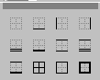

The Borders tool bar floats.
To remove the Border toolbar click on the small l button at the top right of it.

Adding Other Borders
You are not restricted to the borders on the toolbar. You can define any collection of lines around a cell that you wish:

Select the cell(s) to change
Format Menu: Cells
Click on the Borders tab
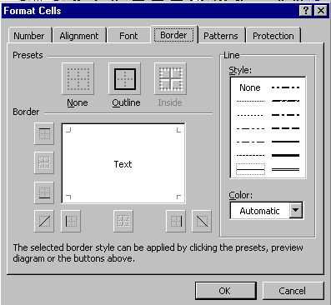

Short Cuts To The Format Cells Box
Select the cells to change then...
CTRL + 1 or
Click the Right Mouse Button And Select Format Cells From The Pop-up Menu

Adding Colour And Shading

Adding A Colour Shade
Select the cells to shade
Click on the downward arrow next to the colour icon
Select a colour that you want from the drop down selection

Repeating A Colour Shade
When you select a colour shade from the drop down list, it then becomes the colour icon. To use it again click select the range to change and click on the button instead of the downward arrow

Changing The Colour Of The Font
Select the cells to change
Click on the downward arrow next to the text colour icon
Select a colour that you want from the drop down selection

Repeating A Font Colour
When you select a font colour from the drop down list, it then becomes the font colour icon. To use it again click select the range to change and click on the button instead of the downward arrow

Tearing Off The Colour Shade Or Font Colour Toolbars
If you intend to use the toolbar a lot then you can tear them off and leave them on your worksheet, close to where you are working

Click on the downward arrow next to the icon.
Click and drag down on the small bar at the top.

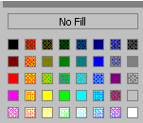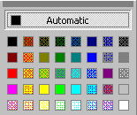

To remove the toolbars click on the small button at the top right of it.

Use AUTOFORMAT for instant style!
Excel comes with some very nice formatting styles already built in. It's easy to apply these to your worksheets and produce instantly impressive results (including 3D effects!).

Selecting Your First AUTOFORMAT style
Select the area to apply the style to, usually a table
Click on Format The Format Menu will drop down
Click on AutoFormat The AutoFormat box will appear

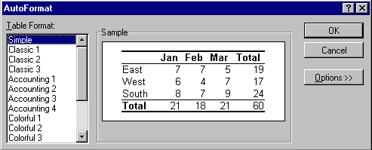

Select a style from the Table Format List You can scroll down for more
Click on OK

Being More Decisive With Your AutoFormat Style
You can pick and chose which parts of the AutoFormat style you want to use. For instance you may not want to change the column widths automatically.

Select the area to apply the style to Usually a table
Click on Format The Format Menu will drop down
Click on AutoFormat The AutoFormat box will appear
Select a style from the Table Format List. You can scroll down for more
Click on Options>> The AutoFormat Box will grow !!!
Click on the Formats options you don’t want A cross in the box means it is selected
Click OK
AutoFormat Will Attempt To Guess The Area To Format

If you click inside a table of data then select AutoFormat, AutoFormat will Automatically select the table for you!

Don’t Select The Whole Spreadsheet
Don’t select the whole spreadsheet (or any very large area) and try AutoFormat, it will take a very long time and probably won’t look very good in the end!

Conditional Formatting
This Features allows you to apply formatting to cells that meet a certain criteria. For example you might be analysing sales figures and wish to apply a green shading to sales figures that exceed 50,000 in value. You might also want apply red shading to sales figures that do not reach 40,000 in value.

Apply conditional formats to cells
Select the cells you wish to format conditionally
Click on the Format Menu
Choose Conditional Formatting
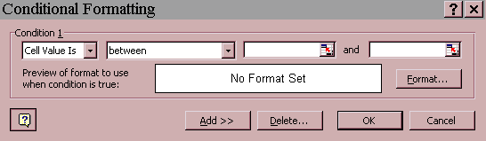
Click Cell Value is
Select comparison phrase
Type a value in the appropriate box
Click on the Format button
Select the font style, font colour, borders, shading you wish to apply if condition is met
To add another condition click on add You can specify up to 3 conditions
Click OK, when finished

To Remove Conditional Format
Select a cell or cells that has conditional formats you want to remove
Click on the Format menu
Choose Conditional Formatting
Click on the Delete button
Select the Conditions to Delete
Click OK
Click OK again

Removing & Copying Formatting

Removing All Formatting
Select the cells to change
Click on the Edit menu The menu will drop down
Click On Clear
Click on Formats

Copying Formatting With The Format Painter
Select the cells that have the nice formatting
Click on the format painter icon
Select the cells to copy the formatting to

Using Format Painter To Copy Formatting To More Than One Place
Select the cells that have the nice formatting
Double-click on the format painter icon It will stay “depressed”
Select the cells to copy the formatting to
Select more cells to copy the formatting to
And so on
When you have finished, press ESC or click on the format painter icon again

Seeing More Of The Worksheet On Screen

Zooming In And Out On Your Work
Click on the downward arrow next to the Zoom Control Drop Down List
Click on the size you want

Filling The Screen With Your Selected Cells
Select the cells to zoom in on
Click on the downward arrow next to the Zoom Control Drop Down List
Click on Selection

Putting The Display back to Normal
Click on the downward arrow next to the Zoom Control Drop Down List
Click on 100%

Zooming In Our Out To Any Size
Click inside the zoom control box
Type a percentage
Press Return
You Can Also Use The View Menu

View Menu : Zoom will give the same options as above (it’s just another way of doing it)

Working Full Screen
If you want to work full screen, with no icons displayed...

Click on the View Menu
Click on Full Screen A toolbar appears.
To return to normal view, View Menu : Full Screen again
or click on Close Full Screen on the toolbar 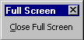

Printing

Objectives

By the end of this session you will be able to:-

- Carry out basic printing
- Use selective printing
- Use print preview
- Change the page set-up of your spreadsheet
- Change the orientation of the page
- Add headers and footers

Basic Printing

Basic Printing
To print the worksheet with the print setting as they were set previously:

Click on the Print Icon A dialog box will appear informing you that the spreadsheet is printing
When the box disappears, the entire worksheet will be printed

Printing Only Part Of Your Spreadsheet
Select the area you want to print
Click On File menu The File Menu will drop down
Click on Print
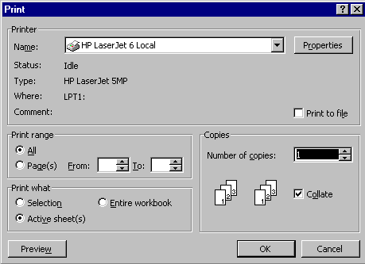

Click on “Selection” in the “Print What” box
Click OK

Other Options In Printing
Click on File Menu
Click on Print
Change the number of copies, the page range and what you want to print
Click OK

Print Preview: So What Will It Look Like On Paper?

Getting A Print Preview
Click on the Print Preview Icon The screen will change to the print preview

Zooming In & Out On The Print Preview Page
Move the mouse over the area to zoom in on
Click

To Zoom out:

Click once more over the page

Adjusting The Margins & Columns In The Print Preview
Click On The Margins Button The Margins and Column Markers will appear
Move the mouse over a margin line or column marker The cursor will change to a cross arrow
Click and drag to adjust the margin or column

Seeing The Next Or Previous Page
Click on the Next button for the next page
Click on the Previous button for the previous page

The bottom left of the screen indicates which page you are on (i.e. Page 1 of 2)

Scrolling Through Lots Of Pages
Use the scroll bar on the right of the screen to scroll though pages quickly.

Changing The Page Setup
Click on the Setup… button The Page Setup box will appear
(See “Page Setup” - page 84) Print and Print preview buttons

Page Setup
Page Setup lets you change many settings regarding how your worksheet will look when printed.

To Access The Page Setup Menu
Click on File The File Menu will drop down
Click on Page Setup The Page Setup box will appear

It can also be accessed from within the Print menu, prior to printing, and from the Print Preview screen.

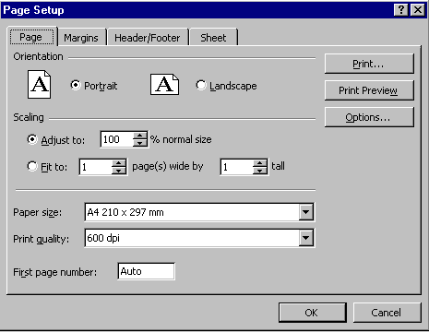

The Page Setup Tabs
The Page Setup is split into five sections (The chart one is only available when you have a chart selected)

Page Tab Controls page orientation, scaling, paper size, print quality, and starting page number.

Margins Tab Controls the page margins, header and footer margins, and vertical and horizontal centring.

Header/Footer Tab Select a header or footer from the built-in headers and footers. You can also customise a header and footer.

Sheet Tab Controls print area, print titles, page order, black-and-white printing, draft quality, and printing of cell notes, cell gridlines, and row and column headings. The Sheet tab is displayed if the active sheet is a worksheet or macro sheet.

Chart Tab Controls the size, colour, and output quality of printed charts. The Chart tab is displayed if the active sheet is a chart sheet.

Making The Printed Output Look Good

Centre It On The Page
Click On File Menu
Click On Page Setup
Click On The Margins Tab
Select Centre Horizontally and Vertically
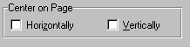

Use Landscape Or Portrait Orientation
Click On File Menu
Click On Page Setup
Click On The Page Tab
Select Landscape Or Portrait
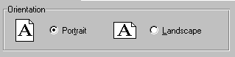

Scale The Output On The Page
Click On File Menu
Click On Page Setup
Click On The Page Tab
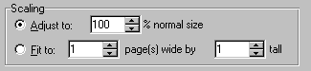

Change the percentage figure to increase or decrease the size
or
Select Fit to 1 page wide by 1 page tall to REDUCE the size of your output to fit a page

“Fit To” Only Reduces The Size
Selecting the “Fit to” option will only reduce the size of the output, not increase it. To increase the size use the “Adjust to” option. You can’t use both options, it’s one or the other

Headers & Footers
This lets you set headers and footers that will print on every page of your worksheet.

Setting Headers & Footers
The headers and footers box's are accessed from the Page Setup box. To access that box:

Click on File The File Menu will drop down
Click on Page Setup The Page Setup box will appear
Click on The Header/Footer Tab
Select a header and footer from the drop down lists
Click OK

If Your Name Isn’t Listed In The Headers And Footers

Go to the Tools Menu : Options : General Tab, click into the User Name section and put your own name in there, Click OK

Custom Headers & Footers
Click on File The File Menu will drop down
Click on Page Setup The Page Setup box will appear
Click on The Header/Footer Tab
Click On Custom Header or Custom Footer
Type or use the icons to enter you header/footer in the desired section
Click OK

Tool | Tool Name | Code | Action
 | Font Tool |  | Displays the Font dialog box
 | Page Number Tool | &[page] | inserts the page number
 | Total Pages Tool | &[pages] | Inserts the total number of pages
 | Date Tool | &[date] | Inserts the current date
 | Time Tool | &[time] | inserts the current time
 | Filename Tool | &[file] | Inserts the filename of the active document
 | Tab Label Tool | &[tab] | inserts the tab name of the sheet

Always Select a Header or Footer that Includes the Date

Using spread-sheets you are likely to end up with a lot of similar print-outs. It is a huge help to have the date (or even the date & time) printed on them.

Creating Charts

Objectives

By the end of this section you will be able to:-

- Insert a chart based on the figures in your spreadsheet
- Move, copy, re-size and delete a chart
- Use the chart toolbar
- Change the chart type
- Edit and format parts of the chart
- Print a chart
- Decide which chart design to use to best represent your figures

Charts: With the Chart Wizard

Creating a Chart in a whizz!!
Click and drag to highlight the data in your table
Click on F11 on your keyboard
A simple barchart appears!!

Creating a Chart using Chart Wizard

Click & drag to highlight area to be charted.
Include: Row & Column Labels and (of course) data. See the example below.
Click on Chart Wizard Icon
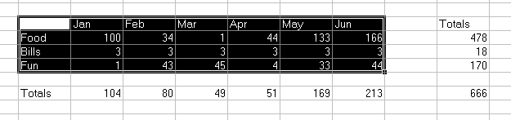

Now Chart Wizard is activated and takes you through the 4 steps of chart creation:

Chart Wizard Step 1: Chart Type
You can choose from either standard chart types or custom chart types. To use the standard chart types:

Click on The Standard Types Tab.
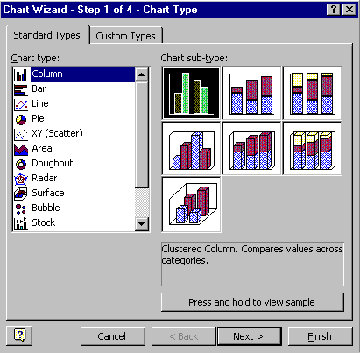
Click on the Chart Type required.
Click on the Chart Sub-type required.
Click on

You can view what your chart will look like.

Click and hold on .

Chart Wizard Step 2: Chart Source Data
Your chart is displayed, based on the data that you have used: Look at the picture of the graph you have created. Is it what you expected? You may need to change some of the settings, if not.
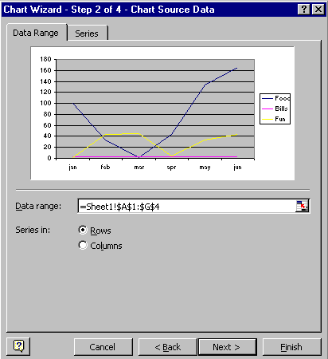

Data Range
Check that you have used the correct data range for your chart.

Series in
If the X axis labels are in the legend and visa versa, you can swap them around with this. Try clicking on Rows or Columns to see how it affects your sample chart

Series Tab
You can add or delete series of data and check that the correct cell range for each series has been chosen.
Click On when finished here

Chart Wizard Step 3: Chart options
You can use the options available with each tab to add final touches to your chart.
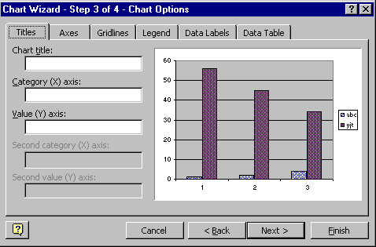

Titles | Add titles to the chart and the X and Y axes
Axes | Displays or hides the X and Y scales on the chart.
Gridlines | Adds or removes gridlines to your chart
Legend | Adds or removes a legend and changes its position
Data Labels | Adds or removes labels to points on the chart.
Data Table | Adds or removes a table containing the data from which the chart was created.

Click On when finished here

Chart Wizard Step 4: Chart Location
Finally Excel asks where you would like to place the new chart: in a new worksheet or as an object in an old one.
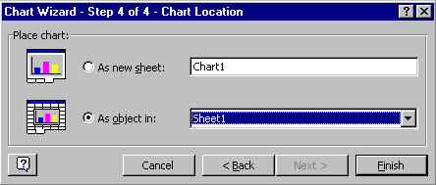

Click on Finish.

Working With A Chart If It Is Inserted As An Object In A Sheet

Moving A Chart
Click on chart to select it Square boxes should appear around edges
Click and drag the chart to the new location

Copying A Chart
To create a second copy of a chart (possibly to use the same data and change the display):

Hold down the CTRL key on the keyboard
Click and drag the chart to the second location

You Can Also Use Cut, Copy And Paste

See page 48 - “Moving And Copying Things”

Sizing A Chart
Select the chart (by clicking on it) Black squares will appear around it
Click and drag on the squares to size the chart

Deleting A Chart
Select the chart (by clicking on it) Black squares will appear around it
Press Delete on the keyboard

Using The Chart Toolbar

Seeing The Chart Toolbar
The toolbar should appear as soon as you click on the chart. If it doesn’t select View Menu : Toolbars : Chart

The Chart Toolbar
Show / Hide Data table
Show / Hide Legend
Click here to slope text.

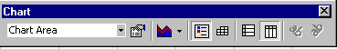
Click here to change the chart type.
Click here to select a chart object.

Click here to change the data series from rows to columns and vice-versa.
Click here to alter the format of the chart object selected.

Tearing The Chart Type Selector Off The Toolbar
If you want you can keep the Chart type selector on screen at all times. You can then use it as a quick way to create or change a chart

Click on the downward arrow next to the chart type icon.
Click on the topmost bar and drag downwards.

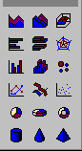
Click and drag the toolbar about by clicking and dragging on the title bar (“Charts”)
Close the toolbar by clicking on the sign in the top right

Changing Your Chart After Creating It

Editing The Chart
Click on the chart

A shaded border will appear around the chart and the Excel menu bar will change: replacing ‘Data’ with ‘Chart’.

Adding Titles
Click on the chart
Click on the Chart menu The menu will drop down
Click On Chart Options The chart options dialog box will appear
Click on the Title Tab
Type in the required titles
Click OK

Adding Another Series Of Data
Select the data in the worksheet
Drag it onto the chart (See page 48 - “Moving And Copying Things” for details on drag and drop)

Removing A Series Of Data
Click once on a series in the chart (you will see squares around it)
Press delete on the keyboard

Formatting Your Chart

Changing Format by Double clicking
Double-click on an element to change A dialog box will pop-up
Make changes as required
Click OK

Changing Formats Using the Right Mouse Button
Click with the Right Mouse Button on the element to change and select an option from the menu
Make changes as required
Click OK

Changing Formats Using the Chart Toolbar
From the Chart toolbar, click on downward arrow next Chart object list box -
Click on the element of your chart you want to change
Click on the Format button A dialog box will appear
Make changes as Required
Click OK

Printing A Chart
You can print your chart on its own piece of paper or you can print it next to your worksheet figures

Printing The Chart On Its Own

Click on Chart to Print
Click on the Print Icon

Printing The Chart Next To Your Figures
Select the figures and the chart to print, by
Clicking and Dragging the whole area The selected area will seem to go behind the chart - this is what you want
Click on File Menu The menu will drop down
Click on Print
Click On Selection
Click OK

Charts: Two Dimensional or Three Dimensional?
It is tempting to always use three-dimensional charts because they look impressive. However they can often be difficult to read.

Three Dimensional Line Charts Can Look Great & Make No Sense At All!
The 3D chart below looks impressive, but is it easy to read? Which costs most in 1995, Butter or Jam? Does cheese cost more or less than jam in 1995? The 2D version looks old-fashioned but it is far easier to answer these questions.

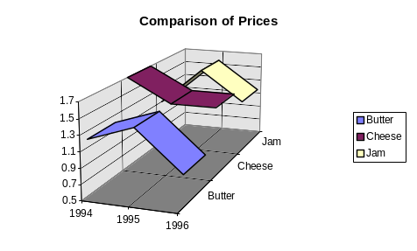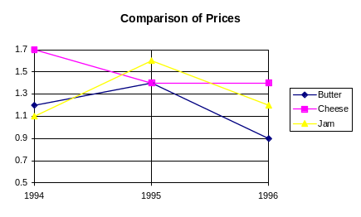

Three Dimensional Column Charts - Also Difficult to Read
The 3D chart below enables comparison between items and for each item over the period. However many people would find the 2D version simpler and clearer:
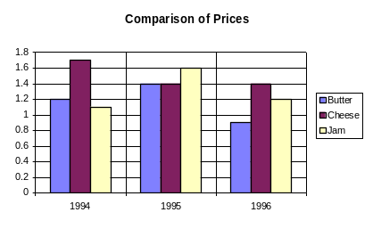
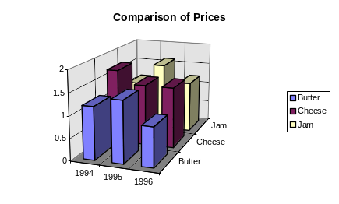

Charts to Display Trends

Line Charts:
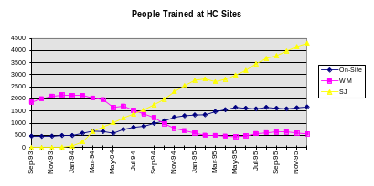Line charts are the most common way of displaying a trend over time.

Column Charts
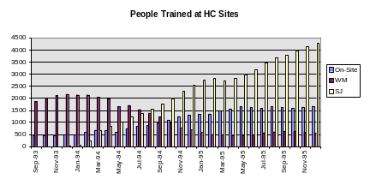Column charts (often called bar charts) are used for trends where comparisons at each time point are wanted.

Bar Charts: Good for Displaying Long Labels
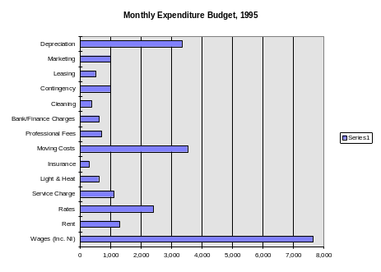With column charts it is often difficult to fit all the labels along the bottom of the chart. In this case a switch to a Bar Chart (sometimes referred to as ‘Rotated Bar’ can be useful):

Charts to Display Proportions
When a set of figures represent parts of a global total, pie and doughnut charts can represent the proportions:

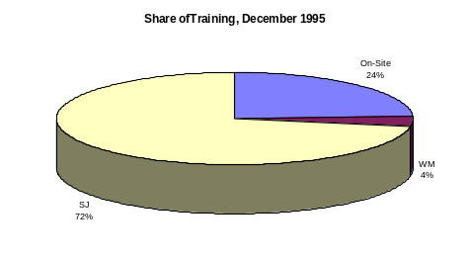Pie Charts: One Set of Figures
Where you are comparing a set of figures at one point in time, a pie chart is the obvious choice.

Advantage: Clear, Simple.
Disadvantage: Only one point in time per chart.

Doughnut Charts: Several Sets of Figures
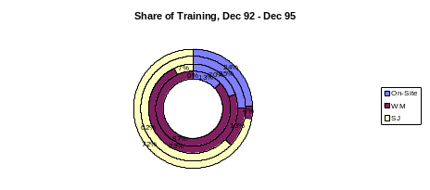Doughnut charts use the same circular idea as pie charts, but allow several years figures.

Advantage: Allows comparison of several time points.
Disadvantage: Unusual, therefore unfamiliar and difficult to understand.

Column Charts: Proportional Option
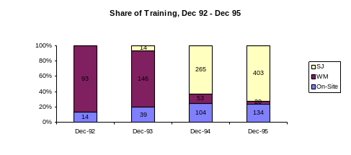The proportional option within column charts enables comparison of proportions over time.

Advantage: Allows clear comparison of proportions at several points in time.
Disadvantage Again, slightly less familiar than pie charts.

Charts to Display Trends & Proportions

Area Charts: Proportions Over Time
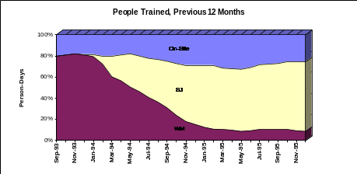

Advantage: Can use many years of figures, shows trend.
Disadvantage: Less familiar than pie charts.

Area Chart: Trends & Proportions
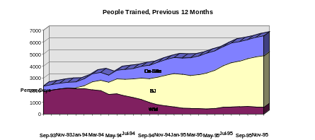

Advantage: Clear on trend, slows comparison over time.
Disadvantage: Less clear on proportions

Making Your Spreadsheet Easier To Use

Objectives

By the end of this section you will be able to:-

- Design Rules
- Group sheets together
- Create formulas that use cells from different worksheets
- Add comments and post it type comment to cells
- Give range names to groups of cells
- Protect your worksheet or workbook
- Use Excel’s toolbars
- Use spreadsheet templates
- Excel in Word

Two Useful Design Rules
When you create a spreadsheet, you should be thinking about how easy it will be to use in the future. Will you or somebody else be able to pick it up and use it straight away or will there be areas that are not easy to understand or change?

Include Blank Rows & Columns in =SUM formulas
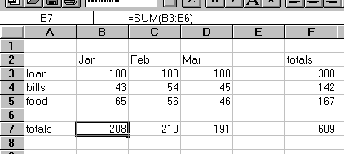

The formula above in cell B7 adds up the figures in B3 to B6, it includes the blank row 6. This means that if you inserted rows at row six for extra items of expenditure the total will adjust automatically and will include the new figures, thus reducing the chances of errors.

Consequently the total formulas in column F include column E in the sum formula (e.g. =SUM(B3:E3))

Never Put A Number In A Formula (For another example see “The Golden Rule of Spreadsheet Design”)
If you put a number in a formula such as B12*0.175 ask yourself the following...

- Does that number mean anything to anyone else?
- If I come back to this spreadsheet in a few months time, will I know what it means?
- What happens if the assumptions behind that number (The VAT rate in this case) changes?
- Will it be easy for me to find all the formulas that refer to this number?
- And if I can find them easily is it easy to change the number quickly?

A much better solution is to put the 0.175 in a separate cell with a label next to it and refer to it as an absolute cell reference within the formula, as shown below.

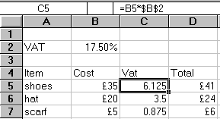
Now if the VAT rate changes you only need to change the figure in B2, thus

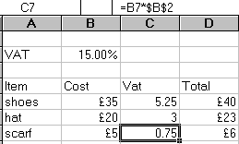

Grouping Sheets
You can enter data on, edit, and format a single worksheet or multiple worksheets in a workbook. Normally you work with one active sheet at a time. The active sheet is the sheet currently displayed in the workbook. The tab of the active sheet is white with bold type.

You can also work with multiple sheets in a workbook simultaneously by making them part of a group selection. For example you can enter common column headings and formulas in several worksheets, or hide several sheets at one time.

You Need A Mouse

You must have a mouse to select a group of sheets.

Selecting A Group Of Adjacent Sheets
Click on the first sheet
Hold down the SHIFT key on the keyboard
Click on the last sheet

Selecting Sheets Not Next To Each Other
Click on the first sheet
Hold down the CTRL key on the keyboard
Click on the next sheet
Keep the CTRL key held down and click on other sheets as required.

Using Sheets That Are Selected
Everything you type or do on one sheet will happen on all the other sheets that are selected.

Selecting All Sheets
Right click on a sheet tab (a short-cut menu will appear)
Click on Select All Sheets

Ungrouping A Selecting Of Sheets
Click on a sheet not in the group
or
Right click on a sheet tab (a short-cut menu will appear)
Click on Ungroup Sheets

Creating Formulas That Link Worksheets & Workbooks

Linking To Another Sheet
Select the cell where the result is to appear
Type =
Use the sheet tabs at the bottom of the screen to turn to the page that contains the figure to link to
Click on the cell to link to and press return

A link has been created between the two sheets in the workbook

Linking To Another Workbook
Open both the workbooks with File : Open (Use the Window Menu to switch between them)
Select the cell where the result is to appear
Type =
Windows Menu : Click on the other worksheet
Click on the cell that contains the figure to link to and press return

Creating An =Sum Formula Across Sheets
This formula will add up cell E11 on every sheet between the ‘Ian’s Expenditure’ sheet and the ‘Steph’s Expenditure’ sheet.

Select the cell on the sheet where the result will appear
Type =SUM(
Click on the first tab sheet to be included
Hold down the SHIFT key on the keyboard
Click on the last sheet tab to be included
Click on the cell to add
Press return

A formula such as the following will be created …

Adding Comments To Your Worksheet
You can add Comments to your worksheet to help understand what you have done! This is a hidden note that you can read when you want but which you wouldn't normally see or print.

Adding A Comment To A Cell
Select the cell that will contain the note
Insert Menu : Comment A “Comment box” appears, with the name of the person who has logged onto the machine.

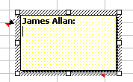
Type in your note
Click OK The note will be added to your cell.

The only indication that it is there is the small red triangle in the top right corner of the cell. (See below)

Red Triangle Indicates A Comment

Reading Your Comment
Rest your mouse on the cell with the red triangle
Comment will pop-up

Deleting A Comment
Rest your mouse on the cell with the red triangle
Comment will pop-up
Click on the View menu
Select Toolbars
Select Reviewing A toolbar will appear

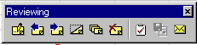

Select the Delete comment icon

You can use your Right Mouse Button here!!
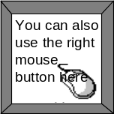
- Right click on the cell with the comment that you want to delete
- Choose Delete Comment from the drop down menu

What do the icons mean?

New Comment

Previous Comment

Next Comment

Show Comment

Show All Comments

Delete Comment

Create Microsoft Outlook Task

Update File

Send Mail to recipient

Formatting A Comment
Rest your mouse on the cell with the red triangle
Comment will pop-up
Right click with your mouse
Select Edit Comment from the drop down menu


If you have a sound card in your computer, then you can record a sound note and embed that in a cell. When you double-click on the cell then the sound will play!

Displaying Comments All the Time
Click on the Tools Menu
Click on Options
Choose the View tab
Select the Comment and Indicator option
Click OK

Printing Comments
Complete the above steps to display comment all the time
Click on the File Menu and Choose Page Setup
Click on the fourth tab called sheet
Under the Comment Section and select “As displayed on sheet” or “At end of sheet”
Click OK

Adding A Post-It Type Comment
You can add a post-it type Comment that sticks on top of your spreadsheet.

Creating The Post-It Note
Click on the drawing toolbar icon
Click on the Text Box Icon
Click and drag a square on the spreadsheet for your post -it note
Click inside the note and type the note you want

Moving, Sizing and Deleting A Post-It Note
Click away from the Comment so that it is not selected
Click on the Comment to select it - it should look like the following
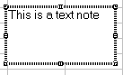
To move the note: click and drag on the border
To size the note: click and drag on one of the squares
To delete the note: press DELETE on the keyboard

Creating Range Names
Instead of referring to the parts of your worksheet with cell references you can give them names instead. This makes your worksheet easier to read and work with.

Giving A Cell or Range of Cells A Name
Select the cells to name (This can be a single cell or a range of cells)
Click into the name definition box
Type a name for the range and press return
You may think nothing has changed, but
when you select the all the cells, the range
name will appear in the definition box.
Using Spaces in Names
Excel doesn’t allow spaces in a range name. It is better to use an underscore ”_” instead.

Creating Names From A List
Select the cells to name and the cells that contain
the labels next to them

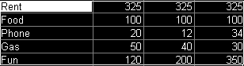

Insert Menu : Name : Create The dialog box will appear
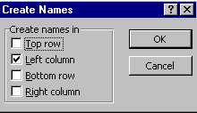
Click OK

Deleting Range Names
Insert Menu: Name : Define
Select Range Name to delete
Click in Delete
Click on OK

Range Names and Absolute Cell References
When you create a range name it acts like an absolute cell reference. This means that when you copy a formula involving a range name it will always point to the same cell. Thus you cannot autofill a formula that contains a range name and get it to work on different columns of numbers.

Using Named Ranges

Moving Directly To A Named Area or Cell
Click on the names drop down list
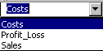
Click on a named range to go to.

Short-Cut Key

You can also press F5, and select a name from there if you wish

Using Names In Formulas As You Type Them
Type =
Type the range name in

Continue with the formula in the normal way (i.e. =loan*period if both loan and period were named cells with figures in them)

Use F3 Instead Of Remembering Names

You can use F3 at any time to bring up a list of names instead of using a cell reference. Just Double-click on the name that you want

Applying Names So They Appear In Existing Formulas
Insert Menu : Name : Apply The dialog box will appear
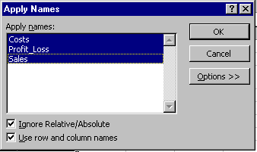
Select the names to apply by clicking on each one
Click OK

Apply Names Options
Ignore Relative/Absolute Replaces references with names regardless of the reference types of either the names or references. If you clear this check box, replaces absolute references with absolute names, relative references with relative names, and mixed references with mixed names.
Use Row And Column Names Uses the names of row and column ranges containing the cells referred to if names for the exact cells can't be found.

Using Multiple Names As Cell References
If you name column B as Jan and then row 2, 3, and 4 as bills, food, and beer respectively, then you could use the following formula to refer to the Jan food figure

=Jan Food (Note there must be a space between the two range names.)

Printing A Named Range Quickly
Use the name drop down list to got to the named range
File Menu : Print
Click on
Click OK

Protecting Your Work
Once you have set up a worksheet, it is too easy to type a number in a place where a formula is contained and thus delete it by mistake! You can avoid this be setting up areas of the worksheet that are protected, that is they cannot be changed.

Step 1. Unprotect the cells you want to be able to change
When you start any spreadsheet all the cells are actually protected, but the protection feature isn’t turned on as yet. Therefore you need to mark the cells you don’t want protected as unprotected.

You would normally want to unprotect just the cells that contain figures (not formulas or text).

Select the cells to unprotect
Click on Format menu
Select Cells
Choose the Protection Tab
Click on Locked to remove the cross from the box
Click OK

Step 2. Turning On The Protection Feature
Once you have indicated which cells are to be unprotected.

Click on Tools Menu
Select Protection
Click on Protect Sheet
Type a password in if you want one You will be asked to confirm it
Click OK The Protection feature is turned on for this sheet.

Don’t Forget Your Password!
Passwords are case sensitive so you need to remember both the word and whether it was typed in capitals or not. If you do forget your password there is not much you can do - try copying and pasting the data to another sheet and work on that. Think about whether you actually need a password or not.

Protection Options
Contents Protects cells on worksheets and protects items in charts. This check box doesn’t appear if the active sheet is a dialog sheet or a Visual Basic module.
Objects Protects graphic objects on worksheets and charts from being moved, edited, resized, or deleted. This check box doesn’t appear if the active sheet is a dialog sheet or a Visual Basic module.
Scenarios Prevents changes to the definitions of scenarios on a worksheet.

Turning Off The Protection Feature
If you need to change the formula, remember to switch off the protection …

Tools Menu : Protection
UnProtect Sheet You will be prompted for your password if you used one.

Protecting The Workbook
You can also protect the way in which your workbook is displayed …

Tools Menu : Protection
Protect Workbook
Type a password in if you want one You will be asked to confirm it
Click OK The Protection feature is turned on for this sheet.

WorkBook Options
Windows Protects windows from being moved or resized. The minimise and maximise icons, Control-menu box, and window sizing borders are hidden.
Structure Prevents changes to the structure of a workbook so sheets can't be deleted, moved, hidden, unhidden, or renamed, and so new sheets can't be inserted.

Turning Workbook Protection Off
Tools Menu : Protection
Unprotect Workbook If needed type in your password
Click OK

Selecting cells for unprotecting in a large spreadsheet
If this is the case you can use the Go To box to select the cells quickly.

Edit Menu : Goto The dialog box will appear
You can also press F5 to bring up the goto box.
Click on the Special button The dialog box will appear
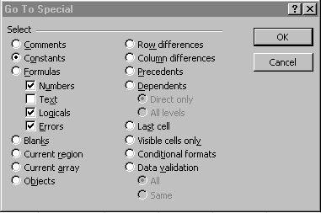
Select Constants
De-select Text The box should look like the one above
Click OK The cells will be selected

Protecting A File
Protecting a file is a powerful feature, but it is vital that you write the password down (in a secret place!), so as you do not forget. If you do forget your password, you will not be able to save any changes to your spreadsheet.

Protecting A File So Others Can’t Change It!
File Menu : Save As The save As dialog box will appear
Click on Options button This dialog box will appear
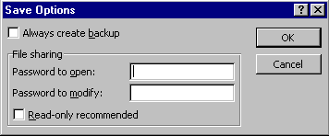
Type in a password in the Password open area
Click OK

Other Options
Always Create Backup Creates a backup copy of a workbook every time you save it. The backup copy is the previous version of the workbook, renamed with a .BAK extension. Be sure the main part of the filename is unique. For example, if you have two workbooks, SALES.XLS and SALES.XLT, the backups for both are saved with the same backup name, SALES.BAK. This file will contain the backup for the last saved workbook.
Protection Password Type the password required to open the selected workbook file. You are prompted to confirm the password. You can assign passwords to workbooks saved as templates and add-in macro file formats, in addition to those saved in the Microsoft Excel file format.
Write Reservation Password Type the password required to save changes to the selected workbook under the same filename. You are prompted to confirm the password.
Read-Only Recommended Displays a message requesting that users access the file as read-only..

Using The Toolbars
Excel comes with many toolbars that you can use or customise.

Showing Or Hiding Toolbars
View Menu : Toolbars
A drop down menu appears
Select the toolbars you want the selected ones have a cross next to them
Click OK

Moving, Sizing and Hiding Toolbars
Click and drag on the title bar or a blank area of the toolbar to move it.
If you drag the toolbar to the edge of the screen it will “dock” there. Click and drag a blank part of the toolbar to make it “float” again.
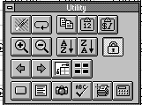
Click and drag on a border to size a floating toolbar
Click on the minus to close the toolbar (or Options : toolbars : click on the toolbar : Click on Hide)

Customising Toolbars
View Menu : Toolbars
Click on Customise The dialog box will appear
Select the Command tab
Click on a category in the Categories list on the left
Click and drag any command to any toolbar currently on screen.

To remove a tool from a toolbar
Click and drag it off the toolbar

To move a tool on a toolbar
Click and drag it to a new location

Resetting A Toolbar
View Menu : Toolbars
Click on the toolbar to reset

Spreadsheet Templates
If you find you use a similar layout for many different spreadsheet (perhaps only the figures change), then you may want to create a template to make things easier.

Creating A Template
Create a worksheet with all the essential
Items you want on it
File Menu : Save As The dialogue box will appear
Click in the Save as file type drop down list
Change the file type to Template It will show Template(*.xlt)
Type in the filename you want for the template
Click OK

Using A Template
File Menu : New The dialogue box will appear
Double-click on the template you want

Excel Spreadsheet Information In Word

Text, figures and charts can be copied from Excel in to Word either:

- Without a link
- Linked to the original source, so that any changes to the original data will be reflected in the copy.

Data from a worksheet can be copied and pasted in to a Word document in one of five ways:
- As a Microsoft Excel Worksheet Object - The copy will be modifiable using MS Excel
- Formatted Text (RTF) Inserted as text with font and table formatting
- Unformatted Text Inserted as text without any formatting
- Picture Inserted as a picture that can be edited in Word
- Bitmap Inserted as a Bitmap picture

Copying Excel Worksheet Data Into A Word Document Without a Link

Highlight the cells that contain the data to be copied
Click on Copy Button
Open or switch to the Word document
Click on paste. The data from Excel will appear in a Word table.

Copying Excel Worksheet Data Into A Word Document With a Link
Highlight the cells that contain the data to be copied
Click on Copy Button
Open or switch to the Word document
Click on Edit Menu
Click on Paste Special

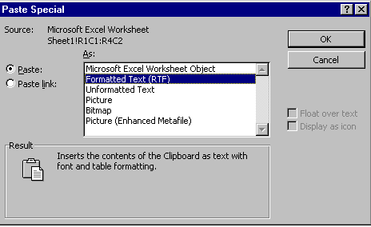

Select how you want the copied data to be pasted
Click in Paste or Paste Link -the later means changes in the source data will reflect in the linked copy
Click OK

Copying An Excel Chart To A Word Document
An Excel Chart can be copied and pasted in to a Word Document in one of two ways:

- As an Excel Chart Object - Can be edited by Excel Chart
- As a Picture - Can be edited in Word as a picture

Both when linked will be inserted as a picture, but any changes to the original data that makes up the chart will be reflected in the pasted copy.

Click on the Chart in Excel
Click on Copy Button
Open or switch to Word document
Click on Edit Menu
Click on Paste Special
Select how you want the copied data to be pasted
Click in Paste or Paste Link Paste Link means that changes in the source data will reflect in the linked copy
Click OK

Editing Embedded Objects
Double click the embedded object This will open up Excel and allow you to make changes

Deleting Embedded Objects
In the Word Document click on the object
Press the Delete key

Appendix

Error Messages
When something goes wrong with a formula Excel produces messages that attempt to describe what the problem is:

#DIV/0! Attempt made to divide by zero - Check the cells used for division in the formula
#N/A! Value not available at this cell - Cell in formula has 'N/A' status
#NAME? Text contained in a formula is not a named range: You have referred to a range that you haven't defined.
#NULL! Two areas do not intersect
#NUM! Incorrect use of function
#REF! No such cell exists : The formula may previously have referred to a cell now deleted
#VALUE! A cell containing text has been included in the formula.

Selected List of Functions
There are over 250 available functions in Excel. These are some of the more commonly used ones:

Statistical Functions
AVERAGE(range) Average all the values in the list
COUNT(range) Counts the number of cells with values in the range
MAX(range) Gives the largest value in a range
MIN(range) Gives the smallest value in the range
SUM(range) Adds up the numbers in a range
STDEV(range) Calculates the Standard deviation for numbers in list

Date Functions
Date functions are based around 'serial numbers' which allow you to add, for instance, 365 to a date to get the same day next year.

NOW() Calculates serial number for today's date. (Format as Date to see in Date format.)
DATE(year,month,day) Creates serial number from given date
DATEVALUE(date text) Converts date text, in any accepted format, into serial number
DAY(serial number)
HOUR(serial number)
MINUTE(serial number)
MONTH(serial number)
SECOND(serial number)
TIME(hour,minute,second)
TIMEVALUE("time text")
WEEKDAY(serial number)
YEAR(serial number)

Maths Functions
ABS(x) Absolute value of x e.g. ABS(-3) gives 3
EXP(x) e to the power of x
INT(x) Integer value of x e.g. INT(3.6) gives 3
MOD(x,y) Gives the remainder when x is divided by y e.g. MOD(10,3) gives 1
PI Gives PI - 3.14159265
RAND Gives a random number between 0 and 0.9999999999
ROUND(x,places) Rounds x to the given number of places
SIGN(x) Gives the sign of the number: 1 if positive, -1 if negative, 0 if zero
SQRT(x) Gives the square root of x e.g. SQRT(9)=3

Trigonometric Functions
ACOS(x) Gives the arc cosine of the number
ASIN(x) Gives the arcsine of a number
ATAN(x) Gives the arc tangent of a number
COS(x) Gives the cosine of a number
SIN(x) Gives the sine of the angle
TAN(x) Gives the tangent of a number

Logical Functions
IF The IF function performs a conditional test
AND Checks to see if all the arguments are true
ISERROR Looks for errors and returns TRUE if found
OR Returns TRUE if any argument in list is true
NOT Reverses the value
TRUE() Returns TRUE
FALSE() Returns FALSE

Lookup Functions
CHOOSE
HLOOKUP
INDEX
LOOKUP
MATCH
VLOOKUP

Financial Functions
FV(rate,periods,pmt,pv,type) Future Value
NPER(rate,pmt,pv,fv,type) Number of Periods to reach Future Value
PMT(rate,nper,pv,fv,type) Payment required to reach Future Value
RATE(nper,pmt,pv,fv,type,guess) Interest rate to achieve Future Value
DDB(cost,salvage,life,period) Depreciation (using Double Declining Balance method)
IPMT(rate,per,nper,pv,fv,type) Calculates interest portion of a payment on an annuity
IRR(values,guess) Internal Rate of Return

Full List Of Functions (Alphabetical)

ABS()
ACCRINT()
ACCRINTM()
ACOS()
ACOSH()
ADDRESS()
AND()
AREAS()
ASIN()
ASINH()
ATAN()
ATAN2()
ATANH()
AVEDEV()
AVERAGE()
BASE()
BESSELI()
BESSELJ()
BESSELK()
BESSELY()
BETADIST()
BETAINV()
BIN2DEC()
BIN2HEX()
BIN2OCT()
BINOMDIST()
CEILING()
CELL()
CHAR()
CHIDIST()
CHIINV()
CHITEST()
CHOOSE()
CLEAN()
CODE()
COLUMN()
COLUMNS()
COMBIN()
COMPLEX()
CONFIDENCE()
CONVERT()
CORREL()
COS()
COSH()
COUNT()
COUNTA()
COUPDAYBS()
COUPDAYS()
COUPDAYSNC()
COUPNCD()
COUPNUM()
COUPPCD()
COVAR()
CRITBINOM()
CROSSTAB()
CUMIPMT()
CUMPRINC()
DATE()
DATEVALUE()
DAVERAGE()
DAY()
DAYS360()
DB()
DCOUNT()
DCOUNTA()
DDB()
DEC2BIN()
DEC2HEX()
DEC2OCT()
DEGREES()
DELTA()
DEVSQ()
DGET()
DISC()
DMAX()
DMIN()
DOLLAR()
DOLLARDE()
DOLLARFR()
DPRODUCT()
DSTDEV()
DSTDEVP()
DSUM()
DURATION()
DVAR()
DVARP()
EDATE()
EFFECT()
EOMONTH()
ERF()
ERFC()
ERROR.TYPE()
EVEN()
EXACT()
EXP()
EXPONDIST()
FACT()
FACTDOUBLE()
FALSE()
FASTMATCH()
FDIST()
FIND()
FINV()
FISHER()
FISHERINV()
FIXED()
FLOOR()
FORECAST()
FREQUENCY()
FTEST()
FV()
FVSCHEDULE()
GAMMADIST()
GAMMAINV()
GAMMALN()
GCD()
GEOMEAN()
GESTEP()
GROWTH()
HARMEAN()
HEX2BIN()
HEX2DEC()
HEX2OCT()
HLOOKUP()
HOUR()
HYPGEOMDIST()
IF()
IMABS()
IMAGINARY()
IMARGUMENT()
IMCONJUGATE()
IMCOS()
IMDIV()
IMEXP()
IMLN()
IMLOG10()
IMLOG2()
IMPOWER()
IMPRODUCT()
IMREAL()
IMSIN()
IMSQRT()
IMSUB()
IMSUM()
INDEX()
INDIRECT()
INFO()
INT()
INTERCEPT()
INTRATE()
IPMT()
IRR()
ISBLANK()
ISERR()
ISERROR()
ISEVEN()
ISLOGICAL()
ISNA()
ISNONTEXT()
ISNUMBER()
ISODD()
ISREF()
ISTEXT()
KURT()
LARGE()
LCM()
LEFT()
LEN()
LINEST()
LN()
LOG()
LOG10()
LOGEST()
LOGINV()
LOGNORMDIST()
LOOKUP()
LOWER()
MATCH()
MAX()
MDETERM()
MDURATION()
MEDIAN()
MID()
MIN()
MINUTE()
MINVERSE()
MIRR()
MMULT()
MOD()
MODE()
MONTH()
MROUND()
MULTINOMIAL()
N()
NA()
NEGBINOMDIST()
NETWORKDAYS()
NOMINAL()
NORMDIST()
NORMINV()
NORMSDIST()
NORMSINV()
NOT()
NOW()
NPER()
NPV()
OCT2BIN()
OCT2DEC()
OCT2HEX()
ODD()
ODDFPRICE()
ODDFYIELD()
ODDLPRICE()
ODDLYIELD()
OFFSET()
OR()
PEARSON()
PERCENTILE()
PERCENTRANK()
PERMUT()
PI()
PMT()
POISSON()
PPMT()
PRICE()
PRICEDISC()
PRICEMAT()
PROB()
PRODUCT()
PROPER()
PV()
QUARTILE ()
QUOTIENT()
RADIANS()
RAND()
RANDBETWEEN()
RANK()
RATE()
RECEIVED()
REPLACE()
REPT()
RIGHT()
ROUND()
ROW()
ROWS()
RSQ()
SEARCH()
SECOND()
SERIESSUM()
SIGN()
SIN()
SINH()
SKEW()
SLN()
SLOPE()
SMALL()
SQRT()
SQRTPI()
STANDARDIZE()
STDEV()
STDEVP()
STEYX()
SUBSTITUTE()
SUM()
SUMPRODUCT()
SUMSQ()
SUMX2MY2()
SUMX2PY2()
SUMXMY2()
SYD()
T()
TAN()
TANH()
TBILLEQ()
TBILLPRICE()
TBILLYIELD()
TDIST()
TEXT()
TIME()
TIMEVALUE()
TINV(_54
)
TODAY()
TRANSPOSE()
TREND()

TRIM()
TRIMMEAN()
TRUE()
TRUNC()
TTEST()
TYPE()
UPPER()
VALUE()
VAR()
VARP()
VDB()
VLOOKUP()
WEEKDAY()
WEIBULL()
WORKDAY()
XIRR()
XNPV()
YEAR()
YEARFRAC()
YIELD()
YIELDDISC()
YIELDMAT()
ZTEST()

Glossary

Absolute Cell References
If you want to copy a formula to another cell, but you want to prevent Excel from adjusting the cell references, make the cell references ‘absolute’. Absolute cell references are indicated by a dollar ($) sign ie $A$1.

Active cell
This cell border of the active cell will be darker than the other cells.

AutoFill
This feature is useful when you need to enter a series of numbers, dates and formulas.

AutoFormat
This will automatically format your table for example by adding heavy lines to form a box around the data.

AutoSum (Σ)
This feature allows you to select the cell range containing the values you want to add together and adds them up.

Cell
This is the basic building block of the Excel worksheet. A cell is formed by the intersection of the row and column gridlines. Each cell is identified by the letter of the column and the number of the row ie cell B7 is in column B and row 7.

Cell Range
A group of cells next to each other. To select a range of cells see page 17, Selecting cells.

Cell References
These are the coordinates (address) of the cell in the worksheet ie C8.

Chart Sheet
This is a sheet in a workbook containing a chart (graph, pie chart etc). The chart sheet is updated when the worksheet data is changed.

Data Series
A data series can be a range of consecutive dates ie Jan, Feb... or used to create quarterly dated headings. Creating a data series can be done easily by dragging the fill handle across the number of cells you want to AutoFill.

Disk Operating System (DOS)
This stands for Disk Operating System. It is your computers ‘housekeeper’. It determines how and where files are stored. Programs written under DOS conventions can only be worked on one at a time (unlike Windows where you can work on more than one program at the same time!!)

Fill Handles
This is a solid black square in the right hand corner of the active cell border. Using your mouse, grab the black square and drag it across your cells to AutoFill

Formulas
Formulas are the basis of Excel. Formulas will do all the calculations that will normally be done by a calculator. If there were no formulas in Excel, there would be no point in using an electronic worksheet. You can use formulas to do simple calculations such as additions, subtractions, multiplication, division as well as statistical, financial and scientific calculations.

Formula bar
This is the bar at the top of the Excel screen. It is used to enter and edit formulas and values. It also displays the formula in a particular cell.

Gridlines
These are the lines that you see in your spreadsheet. You can choose to print them using the Tools menu, then the Options Dialogue box.

Label
This is the text for the provider to use ie names, instructions and cautions.

Legends
A legend (also known as a key) is used in charts and graphs. Excel actually creates legends from the labels of the worksheet data series. The legends can be customised with borders, patterns and different fonts.

Mixed Cell References
In a formula, there can be a combination of relative and absolute cell references. A mixed reference can look like this $A1 or A$1. $A1 refers to column A regardless of the position of the cell containing the formula. The 1 refers to the cell containing the formula.

Paste Function
This function of Excel is to help you enter functions into formulas. The Paste Function give you a list of formulas to choose from and prompt you for the numbers.

Percentages
There are two forms of percentages that are commonly calculated, these are
- a percent of a number (ie 5% of 25)
- one number as a percent of another (ie 25 as a percent of 125)

Relative Cell References
This specifies the address of another cell in relation to the cell containing the formula. A relative cell reference does not contain $ as in absolute cell references.

Sheets
It is possible to insert, delete, rename, move or copy sheets in Excel. The sheet can be a worksheet, chart sheet, module sheet or dialogue sheet. A worksheet is the one most often used.

Windows
Windows is a program that sits ‘on top of’ DOS. The main advantages are that you can switch between programs and you can move/copy data between programs easily using the Clipboard (as in cut/copy/paste)

Worksheet
This is also called a spreadsheet. The worksheet is the primary document used in Excel. A worksheet is made of cells (columns and rows) and is always part of a workbook.

Index

Absolute Cell References 48, 119
Active cell 119
Aligning 57, 58
Arithmetic Symbols 16
Autofill 22, 47
Formulas 47
AutoFill 22, 119
AutoFormat 119
AUTOFORMAT 71
Automatic Error Checking 52
AutoSum
Tips 28
AUTOSUM 28
AutoSum (Σ) 119
Backup 107
BODMAS 16, 26
Bold 56
Borders 68
Cell 119
Cell Range 119
Cell References 119
Centre 56
Printed Output 80
Chart
Printing 90
Chart Sheet 119
Chart Wizard 83
Charts
Creating 82
Editing 88
Circular calculations 51
Closing Documents 40
Colour 70
Columns
Adjusting 77
Deleting 35
Inserting 35
Widening 65
Conditional Formatting 72
Copy
Formulas 22
text 22
Copying 46, 47, 86, 88
Chart 86
Formatting 73
Formulas 47, 48
Cursor Movement 19
Cut And Paste 46
Data Series 84, 119
Adding & Removing 88
Date 114
Date Functions 114
Dates 67
De selecting 17
Deleting
Cell Contents 24
Cells, Rows, Columns 35
Chart 86
Formatting 73
Disk Operating System (DOS) 120
Documents
Closing 40
Opening 40
Drag And Drop 46
Editing The Contents Of Cells 20
Entering Numbers 19
Entering Text 19
Erasing
Cell Contents 24
Formats 24
Error Checking 52
Error Messages 113
ESSENTIAL 52
F4 48
Favourites 45
Fill Handles 120
Financial 115
Financial Functions 115
Font
Changing 60
Normal 60
Fonts
Charts 89
Format Painter 73
Formats
Date 67
Erasing 24
Formatting
Copying 73
Removing 73
Formula 25
Entering 25
Formula bar 120
Formulas 120
copy 22
Copying 47
Linking 98
Using Names In Them 103
Full Screen
Working in 74
Functions 114
Date functions 114
Financial 115
Full List 116
IF 32
Logical 115
Lookup 115
Mathematical 114
Other 32
Statistical functions 114
Trigonometry 115
Glossary 118
Golden Rule
Design 50
Gridlines 120
Headers & Footers 81
Icons 8, 9
IF 32
Instructions 5
Italic 56
Keyboard Use 11
Keys 15
deletion & cancelation 15
Format 15
Function 16
movement 15
Selection 15
Label 120
Landscape 80
Legends 120
Lines 68
Linking
Formulas 98
Logical 115
Logical Functions 115
Lookup 115
Lookup Functions 115
Manual 5
Margins
Adjusting 77
Maths 25
Maths 114
Maths Functions 114
Mistakes
correcting 20
Mixed Cell References 120
Mouse
Basic Use 11
Icon 8
Movement
Cursor 15
Moving
Chart 86
Moving 46
Named Range
Printing 104
Named Ranges
Using 103
Names 102
Applying 103
Never Put A Number In A Formula 50
Note
Post-It 101
Notes
Text notes 99
Number Format 62
Numbers
Bold, Italic, Size 57
Changing the look of 62
Entering 19
Opening Documents 40
Page Setup 78
Tabs 78
Password 107
Paste Function 120
Percentages 30, 121
Pointing
In Formulas 25
with SUM 27
Portrait 80
Post-It
Note 101
Precedence of Calculation 26
Print Area 76
Print Preview 77
Printing 75
Basic 76
Named Ranges 104
Options 76
Printing A Chart 90
Protecting 105
Files 107
Worksheets 105
Quick Movement 15
Range Names 102
Read-Only 107
Redo 21
Relative Cell References 121
Removing
Formatting 73
Repeating 20
Rows
Deleting 35
Inserting 35
Making Taller 65
Saving 37
Default Directory 38
With New Name 38
Scale
Printed Output 80
Screen Layout 7
Selecting
Cells 17
Rows & Columns 18
sheets 97
Selecting Cells 17
Shading 70
Sheets 53, 97, 121
copying 53
deleting 54
grouping 97
moving 53
Moving Through 53
naming 53
seeing more tabs 54
selecting 97
Short-Cut Menu 12
Sizing
Chart 86
Spreadsheet Information In Word 110
Starting
Excel 6
Statistical Functions 114
Statistics 114
SUM 27
AutoSum 28
Summing a Row or Column 27
Symbols
arithmetic 16
Templates
Creating 109
Using 109
Text
Aligning 57
Bigger 56
Bold 56
Centring 57
Italic 56
Smaller 56
Text Note 101
Times 67
Tips
AutoSum 28
TipWizard 13
Titles
In Chart 88
Toolbar
Borders 68
Chart 87
Colour 70
Font Colour shade 70
Formatting 10
Resetting 108
Standard 9
ToolTips 10
Toolbars 108
Customising 108
Moving and Sizing 108
Showing or Hiding 108
ToolTips 10
Trigonometric 115
Trigonometric Functions 115
Typeface
Changing 60
Undo 21, 24
Use First Column
In Chart 84
User Name 81
Windows 6, 121
Wizard
Chart 83
Worksheet 121
Zooming 74
Wrapping Text 58
Zooming 74

