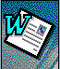 | 

Happy Computers Essentials Guide To
Microsoft Word 97

This course guide is produced for the Happy Computers “Word 97” course.
For all your computer training needs contact:

Happy Computers
St James House
10 Rosebery Avenue
London EC1R 4TD
Bookings: 0171 278 5596

Copies of this guide can be obtained from Happy Computers, fully bound, at a cost of £15 each, or £10 for extra copies for organisations who have booked courses.

Happy Computers allows this guide to be copied, provided permission is sought and the name and phone number of Happy Computers remains on the copies.

Contents
Contents 2
About This Manual 4
Who is it for & how to use it 5
What do the icons mean? 6
Getting Help 7
Getting Started in Word 97 8
Starting Word 97 for Windows 95 9
The Word 97 Screen 10
What are all those pictures at the top of the screen? 11
More Word 97 Toolbars 15
The Office Assistant 17
Typing Text in Word 20
Using the Keyboard 21
Editing Text 22
Using the mouse 23
Moving around your document 24
Quick ways to move around within a document 27
Undo & Redo - a licence To make mistakes! 29
Saving documents 30
More options when saving 31
Opening, creating and closing documents 33
Managing files in the Open dialog box 35
Searching for files in the Open dialog box 39
Print Preview 41
Printing 42
Working with more than one document at a time 43
Zooming in or out on your document 44
Different Views of Your Document 45
Using the six Views 47
Building on the Basics 49
Selecting text with the Keyboard 50
Selecting Text With the Mouse 51
More methods of selecting text 52
Changing the look of text 53
Highlighting Text 54
Changing the colour of text 55
Changing the font 56
Detailed changes to text 57
Applying other effects 58
Underlining text 59
Format Painter 60
Centre, Right, Left And Fully Justified Text 61
Inserting the date & time 62
Changing the case of text 63
Inserting special symbols or characters 64
Inserting accented characters 65
Moving & copying text with Cut/Copy & Paste 66
Moving & copying text with drag & drop 68
Page Layout 69
Page Set-up 70
Margins 71
Setting margins with the Ruler 72
Layout 73
Paper Size & Paper Source 74
Using the ruler 75
Using Tabs 76
Setting Tabs with the ruler 77
Other types of tabs 79
Using indents 81
Setting indents with the ruler 82
Page numbering & page breaks 84
Headers & Footers 86
Bringing it all together 88
Adding borders and shading around paragraphs and text 89
Bullets & paragraph numbering 92
Multi-level numbering (outline numbering) 95
Producing minutes in Word 97 97
Finding & replacing text 99
Using Wizards and built-in templates 100
Columns and Tables 101
Columns 102
Adjusting columns with the ruler 103
Breaks 104
Creating Tables 106
Working with tables 108
Inserting and deleting rows and columns 110
Adjusting the table layout 112
Adding borders and shading 114
Using the Table and Borders Toolbar 116
Special features in tables using the menu 120
Automatic Features 122
Using AutoText 123
Creating your own AutoText 125
AutoCorrect 126
AutoFormat 128
Using AutoFormat without a review 130
More automatic formatting features 131
Spell checking your document 132
Check spelling while you Type 134
Thesaurus: looking for similar words 136
Grammar Checker 138
Index 142
Index 147

About This Manual

Who is it for & how to use it

Who is it for?
This manual is designed for use with the Word 97 course at Happy Computers.

It is also meant as a back up for when you get back to work in combination with the two year telephone help-line you get free with every Happy Computers Course.

It is not meant as a replacement to the full reference manuals that come with Word 97.

How should I use it?
This manual is a step by step guide to the functions taught in the Word 97 course.

You should be able to find the part you're after by looking in the index, and contents and noting that the general course will follow the pattern of this manual.

The step by step parts are in italics. Simply do the things on the left, and read the things on the right for further information.

This is what you do This is a description of what is happening.

What do the icons mean?

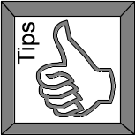Tips
Handy tips that make your work easier

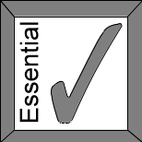Essential
Essential points to understand how to do the work in hand

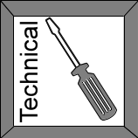Technical
Technical (non essential) points for the technically minded

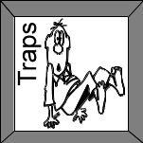Traps
Hints to help with certain features that may just trip you up if you are not aware of them

Right Mouse Button
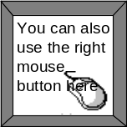
This means that pressing the right mouse button (instead of the left mouse button) will bring up a short cut menu that can achieve the same things as listed in the text

Getting Help

Word 97 keeps the screen fairly simple. But don't expect to have to remember the functions. There are several levels of help:

Using This Guide
This guide contains all the basic functions of Word 97. Use the Table of Contents and the Index to find the function that you need explained.

The Office Assistant
The on-screen Office Assistant is an animated “helper” explains commands in detail. It is simple to use:

Press F1
Type your question
Press Enter

There is also an on-screen Help function. For help on a part of the screen:

Press SHIFT F1
Click on the area of the screen you wish to know about.

The Official Microsoft Word 97 Manual
Software manuals have improved. Use them as a reference on specific functions, rather than for a general read on how to use the software.

Go to the reference section and look up the thing that you want explained.

Getting Started in Word 97

Objectives

By the end of this section you will be able to:-

Start and exit from Word 97
Understand the different parts of the Word 97 screen
Know what the icons are for
Use and turn off the Office Assistant
Enter text
Check your spelling as you type
Use the mouse
Use the keyboard
Move around your document using the scroll-bars, mouse and keyboard
Delete and change text
Use the undo and redo buttons
Create, open, close and save your documents
Manage your files from the open dialogue box
Work with more than one document at a time
Zoom in or out of your document
Use the different views in Word

Starting Word 97 for Windows 95

Starting Word 97 For Windows
Start Button The Start Menu will appear
Programs The Program Menu will appear
Microsoft Word Microsoft Word will start

Exiting Word for Windows
File menu - Exit If you need to save documents you will be prompted to do so.

Or

Click on that appears on the top right hand corner of the Microsoft Word 97 window

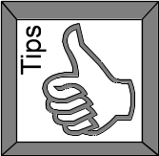Tip - keyboard shortcut
Alt-F4 to exit Word

The Word 97 Screen
Here is a picture of the Word screen in normal view (see section “Different views of your document”). Use it as a reference throughout the course, and mark your own comments on to it. Over the page is a description of the different icons at the top of the screen.
Title Bar
Menu Bar
Standard Toolbar
Formatting Toolbar

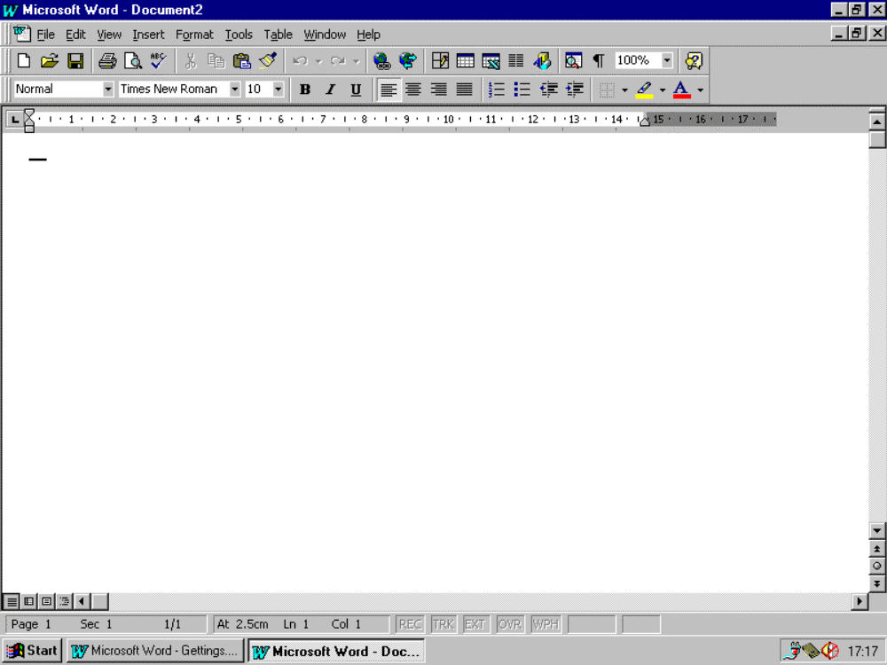
Scroll Bars
Status Bar
Task Bar
Status Bar

Keep your eye on the status bar
If Microsoft Word 97 seems to have stopped or it is beeping at you and you don’t know why, check out the status bar, there may be a message there explaining all.

What are all those pictures at the top of the screen?
Here is a brief description of the pictures (we’ll be calling them icons from here on) at the top of the screen. These are very useful for doing things quickly, and you will be using most of them in more detail throughout the course. These icons appear in groups known as Toolbars.

The Standard Toolbar
New - creates a brand new document. See page 2
Open - opens existing documents. See page 38
Save - click here to save a document for the first time. See page 34
Print - prints one copy of the open document. See page 47
Print Preview - shows you how the doucment will look when printed. See page 51
Spelling and Grammer - checks document for errors. See page 152
Cut - removes text etc and places it on the Clipboard. See page 78
Copy - copies text, etc and places it on the Clipboard. See page 78
Paste - puts the contents of the Clipboard into the doucment. See page 78
Format Painter - easy way to copy formatting only. See page 70
Undo - undoes the last action you did. See page 32
Redo - undoes the undo! See page 32
Insert Hyperlink - creates a link to a web site. Not covered on this course
Web Toolbar - turns the Web Toolbar On. Not covered on this course
Tables and Borders - turns on the Tables toolbar. Covered only on the Intermediate course
Insert Table - puts a table into the document. Covered only on the Internediate course
Insert Excel Spreadsheet. Not covered on this course
Columns - converts text to newspaper style columns. Not covered on this course
Drawing - turns on the Drawing toolbar. Not covered on this course
Document Map - lists all headings created with Heading Styles. Not covered on this course
Show/Hide - turns on symbols that represent certain formatting.
Zoom - makes the doucment appear close up or far away. See page 46
Office Assistant - turns on a cartoon helper. See page 8

The Formatting Toolbar
Style - applies Styles to selected text. Not covered on this course
Font - changes the font (typeface) of selected text. See page 65
Font Size - changes the size of the selected text. See page 65
Bold - makes the selected text bold. See page 61
Italic - makes the selected text italic. See page 61
Underline - underlines the selected text. See page 61
Alignment - changes the position of the text on the page relative to the margins. See page 71
Numbering - automatically numbers lists or paragraphs. See page 107
Bullets - puts bullet points to the left of lists or paragraphs. See page 107
Border - adds borders/lines to tables, text. Covered only on the Intermediate course
Highlight - puts coloured shadin garound selected text. See page 63
Font Colour - changes the colour of selected text. See page 64

Using ToolTips
If you want to find out about an icon quickly you can use ToolTips
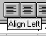

Move the cursor over the icon and leave it there for about a second (Don’t click)

The ToolTip will appear below the icon and a description will appear at the bottom left of the screen (in the status bar).

Turning ToolTips on or off
If you can't see ToolTips on your screen, or you want to turn this feature off, then follow the steps below.
View menu - Toolbars
Customise
Options tab
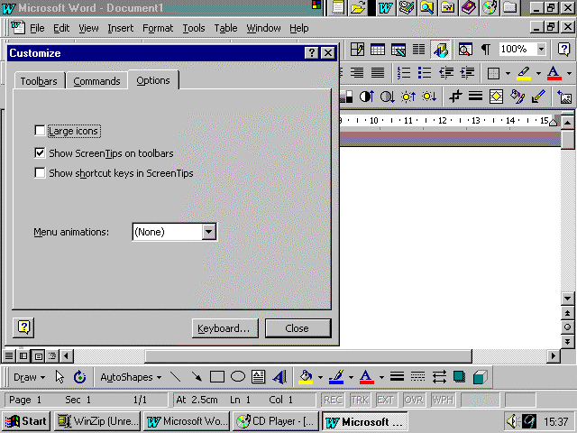

Turn on: click Show ScreenTips on toolbars.
Turn off: click off tick in Show ScreenTips on toolbars

More Word 97 Toolbars
Listed below are the various toolbars that you can use in Word 97. They give you quick access to frequently used commands. Note that none of these are covered in the Essentials course.

Autotext Toolbar | 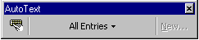
Control Toolbox | 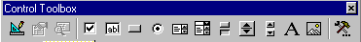
Database | 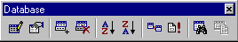
Drawing
Forms | 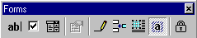
Picture | 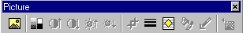
Reviewing | 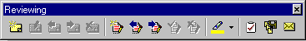
Tables and Borders
Visual Basic | 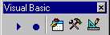
Web | 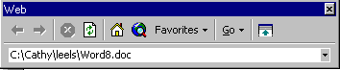
WordArt | 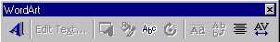

Turning toolbars on or off
View Menu - Toolbars menu listing all available toolbars appears
Click the toolbar that you wish to turn on or off

or

Right-click any toolbar menu listing all available toolbars appears
Click the toolbar you wish to turn on or off

The Office Assistant
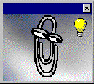

The Office Assistant is designed to help you whilst you are working in Word 97. It provides you with Tips of the Day, Help and answers your questions. It will also provide you with relevant suggestions while you are working on a particular feature.

Turning on the Office Assistant if not showing
Click the Office Assistant icon

Hiding the Office Assistant
Click the Close button top right of the Office Assistant

Asking a question
Click on the Office Assistant icon The Office Assistant will appear
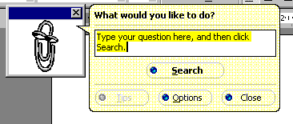
Type the question you would like to ask
Search A list of related topics will appear
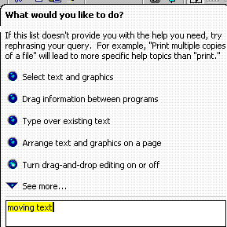
Click the blue dot next to the topic listed to see more
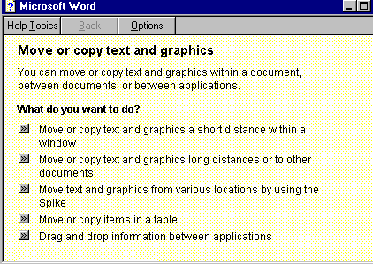
Follow the instructions given

Printing the instructions
Options button
Print topic
OK

Selecting a different Office Assistant
Click the Office Assistant icon
Options (If Options is not showing, click the Office Assistant again)
Gallery tab
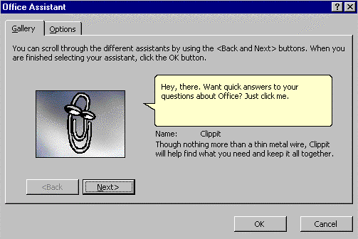

Use the Next and Back Buttons
OK when you have made your choice

Changing Office Assistant’s options
Click the Office Assistant icon
Options (If options button is not showing, click the office assistant again.)
Options tab

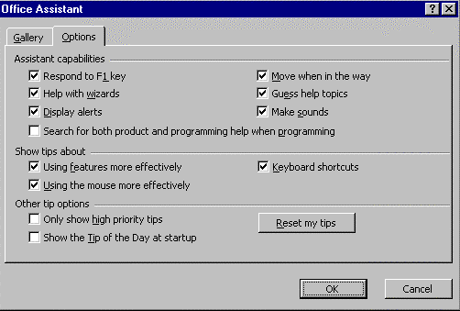

Make changes
OK

Tip - how to stop it popping up!
The Office Assistant pops up when you are typing if it thinks it has a relevant tip for you. To turn this off, remove the tick from the "Guess help topic" box in the Options box above.

Typing Text in Word

Typing text
When you start Word, a blank document appears, ready for you to start typing. A blinking vertical bar called the insertion point (or cursor) indicates where text will appear when you type.
Unlike using a typewriter, you do not have to start a new line when you reach the right margin - Word automatically "wraps" text to the next line. You press RETURN (sometimes called the ENTER or CARRIAGE RETURN key) only when you want to start a new paragraph.
You can delete characters to either the left or right of the insertion point .

Insert or Overtype?
Normally when you type you are in Insert mode. This means that if you type in the middle of a sentence your new text is inserted in the paragraph and everything else shuffles down the page to make space for it.
If you are in Overtype mode then what you type simply goes over the existing text.
To change from Insert Mode to Overtype Mode and vice-versa:

Press the Insert key on the keyboard
Or
Double-click the OVR mark on the Status Bar at the bottom of the screen

Double click here to change to Overtype mode

Using the Keyboard

To create a new line in Word
Press the enter (or hard return) key found on the right of the keyboard)

To create capital letters
Hold down the shift key while you type the letter



Note: There are two shift keys, one the left and one on the right of the keyboard

To capitalise all the text you are typing
Press the caps lock key A light will appear above the words "Caps Lock" on the right hand side of the keyboard
To turn off this feature, press the caps lock key again

To delete text
Click your cursor next to what you wish to delete
Press the Delete key (sometimes marked as “del”) to delete text to the right of the cursor
or
Press the Backspace key to delete text to the left of the cursor

Editing Text

Selecting text
When you want to change something in a document, you first highlight what you want to change. This is called selecting.
Move the mouse pointer to the left of the word you wish to select
Hold down the left mouse button
Drag the mouse pointer over the word
Let go of the mouse button. The text will be selected

Deleting text 1
Select the text
Press DEL on the keyboard

Deleting text 2
Click in the place to make the change The cursor (the insertion point) will appear
Press the Delete key on the keyboard The characters to the right of the cursor will disappear
Press the Backspace key on the keyboard The characters to the left of the cursor will disappear

Typing over selected text

Here's a good tip. If you select text (see section “selecting text”) and then start typing, anything you type will replace what is selected!

Deletion keys
CTRL-BACKSPACE Deletes back to the beginning of a Word
CTRL-DEL Deletes to the end of Word

Using the mouse

Many Word features and functions can be carried out using just the keyboard, but the mouse is designed to "point and click" the screen, thus making it easier to use the software.
Some functions can only be done using the mouse such as drawing pictures. Other functions can be achieved using both the mouse and the keyboard.
You will notice the mouse pointer changes shape or direction on the screen, depending what you are pointing at.

Mouse actions

Click | Point and click the left mouse button.
Double-click | Quickly press the left mouse button twice over the desired location
Click and Drag | This means that you left click on something, hold the left mouse button down, and drag to another area of the screen.
Right-click | Point and click with the right mouse button. This will display a menu appropriate to the item that you clicked on.

Shortcut menus - saving time

Shortcut "pop-up" menus appear when you right click (i.e. click the right mouse button) over a particular item. The menu displays appropriate commands relating to that particular item.

Eg. Right click over text displays the following shortcut menu:

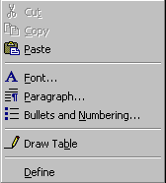

Moving around your document

Using the keyboard to move around the document
↑ Up a line
↓ Down a line
← Left a character
→ Right a character
CTRL ← Left a word
CTRL → Right a word
HOME Far left of this line
END Far right of this line
CTRL ↑ Up a Paragraph (Beginning of previous paragraph)
CTRL ↓ Down a Paragraph (Beginning of next paragraph)
CTRL HOME Top of Document
CTRL END Bottom of Document
Pgup (Page Up Key)Up a screen
Pgdn (Page Down Key)Down a screen
F5 Go directly to a page

Scroll bars
Use the scroll bars to move about your document. There are two scroll bars, one to move you up and down and one to move left and right. They both work in the same way - just click on the arrows to move you around the document.
However, THE SCROLL BARS DO NOT MOVE THE FLASHING CURSOR!! You must always click with the mouse pointer into the document before you start typing
Click here to scroll up one line at a time
Click and drag this box up and down the scroll bar to move right through the document

Click here to scroll down one line at a time
Click here to go back one page

Click on the relevant arrow once to move slowly
or
Click and hold the mouse button down on the relevant arrow to move quickly

The Insertion Point
The Insertion Point (cursor) is the flashing vertical black mark that indicates where you will type in your text.

To move the Insertion Point.

Click in the new place The Insertion Point will move
Or
Use the arrow keys on the keyboard to move the Insertion Point

Use the Enter key to move down the document

You can only move the Insertion Point to a place you have already typed into. To make more space, you will need to insert blank lines by pressing the return key at the end of the existing text in your currently displayed document

Going directly to a page
Double click on left side of the status bar at the bottom of the screen, over the word “Page” A dialog box will appear
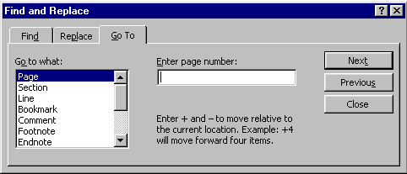
Type in the page number
OK (or press Enter)

Use F5 Key

You can also use the F5 key to bring up the dialog box

Use Ctrl-g
You can also use Ctrl-g to bring up the dialog box

Where am I?
If you want to know where the Insertion Point is (not what you are looking at, which could be different), look at the status bar at the bottom of the screen.

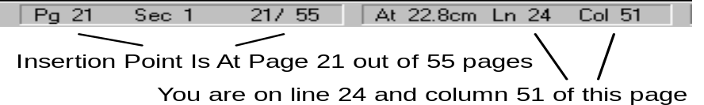

Quick ways to move around within a document
To quickly browse a document, you can use the Select Browse Object button to choose a convenient method of navigating around a document by sections, graphics, tables, changes to text, etc.
Note: this is not trained on our courses, but you could try it out yourself at work

The select browse object button
It is found towards the bottom of the vertical scrollbar on the right of the screen.

When clicked on, the following box appears:
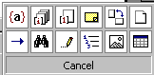

When one of the browse icons has been selected the Previous Page and Next Page buttons on the vertical scrollbar change from black to blue.

What do all the icons do ?
 | Browse by Field | Clicking will take you to the Previous Field  Clicking will take you to the Next Field
 | Browse by Endnote | Clicking will take you to the Previous Endnote  Clicking will take you to the Next Endnote
 | Browse by Footnote | Clicking will take you to the Previous Footnote  Clicking will take you to the Next Footnote
 | Browse by Comment | Clicking will take you to the Previous Comment  Clicking will take you to the Next Comment

 | Browse by Section | Clicking will take you to the Previous Section  Clicking will take you to the Next Section
 | Browse by Page  (the default method for browsing) | Clicking will take you to the Previous Page  Clicking will take you to the Next Page
 | Goto | Displays the Goto dialog box
 | Find | Displays the Find dialog box
 | Browse by Edits | Clicking will take you to the Previous piece of Edited Text  Clicking will take you to the Next piece of Edited Text
 | Browse by Heading | Clicking will take you to the Previous Heading  Clicking will take you to the Next Heading
 | Browse by Graphic | Clicking will take you to the Previous Graphic  Clicking will take you to the Next Graphic
 | Browse by Table | Clicking will take you to the Previous Table  Clicking will take you to the Next Table

Undo & Redo - a licence To make mistakes!
Word 97 provides 500 levels of undo and redo. This means that you can not only undo the last thing you did (as in other programs) but the one before that and before that and so on up to 500 actions! Not only that, if you undo something that you did not mean to then you can redo up to 500 levels of undo!
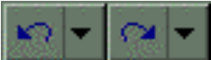
Redo up to 500 undo’s

Undo Last Single Action
Redo Last Single Undo
Undo up to 500 actions

Undoing the last thing you did
Click the Undo button
Or
CTRL-Z

Redoing the last thing you undid!
Click the Redo Button
Or
CTRL-Y

Undoing up to 500 actions
Click on the down arrow next to the undo button (a list will drop down)
Use the scroll bar to scroll to the last action you want to undo
Click on the action The last x number of actions will be undone

It will undo all the last x number of actions!
Just be aware that you can't actually scroll down the list and undo, say, the last but one action. You have to undo both the last and the last but one. Undo doesn't allow you to be selective.

Redoing up to 500 things you undid!
Click the down arrow next to the Redo button a list will drop down
Scroll to the last action you want to redo
Click the action the undos will be redone!

Saving documents

Saving a document for the first time
Click the Save icon
Click this down arrow to change the folder your document will be saved in.

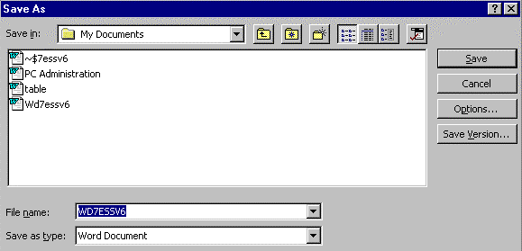
Type your filename here.

Type in the name of the document (up to 255 characters long).
Change the folder to save the file in if required
Save or press Enter

Filenames
When you first save a document, Word picks up the first line of your document, and uses it as a filename. This can be useful, but often you will want your own filename.
If the filename is highlighted in blue - you can type over it. As soon as you start typing the name in blue will disappear and will be replaced with whatever you type.

Saving a document again after changes
Click the Save icon the save will be "updated" without further prompting

Save regularly!
As you are working on a document, get into the habit of clicking every few minutes on the Save icon. This will "update" the document and protect it if your PC hangs or you loose power. If you don't save regularly, you may lose work!

More options when saving

Creating a copy of a document using Save As
If you want to create an identical copy of a document, this is one way of doing it. Saving with another name will leave the original intact, so you’ll have two documents the same but with different names.
File - Save As the Save As box will appear (see previous page)
Type in a name for the document
Change the folder to save the file in if required
Save or press Enter

You may be prompted for Document Properties (Depending on how Word has been set up on your computer). If so enter the necessary information and click OK.

Changing where files are normally saved
If you save most of your files in one particular folder, you can set it up as the “default file location” so that Word saves your files to that folder unless you tell it otherwise.
Tools Menu - Options

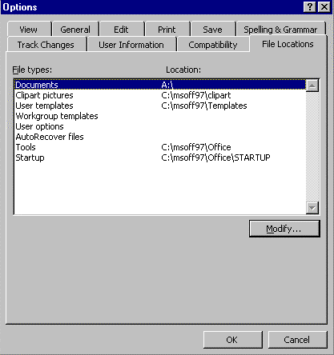

File Locations Tab
Documents
Modify A dialog box will appear
Choose the folder you want documents to be saved in
OK

Creating a folder in the Save As dialog box
File menu - Save as
In the Save In Drop-Down list, change to the drive or folder that will be the parent of the new folder (i.e. the folder in which your new folder will be created)
Click the Create New Folder icon 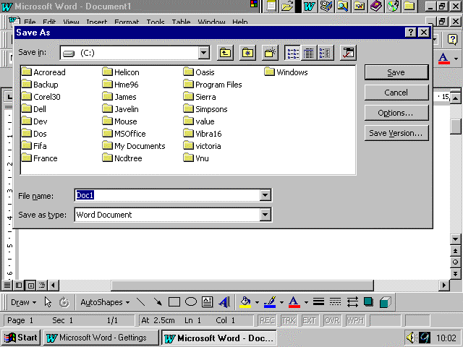
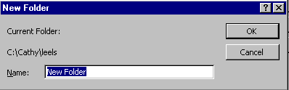

Type a name
OK

Opening, creating and closing documents

Opening saved documents
Click the Open Icon
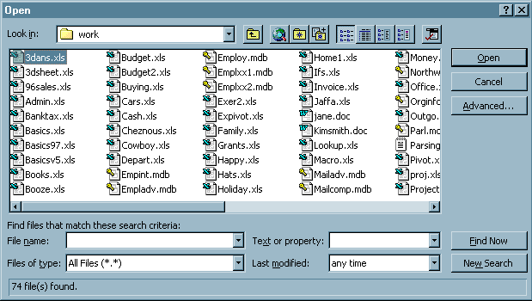

To change the folder you wish to look in:
Click on the down arrow next to the 'Look in' box.
(In the above dialogue box, word is looking at the contents of the folder called "Work")
Click on the name of the file to be opened It will be highlighted
Open

You can open more than one file at a time
You can select and open as many files as you want in one go. To select more than one file, use either the shift key and click on the first then the last file, or the CTRL key and click on files individually. Alternatively, you can drag around the files to select a block

Creating new documents
Click on the new document icon a new document will appear

Creating new documents based on a template
Templates allow you a head-start in creating documents. When you create a new document based on a template some of the text will already be there, and you just have to fill in the rest.
File Menu - New
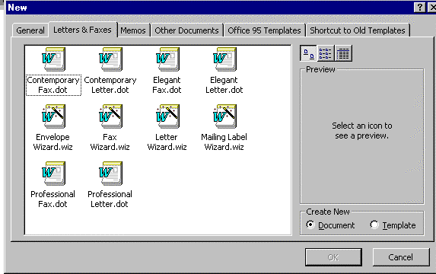
Click on the tab you require (e.g. Letters and Faxes, Memos)
Click on the template you wish to use (e.g. Professional Letter)
OK

Closing documents
File menu – Close If the document needs to be saved, you will be prompted to do so.
This X will close down Word
Or

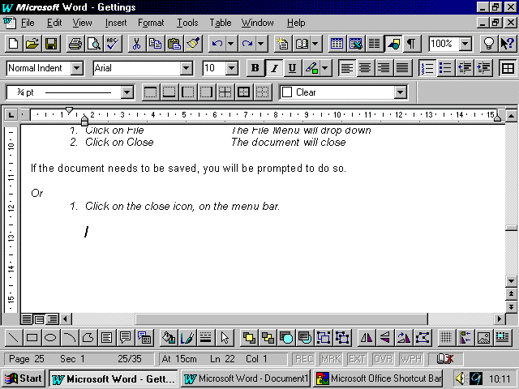
Click on the close icon (the “x” on the menu bar)
This X will close down the document

Managing files in the Open dialog box

Changing how you see your files in the Open dialog box
Click the Open icon
Use the buttons shown below to change the view of your files

Details
Preview
Properties
List

The default view is list. This. Other views are:

List Shows the names of your files in alphabetical order
Details Shows name of file, size, type and date last modified
Properties Shows properties for the selected file
Preview Gives a preview of the selected file

Sorting files
In the Open dialog box, click the Command and Settings button 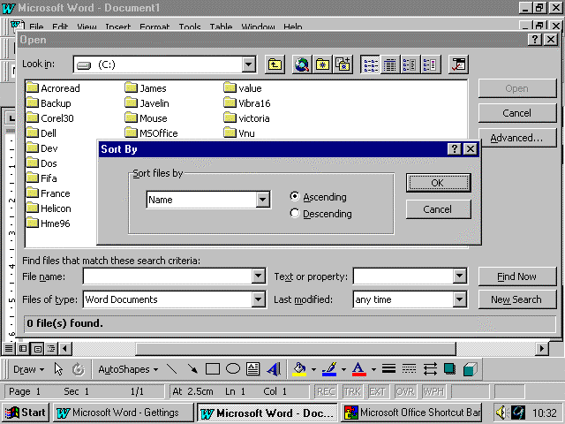
Click Sorting from the menu
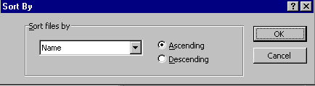
In the ‘Sort files by’ drop down list
specify a sorting option - Name, Size, Types of File or Last Modified
Choose whether you wish the files to be displayed in Ascending or Descending order
OK

Copying files using the Open dialog box
In the Open dialog box
select the file(s) you wish to copy
Right-click the file(s) a pop-up menu will appear
Copy
From the Look in drop-down list click the drive or folder you wish to copy to
Right click - Paste

Moving files
In the Open dialog box select the file(s) you wish to move
Right-click the file a pop-up menu will appear
Cut
From the Look in drop-down list
click the drive or folder you wish to move to
Right click - Paste

Deleting Files
From the Open dialog box
select the file(s) you wish to delete
Right click the file a pop-up menu will appear
Delete The file will go to the Recycle Bin

Using the Recycle Bin to retrieve deleted files
Close Word, and any other open programs You will be returned to the
Windows 95 desktop
Double-click on the Recycle Bin icon
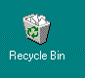
Select the file you wish to retrieve
File menu – Restore The file will be restored to its original
location
File menu – Close to Exit

True Delete (avoiding the Recycle Bin)
From the Open dialog box, right click the file
Hold down the SHIFT key
Delete The file has gone for good!

Renaming a file
From the Open dialog box, right click the file you wish to rename
Rename
Type the new name
Enter The file will have a new name

Copying file(s) to a floppy disk
Put a floppy disk into the floppy disk drive
From the Open Dialog box, right click the file
Send to - 3 1/2 Floppy The file will be copied to the floppy disk

Favourites
Use the Favourites folder to store shortcuts to files and folders of interest. You can use a shortcut for quick access to the file without having to remember where the file is located.

To add a file or folder to the Favourites folder…
Select the file or folder you want a shortcut for
Click the Add To Favourites icon
Click Add Selected Item To Favourites.

To open a favourite file or folder…
Click the Look In Favourites icon
Double-click the shortcut or the filename or folder name.

Access the Web using the Open dialog box
This feature will only work if your PC is connected to the Internet already
Click the Search the Web icon You will be connected to your internet browser

Searching for files in the Open dialog box
Word can help you re-locate a lost document using a basic or an advanced search. However you must know at least one piece of information about it, which the computer can base the search on.
The kind of information (or criteria) you need to know one of the following:-

The type of file, e.g. (Word document, Excel spreadsheet)
The filename
Any text that the document contains (people or place names are good)
The date that you last worked on the document

It is also useful to know which drive you saved the document on. Word can only search one drive at a time.

Performing a basic search
To carry out a basic search you must know which folder your document or documents are in

Click the Open icon The Open dialog box will appear
If necessary, change the folder that Word is currently looking in
Type in any information you know about the document into the relevant boxes:-
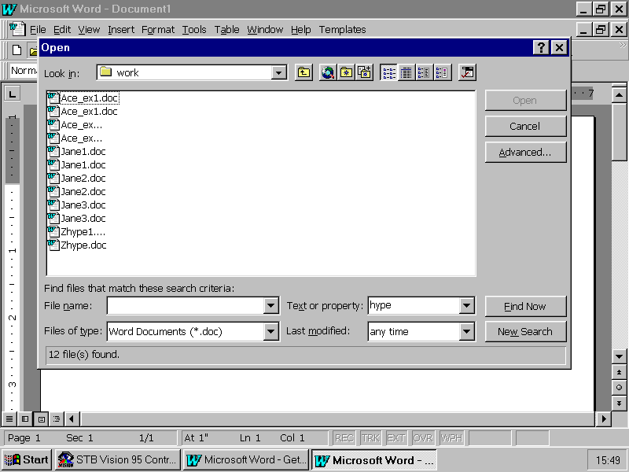

If you know the filename.... | Type it into the filename box
If you know any text that’s in the document…. | Type it into the text or property box
If you know the type of document you are looking for...... | Click on the down arrow next to Files of type  Click on the file type you are looking for (e.g. Word documents)
If you know the date that you last worked on the document | Click on the down arrow next to last modified  Click on the option you require (e.g. yesterday)

Click on Find Now Word finds all documents that match your criteria

Performing advanced searches

If you do not know which folder you saved your document in you can perform an advanced search. However you have got to tell the computer which drive to look in.
Click the Open icon
Click the down arrow next to Files of Type
Click on the type of file(s) you are looking for (e.g. Word documents)
Advanced The following dialog box will appear

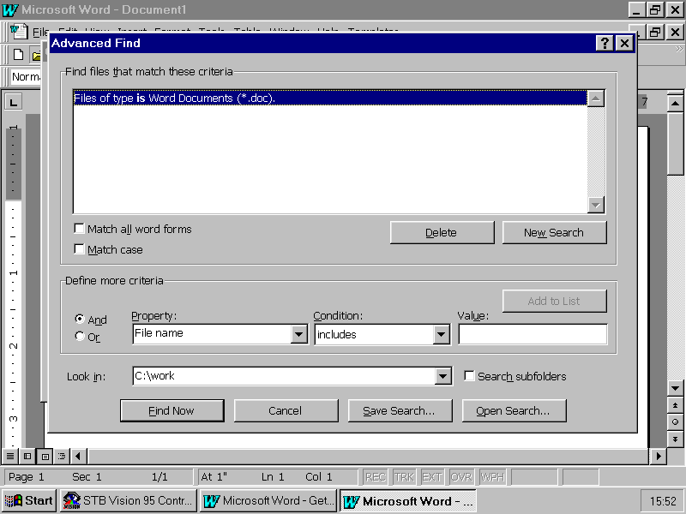
Change the drive or folder that Word is looking in from here

(At the top you will see a list of criteria, which includes the type of file that you just choose)
If necessary, change the folder or drive that Word is looking in:-
a) Click on the down arrow to the right of the Look In box
b) Click on the drive you require
Make sure that the search subfolders box is checked (if it is blank, click inside it)
Click on the down arrow underneath Property
Click on the property you want to search for (e.g. filename, creation date, last printed)
Click on the down arrow underneath condition
Click on the condition you require for the property.
Click on add to list The criteria you have specified will appear at the top.
If you know another bit of information about the document, carry out steps 7 to 9 again.
Click on Find Now
You will be taken back to the Open dialog box and Word will display the files that it has found, along with the folders they are stored in.
To clear this search, click on New Search button

Print Preview
Print Preview lets you see exactly how your document will look on the page before you print.

Getting a Print Preview
Click the Print Preview icon

The Print Preview Toolbar

Trap - Be careful with Shrink to Fit
The shrink to fit icon is very useful if you have a document that goes just over one page. However, it may make changes that you didn’t want or expect if you try it on a longer document. In that case cancel the preview and use UNDO.

Zooming in on your document
Position the mouse over the part of your document you wish to zoom in or out of
the mouse pointer will look like a magnifying glass
Click

Returning to Normal view
Click on Close on the Print Preview toolbar

Printing

Printing the whole document
Click the Print Icon

Printing certain pages
File menu - Print

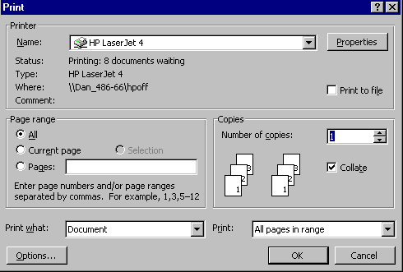

Click in the Pages box
Type page numbers and/or ranges e.g. 1,3,5-9 prints pages 1 3 and pages
5 to 9
OK

Working with more than one document at a time
Microsoft Word 97 allows you to work on many different documents at the same time. Each time that you open a new document it is placed in a new document window until you close it.

Switching between open document windows quickly

To quickly switch to the next window, you can press CTRL-F6

Switching between documents
Window Menu
Click the required document that document will come to the fore

The information in the current window will not be lost. This window will be stored until you switch back to it, or until you exit Word (when you will be asked if you want to save this document.)

Closing a document
Switch to the document
File Menu - Close

Don't have too many document windows open
Don’t keep documents open if they are not needed, they are taking up your computers resources and could slow things down on a slow PC. Close them!

Zooming in or out on your document

Zoom Control
Click the down arrow next to the zoom control A menu will drop down

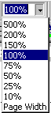

Click on the Zoom level you want

More Zoom Control!
View Menu - Zoom
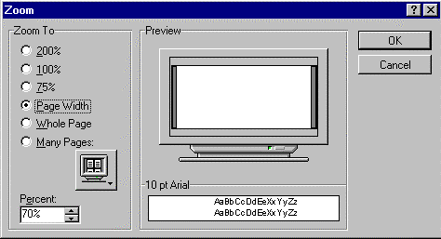
Click on the Zoom level you want
Or
Change the percentage figure by clicking on the small arrows next to it

Different Views of Your Document
Word 97 provides six ways to view documents on the screen. Each view allows you to concentrate on different aspects of your work.

Normal View
Normal view is the default document view you probably will use for most typing, editing, and formatting.

Outline View
In outline view, you can collapse a document to see only the main headings or expand it to see the entire document.

This makes it easy to move and copy text and to reorganise long documents. Not covered on this course.

Online Layout View
A view that optimises the layout of a document to make online reading easier. For example, text appears larger and wraps to fit the window, rather than the way it would actually print. In online layout view, Word automatically displays the Document Map, a separate pane that you can use to navigate around your document or track your location in it. Not covered on this course.

Page Layout View
In page layout view, you can see a document just as it will look when printed and refine its text and formatting.

Print Preview View
Print Preview shows entire pages at a reduced size so that you can view one or more pages at a time, check page breaks, and see what changes you may need to make to text and formatting.

Master Document View
A master document helps you organise and maintain a long document, such as a book or a multi-part report, that is divided into several separate documents called sub-documents. In master document view, you can work in a single document window and still see the overall organisation of all parts of the master document. Not covered on this course

Full Screen View
To see only a document on screen -- without rulers, toolbars, and other screen elements -- choose Full Screen from the View menu. In full screen view, you can choose commands with shortcut keys and display shortcut menus while you work.
To return to the previous view, click the Full Screen button in the bottom-right corner of the screen or press ESC.

Using the six Views
Use A Combination of Views
Use a combination of views to work more efficiently. For example, you can switch from Normal View to Page Layout for a more detailed view and to add final formatting touches.

Changing the Views with the View menu
View Menu - Click the view you want from the menu

Full Screen View
To cancel the Full Screen View press ESC or click on the full screen icon 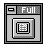

Changing To Normal, Outline or Page Layout View with Icons
Click the Icon required at the bottom left of the screen
Outline View
Normal View

Online Layout View
Page Layout View

Changing To Print Preview
Click on the Print Preview icon on the Standard toolbar

To close Print Preview, click on the Close button

Building on the Basics
Objectives

By the end of this section you will be able to:-

Select text
Make text bold, italic or underlined
Highlight text
Change the colour of text
Change the font of text
Use the format painter to copy the style of one piece of text onto another
Change the alignment of text
Insert special symbols into your document
Move and copy text with cut, copy and paste
Move and copy text with drag and drop

Selecting text with the Keyboard
With all Windows programs, to make a change to anything, you first have to select it. Here's how to select text in Microsoft Word for Windows '97.

To select text
Place the cursor at the start of what you wish to select
Hold down the SHIFT key
Move the cursor along the text you wish to select using the arrow keys

To cancel a selection
Press a cursor key again, without holding down shift

To select a word
Place the cursor at the start of the word
Hold down shift and control
Press the left arrow key

To select a line
Place the cursor at the start of the line
Hold down the shift key
Press end

To select the entire document
Press Ctrl + A at the same time

Selecting Text With the Mouse
With all Windows programs, to make a change to anything, you first have to select it. Here's how to select text in Microsoft Word for Windows '97.

To select text
Place the mouse pointer at the start of what you wish to select
Click and drag over the text

Smart Selection
When you click and drag over text, Word ’97 uses smart selection. This means that if you start dragging from the middle of a word and carry on to other words, the bit of the first word that you missed is automatically selected! Try it and see.

To cancel a selection
Click once in a white space on the right hand side of your document

To select a word
Double-click on the word

To select a sentence
Hold down CTRL and click anywhere in the sentence

To select a line
Click to the left of the line NOTE the cursor will change to a right arrow when you are in the correct place.

To select a paragraph
Double-click to the left of the paragraph NOTE the cursor will change to a right arrow when you are in the correct place.
Or
Triple-click the paragraph
Selecting Multiple Words, Lines, Or Paragraphs

To select multiple words, lines or paragraphs, select one in the way described above, and then (without letting go of the mouse button) drag the mouse to select others

More methods of selecting text

To select the entire document
There are four ways to select the whole document:
CTRL-A
Edit menu : Select All
CTRL key + click to the left of the document
Triple Click to the left of the document

To select a large area of text: click & shift-click
Click at the start of the text to select
Release the mouse button
Move to the end of the text to select using the scroll-bar
Hold down the SHIFT key and click at the end

Extending your selection
If you have selected text, you cannot extend it by dragging with the mouse alone. (In fact this will tend to drag the selected text around.) Instead:
Hold down SHIFT key
Click on the new end of the text you now want to select to.

Use “Extend Selection”
Click at the start of the text to select
F8 or Double-click on the EXT on the status bar at the bottom of the screen
Use the cursor keys or the mouse to move to the end of the text to select
ESC

To select a table
ALT + Double-click in the table

To select a column in a table
ALT + Click in the table

To select a column of text
ALT + Drag with the left mouse button

Changing the look of text

Make It Bold, Italic or Underlined

Select the text to change
Click on the Icon you want Shown Above

Turning off Bold Italic or Underlined
Select the text to change (the text that is already Bold, Italic or Underline)
Click on the Icon you want (Shown above)

Smart Selection
If you only want to change one word then you do not need to select the whole word, simply put the insertion point (the flashing cursor) inside the word by clicking in it and then make the change.

Short-cut Keys
CTRL + B Bold
CTRL + I Italic
CTRL + U Underline
Make The Changes Before You Type

If you wish, you can make the changes before you type to affect all the typing that follows

Highlighting Text
The Highlight text options work just like a highlighter pen and allow you to emphasise key points in your document. You have 15 different colours to choose from!

Showing highlighted text
Tool Menu -Options
Click the View tab
Make sure that there is a tick in the highlight check box

Highlighting text
Click on the Highlight icon on your toolbar The mouse pointer will change to a highlighter pen
Click and Drag over the text that you wish to highlight The text will be highlighted
To turn off this feature, click back on the highlight icon

Choosing a different colour
Click on the Down arrow next to the Highlight icon Colour options will appear
Choose the colour you want by clicking on it the mouse pointer will change
Click and Drag over the text you wish to highlight
To turn off this feature, click back on the highlight icon

Removing highlighting from text
Select the text that is highlighted
Click on the Highlight Icon

Changing the colour of text

Applying colour to text
Select the text that you wish change
Click on the right arrow next to the Font colour icon
Choose the colour that you wish to apply The text will change to the desired colour

Removing colour formats
Select the text that you wish to change
Click on the right arrow next to the Font colour icon
Choose Automatic

Changing the font

Quick font changes
Select the text to change
Click on the arrow to the right of the font box on the formatting toolbar, shown below

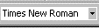
A list of available fonts will drop down
Click on the name of the font you want The text will change to that font

Change the size of text
Select the text to change
Click on the arrow to the right of the font size box on the formatting toolbar, shown below

A list of available sizes for the chosen font will drop down
Click on the size of font you want the text will change

Short-cut keys
CTRL + SHIFT + > Increase Font Size
CTRL + SHIFT + < Decrease Font Size
CTRL + SHIFT + F then down arrow Select Font
CTRL + SHIFT + P then down arrow Select Font Size
Smart election
If you only want to change one word then you do not need to select the whole word, simply put the insertion point (the flashing cursor) inside the word by clicking in it and then make the change.

Detailed changes to text

The font dialog box
Select the text to change
Format menu - Font
Click on Font, Character Spacing, or Animation tab to select the one you want
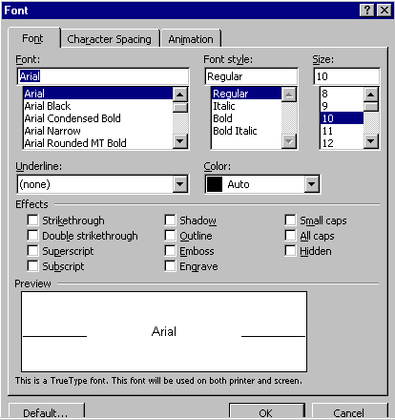
Make changes to the options you want
Keep your eye on the preview to see how the changes affect your text
OK

Changing the default font (the normal one)
Format - Font
Click on the Font Tab if it is not at the front
Make changes to the options you want
Click the default button The dialog box will appear
Yes
OK

Use the preview box
Keep your eye on the Preview to see how the changes affect your text

Applying other effects

The Font Dialog box comes with lots of other effects you can apply to your text. Here is a list of them and how they effect text:
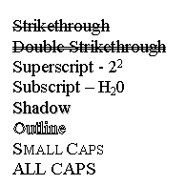

Applying these effects
Select the text to change
Format Menu - Font
In the Font Dialog box under the section headed effects, select the effect you wish to apply
OK

Underlining text
The Font Dialog comes with many different types of Underlining effects that you can apply to text. Here is a list of them and how they effect your text.

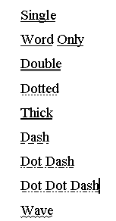

Applying different underlining
Select the text to change
Format Menu -Font
Under the section headed Underline, click on the Downward arrow
Choose the type of underlining you wish to apply

Format Painter
You can format some of your text (change the font, size, alignment etc.) and then copy the formatting to other parts of your text!

Using Format Painter once
Select the formatted text
Click the Format Painter icon
Select the text to change The format will be copied to this text

Using Format Painter to copy formatting more than once
Select the formatted text
Double-click on the Format Painter icon It will stay “toggled” (i.e. pushed in)
Select the text to change The format will be copied to this text
Select some more text
And so on...
When you want to finish, click on the Format Painter icon again or press ESC or start typing

Selecting Text

For quick ways of selecting text see page 38 - Selecting text with the mouse

Centre, Right, Left And Fully Justified Text
What is it? It just means how the text is lined up on the page. Here's an example:.

This is Centred text
This is Left text
This is Right text

This is Fully Justified Text but you can't really see the effect of this unless there are a few lines of text so I am going to have to type a load of nonsense here so that you can see what I mean. Is it clear yet? Take a look at the left and right side of the pages, they have straight lines, don't they? That's what is meant by fully justified.

Centre, right, left and fully justified text that you have already typed
Click in the paragraph to change
Click on the appropriate Icon Shown Below

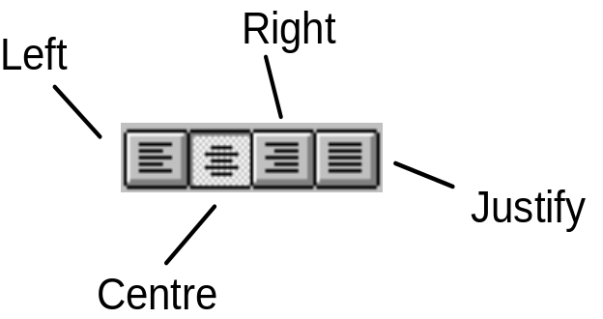

In the above picture Centre has been selected
The changes will apply to a whole paragraph
The alignment type chosen applies to the entire paragraph/ paragraphs selected when the alignment was chosen!

Centre, right, left and fully justified text as you type
Click in the paragraph to change
Click on the appropriate icon Shown Above

Short Cut Keys

CTRL + L Left align CTRL + R Right Align
CTRL + E Centre CTRL + J Full Justification

Inserting the date & time
You can get Microsoft Word 97 to automatically insert the date for you

Inserting a fixed date & time
Insert menu - Date & Time The date Box will appear
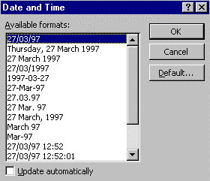
Click on required date/time format
Make sure Update Automatically is not selected (no cross in the box)
OK

Changing the default date
Insert Menu - Date and Time
Choose the Date Format that you wish to become the Default
Click on the Default button
Yes

Quick date & time fields
To quickly get the default date inserted:
Date ALT + SHIFT + D
Time ALT + SHIFT + T
Date & time fields
The above inserts the date as a field. This means that the date or time is “live” so when you look at your document tomorrow it will have tomorrow’s date, or tomorrow’s time

Changing the case of text
Have you ever typed a sentence and then noticed that the CAPS LOCK key was on and had to do it all again? Microsoft Word 97 has the answer!

Using change case
Select the text to change
Click on Format The menu will drop down

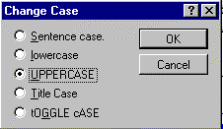
Click on Change Case The dialog box will appear
Click on the type of case you want (see Types Of Case descriptions below)
Click OK

Using the short cut key
Select the text to change
SHIFT + F3 The case will change
Keep pressing SHIFT + F3 until you have the case you want

Types of case
Type of Case - Original case is listed to the right | This is some text in the case listed to the left
Sentence | This is some text in the case listed to the left
lowercase | this is some text in the case listed to the left
UPPERCASE | THIS IS SOME TEXT IN THE CASE LISTED TO THE LEFT
Title Case | This Is Some Text In The Case Listed To The Left
tOGGLE cASE | tHIS iS sOME tEXT iN tHE cASE lISTED tO tHE lEFT

Inserting special symbols or characters

Inserting a special character or symbol
Insert Menu - Symbol The dialog box will appear
Click on the Symbol or Special Characters Tab
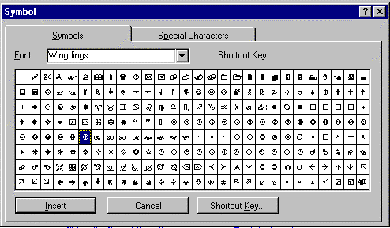
Click on the symbol you want It will be highlighted
Click on Insert The symbol is inserted into your document
Click on another and insert that too, if you wish
If the symbol you want is not displayed, try changing the font from the drop down list
Close

Assigning shortcut keys to a symbol or special character
If you use a particular symbol often then you can assign a shortcut key to it so that you can type it quickly
Click on Insert Menu The menu will drop down
Click on Symbol The dialog box will appear
Click on the Symbol or Special Characters Tab
Click on the symbol you want It will be highlighted
Click on the Shortcut Key button The dialog box will appear
Type the Shortcut Key you want i.e. CTRL + ALT + Q
Check that the shortcut key is not already assigned to something else.
( If it is press the Backspace key and try again)
Click on Assign
Click Close
Click Close
You can now use your shortcut key to put the symbol directly in the document without going through the menus.

Inserting accented characters
There are short-cut key combinations to produce most accented characters:

à, è, ì, ò, ù CTRL ` then the letter
á, é, í, ó, ú CTRL ’ then the letter
â, ê, î, ô, û CTRL SHIFT ^ then the letter
ã, ñ, õ CTRL SHIFT ~ then the letter
ä, ë, ï, ö, ü, ÿ CTRL SHIFT : then the letter
å CTRL SHIFT@ then the letter
ç CTRL , (comma) then the letter
¿ ALT CTRL ?
¡ ALT CTRL SHIFT !

These all work with lower case or upper case letters.

Moving & copying text with Cut/Copy & Paste

Moving text
Select the text to move
Click on the CUT icon or CTRL + X

The text is placed is placed in limbo - (actually in an area of temporary memory called the Clipboard)

Click in the new place for the text
Click on the PASTE icon or CTRL + V

The text is moved to the new place

Copying text to another place
Select the text to copy
Click on the copy icon
A copy of the text is placed in limbo - (actually in an area of temporary memory called the Clipboard)
Click in the new place for the text
Click on the PASTE icon or CTRL + V

The text is copied to the new place

Notes
Once you have placed some text on the Windows Clipboard it stays there until you place something else on to the clipboard. This means that you don't have to paste immediately, you can carry on with something else if you wish and paste the text in later on!

Even after you paste text into your document, there is still a copy of the text on the clipboard, and so you can paste the same text again, and again, and again if you wish to have lots of copies of the same text.

Copying text between documents
Check that both the document you are copying from, and the document you are copying to, are open.
(Click on the window menu to see a list of all open documents)
Select the text you wish to copy
Click on the copy icon
Click on the window menu
Click on the name of the document you wish to copy to
Move your cursor to the correct position
Click on paste

Moving & copying text with drag & drop
Microsoft Word 97 has a really quick way of copying and moving text with Drag & Drop.

Moving text
Select the text to move
Release the mouse button
Click in the selected text and drag to a new location

You will notice that the text does not move until you release the mouse button. You can tell where it is going by the light grey line that moves with the mouse.

Copying text
Select the text to copy
Release the mouse button
Hold down the CTRL key
Click in the selected text and drag to a new location

You will notice that the text is not copied until you release the mouse button. You can tell where it is going by the light grey line that moves with the mouse.

If something goes wrong
Click on the UNDO icon Shown below

See page 32 "Undo and redo - A license to make mistakes!” for more details on Undo.

Smart Selection

When you drag and drop text Microsoft Word 97 will make sure that there are spaces in the correct places

Page Layout

Objectives

By the end of this section you will be able to:-

Change the margins and layout of your page
Change the orientation of the page
Use tabs and indents
Apply page numbering
Put page breaks into your document
Use headers and footers

Page Set-up
You can change the way your paper is set-up, in terms of paper size, margins, orientation etc.

Starting Page Set-up
File menu – Page Set Up

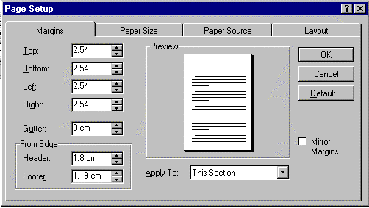

There are four general areas you can change:

Margins
Paper Size
Paper Source
Layout

To change to one of the general areas, click on the appropriate tab to bring it to the front

Default button
Click on the default button after you have made your changes to make all new documents have your new settings
Preview Area

Keep your eye on the preview area - it will show you how your changes will affect your document.

Margins

Margins
File Menu – Page Setup
Click here to make all new documents use these settings
Click the Margin tab if not already displayed

Click here to determine where your changes will affect your document
Gutter
This is useful if you bind documents - it adds the extra margin space to the inside edge
Mirror margins is useful if you print on both sides of the paper
Change the margins by adjusting the top, left right and bottom figures. You can type in a figure or use the arrow buttons

Specify how far the headers and footers are from the edge of the page. You can type in a figure or use the arrow buttons

Change the margin settings using up and down arrows OR by simply typing the new settings into the measurement boxes
OK

Setting margins with the Ruler
You can set the left and right margins with the ruler

Setting margins
Click and drag the margin markers on the ruler (see diagram below)

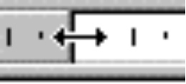
Click and drag here - Make sure you are in the right place by checking that the cursor has changed to the double arrow shape pictured above.

All change

This will affect the whole of your document

Don’t confuse the margins and the indents
When you are changing the left margin with the ruler, make sure that you do not drag the indent marker (it looks like an egg timer!) instead of the margin.
Wait until the mouse looks like a black double-headed arrow, and a yellow box saying “Left margin” has appeared before you drag.

Layout
This feature is not generally trained on an Essentials course
File Menu - Page Set-up
Click the Layout tab if not already displayed
To number every line in a document, select the text and click here

Layout Options

The options in this dialog box are dealt with in more detail in the Happy Computers Microsoft Word 97 Advanced Guide
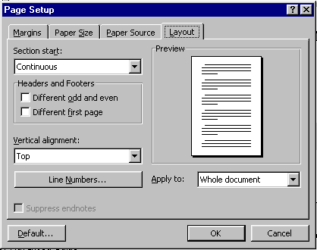

Paper Size & Paper Source

Paper Size
File menu – Page Setup
Click on Paper Size tab if not already displayed

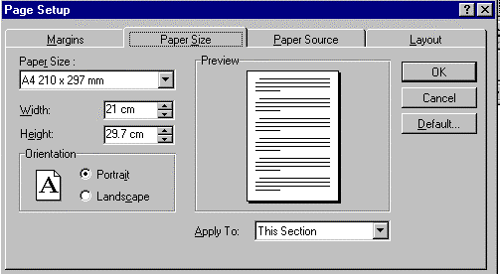
Click here to select a standard paper size
Change the width and height figures to create a non-standard paper size
Chose Landscape or portrait orientation
Click here to determine where your changes will affect your document

4. Make the changes you want
5. Click OK

Paper Source
The settings in this box will change depending on the printer you are using. It enables you to choose which tray in your printer you want the document to be printed from. For instance you may have letterhead paper in one tray and plain in another.

File Menu - Page Set-up The dialog box will appear
Click on Paper Source tab if not already displayed
Select the source for the first page
Select the source for the other pages
Click OK

Using the ruler
The ruler can be used to set tabs, margins, and indents.

Seeing the ruler
If the ruler is not displayed then you can turn it on:

View Menu - Ruler
To hide the ruler, repeat the above

Understanding the ruler

Right margin
Tab type selector
Decimal tab
Left margin
Left tab
Centre tab

First line indent
Rest of paragraph indent
Right tab
Right indent

Changing the measurements on the ruler
If you prefer to work in centimetres instead of inches, or some other form of measurement...

Tools Menu - Options
Click the General Tab
Click the Measurement Units drop down list
Click on the measurement type you want
OK

How the settings change your document
Changing the tabs and indents will only affect the current paragraph, or the selected paragraphs (or the rest of the document if you are at the end of the document with no text selected)

Using Tabs
What is the difference? Here's an example:

This line is tabbed in one place at the start of the line. You will notice that when I get to the second line the text goes back to the start of the line.

This line is indented and guess what is going to happen when I get to the second line. Yes that's it, it stays indented, would you believe!

This line is a hanging indent and guess what is going to happen when I get to the second line. Yes that's it, the second and all the other lines to follow are indented but the first stays at the same place.

Using default tabs
Tabs stops are usually set at 0.5” or 1.25cm automatically (by default). Whenever you press the tab key, the cursor will jump 0.5” to the next tab stop.
Click the cursor where you wish to insert a tab
Press Tab key (it has two arrows on it and is on the left of the keyboard)

Warning!
Depending on the Autoformat settings selected on your PC, doing this may result in a first line left indent being applied to the paragraph, and no tab will have been inserted! (The ruler will show you if this has happened)
If this happens, see section “Changing the AutoFormatting settings” to remedy it.

To remove a tab
Click the cursor after the tabs
Press the Backspace key

Using the Show/Hide button
Normally. you can’t see where you have inserted a tab on the screen, but if you turn on the Show/Hide button, tabs are displayed as small black arrows.

Setting Tabs with the ruler

How changing tabs will affect your document
Changing the tabs and indents will affect the current paragraph or the selected paragraphs (or the rest of the document if you are at the end of the document with no text selected)

Setting tabs with the ruler
Select the type of tab you want, by clicking on the tab-type selector to the left of the ruler (See below for the different types of tabs.)
Left tab (text will line up to the right of the tab stop)
Centre tab (text will line up around the tab stop)
Right tab (text will line up to the left of the tab stop
Decimal tab (The decimal point in figures will line up to the tab stop,
therefore figures will line up neatly underneath each other)
Click on the ruler where you want your new tab-stop to be.
Click between the grey and the white to set the tab

Removing tabs with the ruler
Select the paragraphs to change then ...

Use the following to remove the tabs with the ruler (bear in mind the remarks above)

Click on the tab you want to change A grey dotted line will appear down the screen.
Click and drag the tab mark down off the ruler to remove it.
Click on the “Tab Type Selector” to choose the type of tab before creating a new one
Click on the ruler to create a new tab.

Moving tabs with the ruler
Click on the tab you want to move A grey dotted line will appear down the screen
Click and drag to a new position on the ruler

Types of Tabs
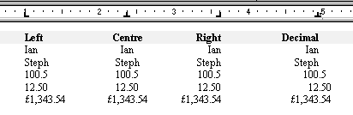

To create a new tab of a certain type

Click on the Tab Type Selector on the ruler until the type of tab you want appears
Click on the ruler where you want the tab

Other types of tabs

Tab leaders
Applying Tabs Leaders are very useful if you wish to create printed forms. For Example:

Name

Address

Tel No Fax No

Types of leaders
Dotted

Dashed

Lined

Setting Tab Leaders
Place your cursor where you want to start
Click on the Format Menu and Choose Tabs A dialog box will appear (Shown below)
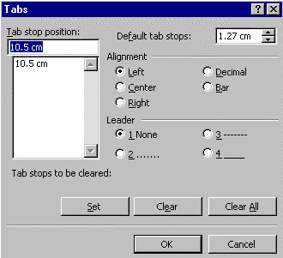

Type the “Tab Stop Position”
Select the tab style you want - Left, centre, right, decimal or bar.
Under the Leader section select the type of leader you want, dotted, dashed or lined
OK

What difference does the tab-type make?
The type of tab will affect the way in which the text appears next to the leader. Look at the diagram below:-
This is a left tab at 7cm with a leader
This is a right tab at 7cm with a leader
This is a centre tab at 7cm with a leader
A decimal tab works the same as a right tab

Setting Bar tabs
A Bar Tab will insert a vertical line at the tab stop

Place your cursor in the position where you want your bar tab to start
Format Menu - Tabs
Type the position for your bar tab
Select Bar as the type of tab
OK

Using indents

Indenting a paragraph
Click inside the paragraph you want to indent
Click on the Increase Indent icon or CTRL + M

Removing the indent from a paragraph
Click inside the paragraph
Click on the Decrease Indent icon or CTRL + SHIFT + M

Hanging indent
Place cursor anywhere within paragraph to be indented
Press CTRL + T

To remove the hanging indent...

Place cursor anywhere within paragraph to be indented
Press CTRL + SHIFT T

Use tabs and indents to line text up
Never try to line text up on the page by pressing the spacebar. It will not work, you will always get uneven lines. Instead use tabs or indents to line your text up and get perfect results!

Setting indents with the ruler
How changing indents will affect your document
Changing the tabs and indents will affect the current paragraph or the selected paragraphs (or the rest of the document if you are at the end of the document with no text selected)

Changing indents with the Ruler
Select the paragraphs to change
Click and drag the indent marks to make the change
This is the Left Indent Marker
The top triangle affects the first line only of the paragraph
The bottom triangle will affect the rest of the paragraph, ie. everything but the first line

This is the Right Indent Marker
Dragging this triangle will affect the right indent of the whole paragraph

Examples
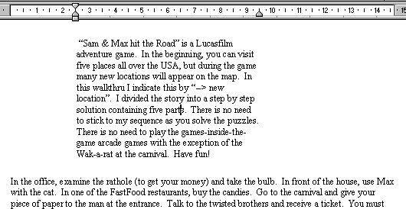
First Paragraph is indented left and right

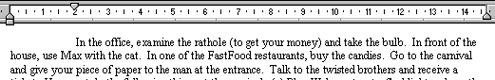
First line only is indented

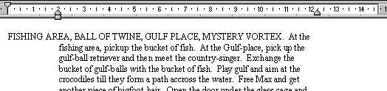
Rest Of Paragraph left indent and right Indent

Page numbering & page breaks

Page numbering

Insert Menu - Page Numbers

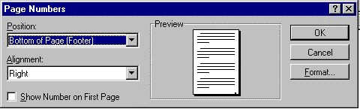
Select a Position for the page numbers from the drop down box
Select the Alignment you want from the drop down box
If you want page numbering on the first page click in “Show Number on First Page” so there is a cross in the box.
OK

The page numbers will be inserted and will automatically number the page in your document

Header & Footers

Page numbers are inserted into a Header or Footer, even though this may not be immediately obvious

No number on the first page
Insert menu -Page Numbers
Make sure that the box next to show numbers on the first page has no tick
OK

Changing the start number
Format menu – Page Numbering
Click the Format button
Click in the white dot next to Start At
Type your start number into the Start Box or use the up/down arrows
O.K.
O.K

Deleting page numbers
Go to Page Layout View (View menu – Page Layout)
Double click on any page number header or footer area opens
Select the number
Press delete (You may need to press delete twice) page numbers are deleted.
Click Close on Header and Footer toolbar

Headers & Footers

Creating Headers and Footers
A header or footer is a standard piece of text, which appears at the top or bottom of every page.
View menu - Header and Footer You will be taken to the Header / Footer view

In Page Layout View
When you are in Page Layout View you can edit a header or footer by double-clicking on the header or footer area.

The Header and Footer Toolbar
Switch between header and footer

Same as previous
Shows next section's header or footer
Insert AutoText entry
Insert page number
Insert date
Insert time

Insert number of pages
Page Set-up
Show/hide Document text
Closes header and footer

Format page number
Shows previous section's header or footer

Creating or editing Headers or Footers
Switch to Header and Footer View (see above) You will be taken to The Header &Footer Screen
Click into the dotted area and type your text
Click CLOSE on the header / footer icons

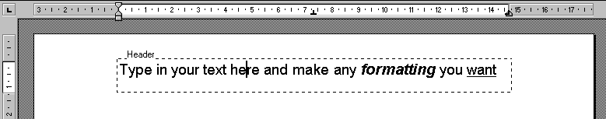

You can click and drag boundary up and down to change the size of the header or footer area

AutoText Entry Icon
The AutoText Icon on the Headers and Footers Toolbar gives you useful options for adding text
Click the Insert AutoText button A pop-up menu will be displayed
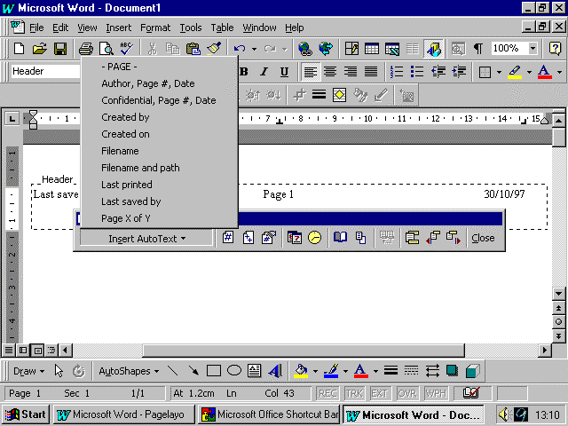
Click here to insert the filename and path
Click on one of these options, and it will insert that information into your header or footer.

Inserting the filename and its location into a header or footer
Click on the Insert AutoText button
Click on “Filename and Path”

Bringing it all together

Objectives

By the end of this section you will be able to:-

Apply borders and shading to text
Create bulleted and numbered lists
Produce minutes
Find and replace text
Use wizards and built-in templates

Adding borders and shading around paragraphs and text

Adding borders using the menu
Select the text or paragraph
Format Menu - Borders and Shading

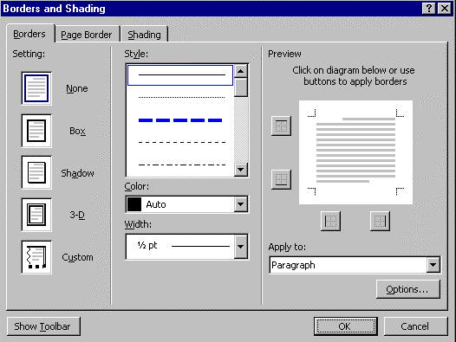

To create a border, click on the Borders tab
Choose the type of setting you require from the left-hand side
Choose a different style, colour and width if desired
Click the border buttons to add or remove the currently selected settings.
OK

Adding shading using the menu
Select the text
Format Menu - Borders and Shading
Click the Shading tab
Make the changes
OK

Adding borders using the toolbar
Select the text or paragraph
View menu - Toolbars
Tables and Borders (if not already ticked)

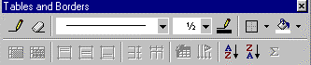

Choose the Line Style for your border by clicking on the downward arrow next to the line style list box.
Choose the Line weight for your border by clicking on the downward arrow next to the Line Weight list box.
Change the colour if desired using the line colour icon
Select the Border list and choose the border you want to add by clicking on an appropriate button:
Outside border
Top Border
Bottom Border
Left Border
Right Border

Adding shading using the toolbar
Select the text or paragraph
View menu -Toolbars
Tables and Borders (if not already ticked)
Click on the downward arrow next to the Shading icon on the Toolbar
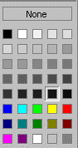

Click the shading or colour you want
To remove colour or shading, click None

Bullets & paragraph numbering
If you need to add bullets, or number a set of paragraphs, it is easy to use Word’s automatic bullets or paragraph numbering facility. Then if you need to insert a paragraph or item in your list, Word will automatically renumber all the entries below the insertion.

Happy
This is a Bulleted List
Smiley
Grinny
This is a Numbered List
Happy
Smiley
Grinny

Applying bullets or numbers to existing text
Select the list
Click on the Numbering Icon 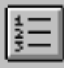
Or:
Click on the Bullets Icon 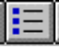
Deselect your text

Applying bullets or numbers as you type
Place your cursor where you want to start numbering
Click on the bullet or number icon, as shown above
Type your paragraphs, pressing enter at the end of each list. Word will automatically give you the next number or bullet

Creating a blank line between numbers or bullets
Hold down the SHIFT key and press Enter

Ending bullets or numbering
Press Enter so that you are on a blank line with just a number or bullet
Click on the Numbering or Bullets Icon again

Or
Press Enter twice Numbering or bulleting will end

Automatic numbered & bulleted lists
If this feature is turned on, when you start a list with a number or an asterisk followed by a punctuation mark like a full stop, Word continues numbering, or adding bullets to each line until you press return twice. You may want to turn this feature off:
Tools menu – AutoCorrect
Click the AutoFormat As You Type tab
Uncheck the Bulleted List or Numbered List options
OK

Changing the bullet type
Format menu- Bullets & Numbering
Click on Bulleted tab (if not already shown)

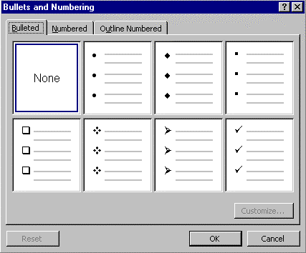
Click on the Bullet Style you require It will become selected
OK
You can now start typing your paragraphs (see previous page for guidance)

Customising a bullet style
Click on Format menu - Bullets & Numbering Click on the Tab marked - Bulleted (if not already shown)
Click the Customise Button
Click on Bullet Button
Select the font you wish to choose the Symbols from
Click on the Symbol you want
If you wish to change the size or the colour, click on Font button, and make the necessary
changes
OK

Removing numbering or bullets
Select the paragraphs
Click the Numbering or Bullets Icon to remove numbers or bullets
Deselect your text

Multi-level numbering (outline numbering)
It’s best to do this as you type! For Example, do you have to produce lists which might look something like this:

Example
1) This is the main level of my list
2) This is another main level.
a) This is the secondary level.
b) This continues the secondary level.
3) This goes back to the main level again.
a) This goes back to the secondary level.
b) Secondary level.
c) And again.
i) This is a third level.
ii) And this.
4) Here I am back to the main level.

Click in the document where you want to start your list
Format menu - Bullets & Numbering
Click the Outlined Numbered tab (if not already shown) The Multi-Level options appear (choice of 7 styles)
Click the Multi-Level Numbering Style you require
OK

Typing in your multi-level list - step one
Type your lines/paragraphs, pressing Enter at the end of each one
Word will automatically give you the next number

If you require a gap between each numbered paragraph press SHIFT + Enter.

Changing to level 2
Having typed the last line/paragraph in level 1, press Enter.
To change this number to the next level, click on the Increase Indent Icon 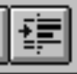
or
press your tab key
Type your line/paragraph pressing Enter at the end of each one
Word will automatically give you the next number in the second level

Changing to level 3
Having typed the last line/paragraph in level 2, press Enter.
To change this number to the third level, click on the Increase Indent Icon or press your tab key
Type your line/paragraph pressing Enter at the end of each one
Word will automatically give you the next number in the third level

Changing back a level
Click on the Decrease Indent Icon 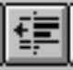 or press SHIFT and Tab together

Turning the numbering off
Press Enter so that you are on a blank line with just a number
Click on the Paragraph Numbering Icon again to turn Paragraph Numbering off
or
Press the enter key twice

Producing minutes in Word 97
There are two effective ways of producing minutes using Word 97. One is to use a table, the other is as follows:

How it will look
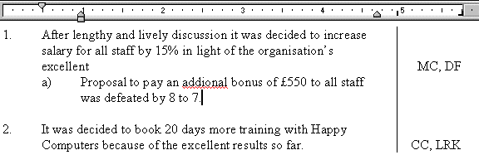

The process
Turn on multi-level paragraph numbering
Reduce the right hand indent by 1 inch
Set a right hand tab for your Action column
Set a bar tab for the vertical line

Set-up multi-level paragraph numbering
Place your cursor where you want to start producing your minutes
Format menu - Bullets and Numbering
Click on the Outline Numbered tab
Click on a style
Click OK

Changing the right indent marker
Format Menu - Paragraph
Make the Right Indent about 1 inch

Setting the right tab
Using the ruler, change your tab indicator to a right tab
Set this tab on the far right of your margin

Setting a bar tab (to put in a vertical line)
Format menu - Tabs
Specify a position that is equal to where your right indent is currently
Specify the tab type as bar
OK

Typing your minutes
Start typing the first point of your minutes in the multi-level list
When finished, press the tab key to get to the action column
Type the relevant information into the action column
Press return or shift-return to get back to the main points area

Finding & replacing text
Shortcut Keys

CTRL + F Find
CTRL + H Replace

Search (without replacing)

Edit menu - Find
Type the word you are looking for
Click Find Next the word will be highlighted in the text
Click on Find next again if you want to find the next occurrence of the word
Click Cancel when you have finished your search

Find & Replace
Edit menu - Replace the Replace Box will appear
Type characters to be searched for
Click in Replace with box
Type characters to replace these with
Click Find Next
If the correct word is highlighted, click Replace button
If you are confident that you want to replace everything ,click Replace All
When finished click the Close button

Be careful with replace all

If you click on Replace All, check your text to make sure that things haven’t been changed unexpectedly

Searching just a part of the text

If you only want to search part of your document, and not all of it, then simply select the part you want to search before you do the search

Using Wizards and built-in templates
Word comes with many “Wizards” and templates that get you started in creating your own documents. “Wizards” are fully automated step by step guides to creating things like Calendars, Newsletters and Standard Letters.
Templates are the basis for a document and help you create things like fax cover sheets, memos or invoices. In the Happy Computers Advanced Guide you can discover how to create your own templates.

Creating a new document based on a template
File Menu - New
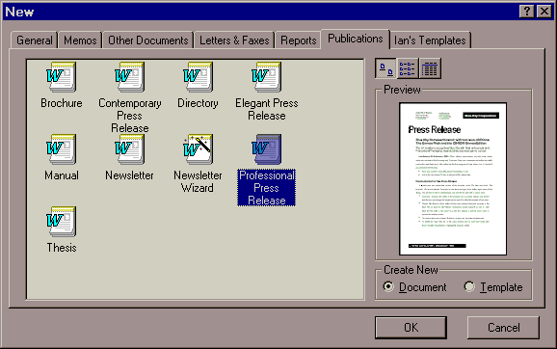
Select the type of document you want from the tabs at the top
Click the template you want to base your document on
(e.g. Professional Press Release) a preview will appear.
OK

Columns and Tables

Columns
The “Columns” feature in Word 97 is designed to make normal paragraphs of text appear in columns, rather like newspaper columns. It is useful for creating leaflets and newsletters, but don’t try using it for minutes or other lists of information – use a table or tabs instead.

Work in page layout view

To see the effect of columns you must be in Page Layout View. View Menu : Page layout or click the Page Layout View icon at the bottom left of the screen.

Creating columns
Select the text to put in columns (If you want to do the whole document have no text selected)
Click on the column icon and move the mouse pointer over the number of columns you want The columns are created !!

Removing columns
Select the text that is in columns
Click on the column icon and move the mouse pointer over one column

Section Breaks

When columns are created, Word creates section breaks too, but it doesn’t remove them when you remove columns. You will need to delete them by hand if you don’t want them to affect any other part of your document. Go into Normal View for this. A Section Break is shown as a dotted line with the words “Section Break”.

Formatting columns in more detail
Select the text to format
Format Menu : Columns
Make your changes
OK

Adjusting columns with the ruler

Adjusting columns with the ruler
Click inside the columns you want to adjust
Turn on the ruler if it is not displayed (View Menu : Ruler)
Click and drag the column markers to adjust the columns

Click and drag here to adjust column width

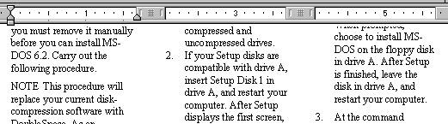

If you can’t adjust the column widths
If no shaded area is shown on the ruler and you can’t adjust the column widths it means that you have “Equal Column Widths” selected. To deselect it click Format Menu : Columns, and Click on Equal Column Widths.

Breaks

Column and page breaks
Page Break Inserts a manual page break. Word automatically adjusts the automatic page breaks that follow. Word cannot move page breaks you insert manually; you must adjust them yourself.
Column Break Inserts a manual column break. Word places the text following the column break into a new column.

Creating page breaks
Click your cursor where you want to insert a page break
Insert menu - Break
Choose Page Break from the options
O.K.

Creating a Page Break with the Keyboard!
Press CTRL + Enter

Section breaks
Section breaks are necessary if you want to apply certain types of different formatting to parts of your document. For instance you could have some pages in portrait and some in landscape. Or different numbering sequences in a long document.
The types of section breaks are...

Next Page Breaks the page at the section break and starts the next section at the top of the next page.
Continuous immediately follows the previous section without inserting a page break. Word fills the last page of the previous section with text from the new section. If the previous section has newspaper-style columns, Word balances the columns above the section break and then fills out the page with a new section.
Even Page Starts the next section on the next even-numbered page. This section break is often used for chapters that begin on even-numbered pages. If the section break falls on an even-numbered page, Word leaves the next odd-numbered page blank.
Odd Page Starts the next section on the next odd-numbered page. This section break is often used for chapters that begin on odd-numbered pages. If the section break falls on an odd-numbered page, Word leaves the next even-numbered page blank.

Creating section breaks
Click the cursor to the place in your document where you want the first section break
Insert Menu : Break
Select the type of break you require
Click OK
If necessary, move the cursor to the next position where you require a section break, then repeat steps 2-4.

Deleting breaks
Switch to Normal View (View Menu: Normal or the icon at the bottom left of the screen)

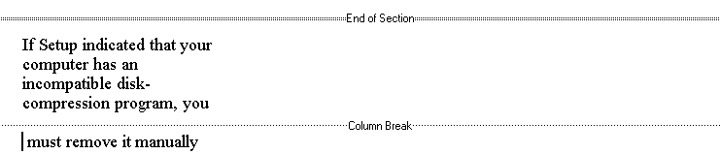

Click on the line with a break
Press Delete

Creating Tables
Word for Windows enable you to easily present information in tabular format, with or without lines around the table cells.
Before inserting a table …..
….press Enter at least once. This will enable you to typ ordinary text above the table later if you wish. If you don’t create this line space, you won’t be able to type anything above the table

Creating a table with the icon

Click in your document where you want the table to go
Click the Insert Table Icon
Click and drag over the grid for how many rows and columns you want
Release the mouse button

Creating a table with the menu
Click in your document where you want the table to go
Table Menu: Insert table

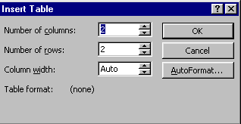

Select number of columns and number of rows required
Change the column width if you wish
Click on Autoformat to format the table if you wish to apply a format to your table
OK

Drawing a table
This option allows you to draw a table anywhere in your document using a pencil pointer. It makes creating complex tables a simpler task.
Click on the table menu
Click Draw Table the table and borders toolbar will appear and your mouse pointer will change to a pencil
Click and drag the outline for your table first
Click and drag your rows and columns.
Drag the dotted line until it stretches where you want it to go.
If the line does not stretch far enough, it will not be drawn.
When you have finished drawing your lines click on the draw table icon on the Table and Borders toolbar - or close the table and borders toolbar.

Working with tables

Moving around a table with the keyboard
TAB - takes you to the next cell
SHIFT-TAB - takes you to the previous cell
Arrow keys -move up, down, left, right one cell at a time
Clicking into a cell works, too!

Stopping the borders printing
When you first create a table, Word ’97 automatically puts borders on it. These will print. So it’s often a good idea to turn them all off before you begin to format your table with your own borders.
To turn off the printing borders

Select the whole table
Click on the drop-down arrow next to the borders icon 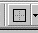
From the drop-down grid, select the no borders icon at the bottom right
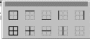

Turning the gridlines on and off
When you turn off the borders, you may see light grey lines known as gridlines. These do not print, but show you the structure of your table.
Table menu - Show/hide Gridlines

Selecting cells using the mouse
In order to do anything in a table your must select the correct cells first.
Select a cell | Click in the bottom left corner of the cell to select | You mouse pointer will be an right pointing arrow
Select a Row | Click outside to the left of the row you want to select | Your mouse pointer will be an right pointing arrow
Select a column | Click the top line of the column you want to select | Your mouse pointer will be an black down arrow
Select a table | Click and drag from the outside to the left of a row and drag downwards | Your mouse pointer will be an right facing arrow

Selecting cells using the menu
To select a row | Click into the row | Table menu - Select Row
To Select a column | Click into the column | Table menu - Select Column
To select a table | Click into the table | Table menu - Select Table

Selecting cells using the keyboard
To select a cell | Click into the cell | Hold down Shift +press End
To select a column |  | Hold down Alt + click into the column you wish to select
To select the entire table |  | Hold down Alt + double click into the table

Inserting and deleting rows and columns
Inserting a new row at the end of the table

If you are in the bottom right cell of the table, press the TAB key - a new row will be inserted

Inserting a row or rows
Select the row(s) below where you want the new row(s) to appear
Click the Insert Row icon that has now appeared on your Standard toolbar
or
Table menu - Insert Rows
or
Right click over the selected rows and click Insert Rows from the pop-up menu

Selecting rows

Word inserts the number or rows you have selected. If you select 3 rows then 3 rows will be inserted above them.

Deleting a row or rows
Select the row(s) to delete
Table menu - Delete Rows
or
Right click over the selected row(s) and click Delete from the pop-up menu

Inserting a column or columns
Select the columns(s) to the right of where you want the new columns(s) to appear
Click the Insert Column icon that has now appeared on your Standard toolbar
or
Table menu - Insert Columns
or
Right click over the selected columns and click Insert Columns from the pop-up menu
Deleting a column or columns
Select the columns(s) to delete
Table menu - Delete Columns
or
Right click over the selected columns(s) and click Delete Columns from the poop-up menu

Fitting columns on the page
Sometimes when you insert new columns, the table falls off the end of the page. This is easily solved if you use Word’s autofit feature
Select the entire table
Table menu -Cell Height and Width
Click the columns tab
Click on Autofit The column widths will be adjusted

Adjusting the table layout

Changing column widths with the mouse inside the table
Position the mouse on the border of the column that you wish to re-size
The mouse will change to a double-headed arrow
Click and drag to re-size the column

This may not change the overall size of the table!
When you adjust the size of columns inside the table, the overall size will stay the same. So when you adjust a column width, the columns next door will either get bigger or smaller depending on how you re-size.
If you want to change the overall size you must drag the extreme right or left edge to make the table bigger overall

Changing column widths with the ruler
If the ruler isn’t displayed select View Menu : Ruler
Position the mouse over the column marker to the right of the column you wish to re-size
Click and drag the column marker to adjust the width

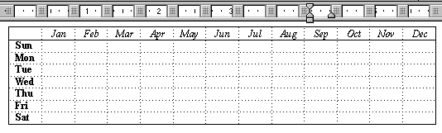

Other Ways To Change Widths
Holding down the SHIFT key as you drag will mean only the column to the right changes it’s width

Holding down the CTRL key as you drag means all columns to the right are made an equal width

Holding down the CTRL + SHIFT keys as you drag means that the width of the table is changed but the width of other columns is unchanged

Holding down the ALT key with the above combinations will display the measurements as they change in the ruler area.

Changing the column spacing
The column spacing affects the cell’s available width. For example if a column width is 5cm and column spacing is set to 1cm, the column width available for text would be 4 cm.
Select the columns to change
Click on the table menu
Click on the Cell Height and Width and choose the column tab
Specify a number in the Space Between Columns text box
Click OK

Changing row height using the mouse
Make sure you are in Page Layout View – (View Menu – Page Layout)
Position the mouse pointer over the horizontal gridline – it will change into a double headed black arrow shape
Drag the line up or down and release the mouse

Changing row height using the menu
Select the row(s) to change
Table menu - Cell Height and Width
Click the Row tab
Make changes to the options you want - Auto, At Least and Exactly

Putting space around text
This allows you increase the space between text and the border of the cells/rows
Select the row(s) you want to change
Format menu - Paragraph
Specify a spacing before and a spacing after in the appropriate boxes
OK

Customise the spacing
The spacing before and after feature goes up in increments of 6 points if you use the up and down arrows. You can simply type in your point size if you prefer

Adding borders and shading

AutoFormatting a table
For a quick and impressive format of a table use the Autoformat feature of Word 97
Click inside the table
Table Menu : Table Autoformat
Make the changes you want
Click OK

Using the menu to add borders
Select the part of the table that you want to add a border to
Format Menu - Borders and Shading
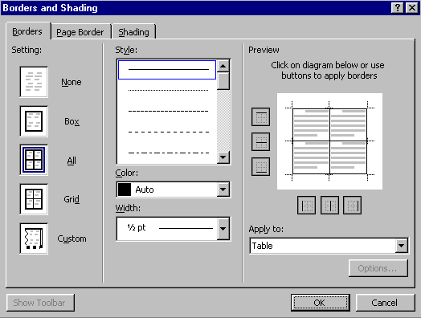
Click on the type of setting you require
Select a line style for your border from the style list
If you require, click on the drop-down arrow underneath “Colour” to change the colour of your border.
If you require, click on the drop down arrow underneath “Width” to change the width of your border
If you are using the “Custom Setting”, click on the preview to add your borders (see further instructions over)
OK
Using the custom setting to add your own borders
Select the part of the table you wish to add borders to
Format menu -Borders and Shading
Click the Custom Setting
Select the line style, colour and width you require for your first border
Click on the preview, or the relevant border button to add this border
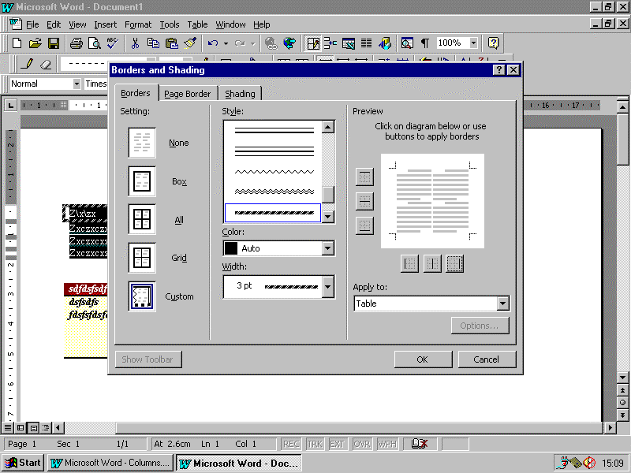
Click here to add a line to the left of every cell currently selected
To turn borders off
Click on the relevant borders button and the border should disappear
If it doesn’t, then read the tip below!

If the border does not disappear
Check that the selected line style, colour and width match the border you are trying to delete. If they don’t, Word thinks you are trying to change the border, not get rid of it. Click on the Border button again to take the border off.

Using the menu to add shading
Select the part of the table you want to add shading to
Format menu - Borders and Shading
Click the Shading tab
Click the fill colour you require
Add a pattern style if you require
OK

Using the Table and Borders Toolbar

Displaying the borders and shading toolbar
Click the Table and Borders Icon -
The toolbar shown below should appear

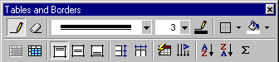

Draw table lines
Erase lines
Border Style
Border Weight
Border Colour
Border type
Shading
Merge Cells
Split Cells
Align Top
Align Centre (vertically)
Align bottom
Distribute Rows Evenly
Distribute Columns Evenly
Table Autoformat
Change Text Direction
Sort Ascending
Sort Descending
AutoSum

Changing borders using the toolbar
Select the part of your table that you wish to add borders to
Click on the drop down arrow next to the line style icon 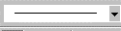, then click on the line style you require.
If necessary, click on the drop down arrow next to width icon , then click on the width you require
If necessary click on the border colour icon and click on the colour you require for your border
Click on the drop down arrow next to the border icon 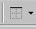, then click on the border you wish to change. (see below)

Outside border | Top border | Bottom border | 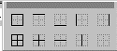 Left border | Right border
All borders | Inside borders | Horizontal inside  borders | Vertical inside  borders
No border – for removing borders altogether

Adding shading to your table
Select the part of your table you wish to add shading to
Click on the drop down arrow next to the Colour Shading icon -
Click on the colour required

Erasing lines in a table
Click on the Eraser button -
Click and drag over the lines to erase

Merging cells
You can merge cells that are next to each other
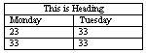
Select the cells to Merge
Click the Merge Cells icon - 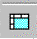

Splitting cells
You can split cells to create extra columns in certain rows.
e.g.

Select the cells to Split
Click on the Split Cells icon -
From the Dialog box, type in the number of columns or rows you require
OK

Aligning text vertically in a cell
Text in a cell can appear at the top, the middle or the bottom of the cell
Select the cells
Click on the appropriate button - Align bottom 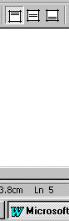, middle or top

Distribute rows and columns evenly
These options allow you to make rows and columns have equal height and equal width respectively
To distribute rows evenly:

Select the rows to make equal height
Click on the Distribute Rows Evenly button -

To distribute columns evenly

Select the columns to make equal width
Click on the Distribute Columns Evenly button -

Change text direction
Text in a cell can appear in different directions. Here is an example of how you can change your text:
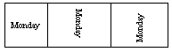

Select the cells to change
Click on the text direction button - until the text is in the position you require

Sorting in a table
Select the column to sort by
Click on the Sort Ascending or Sort Descending button
(Word will assume that you do not want to include the first row in the Sort)

Adding in a Table
Word can do simple spreadsheet-style functions in a table. If you have a column of figures and you want to add them up:
Click into the cell that will contain the total
Click on the AutoSum button -

Special features in tables using the menu

Doing maths in tables
Select the cell that will contain the total
Table Menu : Formula Word will guess what you want to do!
If the guess is correct, Click OK
If not create a formula by selecting a function from the Paste Function list
click OK

Merge cells – joining two or more cells together
You will often want to put headings across the full width of the table:
Select cells to be joined
Table Menu - Merge Cells

Split able into two
Your table can be split into two tables at any point:
Click in Table at point of split.
Table Menu - Split Table
Makes the changes as required
OK

Split a cell
You can split a cell into columns
Select the cell
Table Menu - Split Cell
Select the number of columns
Click OK

Creating table headings
You assign a row as a table heading it will be repeated on following pages if the table spans more than one page
Select the first row (you must do this) and any following rows you want as your Table Heading
Click on the Table Menu- Table Headings

Converting text to a table
You can convert text into a table if it is separated by tabs, spaces or commas
Select the lines of text that you want to convert
Table menu - Convert to Table
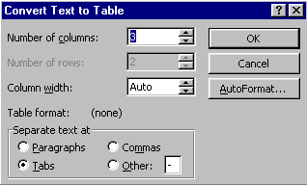
Make any changes required
OK

Use the UNDO button
If you do not like what it has done or if it was not what you expected, click on the UNDO button

Automatic Features
Objectives

By the end of this section you will be able to:-

Use AutoText to create a short-cut for producing bits of text that you often type
Use AutoCorrect to rectify your typing mistakes automatically
Use Autoformat to apply an attractive design to your documents
Use the spell-checker
Use the thesaurus
Use the grammar checker
Use print preview to see how your work will appear when printed.

Using AutoText
Word ’97 has many pre-set AutoText entries to help you produce commonly used phrases quickly, such as signing off a letter. You can also add your own AutoText entries to the ones that already exist.

Inserting pre-set AutoText from the menu
Insert menu – AutoText A new menu will appear
Click on the type of phrase you require
NB: Any AutoText phrases that you create will be listed next to Normal
Click on the phrase that you wish to insert

Inserting existing AutoText with the keyboard
Type the name of the AutoText
Press the F3 key

Essential
Do not press the space bar after you type the name for your AutoText – it won’t work!

Inserting existing AutoText with the AutoComplete feature
When you start to type something which has already been made an AutoText, you may see a yellow box appearing above where you are typing. This is the AutoComplete feature
e.g.
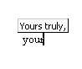
Make sure that the AutoComplete tips feature is turned on (See below)
Start to type the AutoText
When you see the yellow box press enter Word will finish typing the phrase

Turning on the AutoComplete tips feature
Sometimes you may not see the yellow boxes which allow you to use the AutoComplete tips feature. This is because the option is turned off. To turn it on again, follow the steps below
Insert menu - AutoText
Click on AutoText…. A dialog box will appear (shown below)
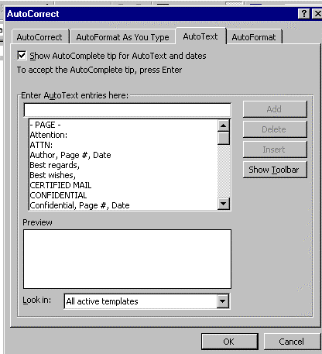
Make sure that the Show AutoComplete tip for AutoText and dates is ticked.
If it isn’t, click into the white box

Turning off AutoComplete tips
Sometimes you may want to type text normally, without being interrupted by the yellow boxes. You can turn off the feature, by making sure that the box in the dialog box is blank, or when you see the yellow box you can press escape to get rid of it.

Creating your own AutoText

Creating an AutoText entry which you can insert using AutoComplete tips
Type the text that you wish to re-use
Select the text
Insert menu - AutoText
Click on New
Do not change the name, just click OK

Creating an AutoText which you can insert using the keyboard
Type the text that you wish to re-use
Select the text
Insert menu - AutoText a pop-up menu will appear
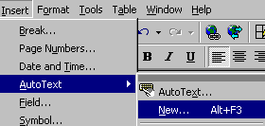

Choose New Create AutoText box appears

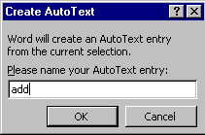

Press Delete key to get rid of the suggested AutoText name
Type in a short meaningful name
OK

Deleting AutoText
Insert menu - AutoText
Click on AutoText A dialog box will appear
Select the AutoText you wish to delete from the list
Delete
OK

AutoCorrect
AutoCorrect automatically corrects your spelling mistakes as you type.

Switching AutoCorrect on
To see AutoCorrect working you have to make sure the AutoCorrect features are switched on:
Tools menu - AutoCorrect AutoCorrect box appears

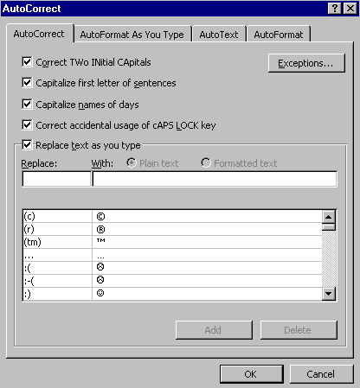

Click to place a tick in the boxes next to the options
OK

AutoCorrect Options
This is what the AutoCorrect options mean:
Correct two initial capitals | THe | becomes | The
Capitalise first letter of sentences | end. beginning | becomes | end. Beginning
Capitalise names of days | monday | becomes | Monday
Accidental usage of the CAPS LOCK key | tHERE IS | becomes | There is

Adding your own ‘Replace text as you type’ entry
You can add your own entries to be automatically corrected:
Tools menu - AutoCorrect
In the “Replace Text As You Type” section, click into the ‘replace’ box
Type the incorrect spelling of a word you often misspell
Click into the ‘with’ box
Type the correct spelling
Click on the Add button
OK

Deleting a Replace Text As You Type entry
To delete an AutoCorrect entry:
Tools menu - AutoCorrect
In the “Replace Text As You Type” section, use the scrollbar to find the entry to you want to delete

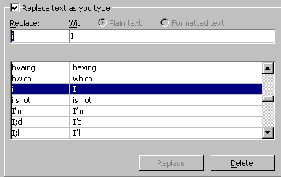

Select the entry to delete
Click the delete button
OK

AutoFormat
AutoFormat analyses a Word document to identify specific elements, and then formats the text by applying styles from the attached template. When Word automatically formats a document, it makes one or more of the following changes, depending on the options you’ve selected on the AutoFormat tab in the Options dialog box (Tools menu):

Applies a style to each paragraph.
Removes extra paragraph marks (¶).
Replaces indents inserted with the SPACEBAR and TAB keys with paragraph indents.
Inserts bullets (•) in place of asterisks (*), hyphens (-), or similar characters that may have been used to denote bulleted lists.
Replaces (C), (R) and (TM) with copyright ©, registered trademark ®, and trademark symbols ™
Replaces straight quotes " with curly quotes “”

Using AutoFormat
Select the text to AutoFormat (for the whole document, do not select any text)
Format Menu: AutoFormat
Click on the options button and change any options you want
OK
OK

Word will AutoFormat the document (it may take time if it is a big document)

Reviewing changes

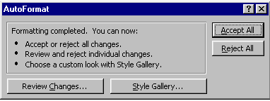

If you wish to change the styles used click on style gallery
Click on Review Changes

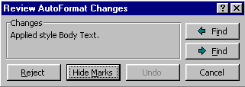
Move forwards and backwards from change to change
Rejects the current suggested change
Hide revision marks

Go through the document and reject any change you don’t want
At the end you will be taken back to the AutoFormat box (or click Cancel to do this)
Click Accept or Reject All

Using AutoFormat without a review

The AutoFormat option
Select the text to AutoFormat (for the whole document do not select any text)
Format menu - Autoformat

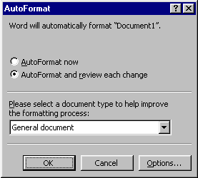

It is recommended that you choose the “AutoFormat and review each change” button
OK Word will automatically format the document

Undoing The AutoFormat
Click on the Undo Icon on the standard toolbar or CTRL-Z

AutoFormat without a review may cause problems

Unless you are confident that AutoFormat is going to work well, always do it with a review, just in case you miss something!

More automatic formatting features
Word 97 can be set-up to make changes to the formatting of documents automatically, while you are typing, without letting you know it’s doing anything special!

Changing the AutoFormatting Settings
Tools Menu – AutoCorrect
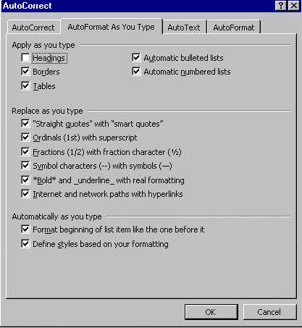

Click on the AutoFormat As You Type tab

Turn this one off!
It is suggested that the last option - The Define Styles Based On Your Formatting Option - be deselected !! With this option selected, after typing some text and applying some formatting (e.g. bold and a different size),Word 97 will create a new style based on the manual formatting you applied to the text.

Spell checking your document

Spell-Check
Click on the Spell Check Icon or F7

Or
Tools menu - Spelling and Grammar The following dialogue box appears:

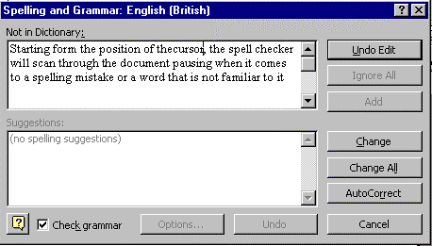
Starting from the position of the cursor, the spell checker will scan through the document, pausing when it comes across a word or grammatical structure not in its dictionary or grammar database. You can choose one of the suggested alternative spellings by clicking on it and then clicking on Change, or you can choose to...

Ignore Ignore this word, look for next incorrect word
Ignore All Ignore this word (and any further occurrences of this word), look for next incorrect word
Add Add word to dictionary (So that it won't be picked on in future)
Change Change to current suggestion
Change All Change this word (and any further occurrences of this word) to current suggestion
AutoCorrect Puts a spelling correction into AutoCorrect for future use
Options Brings up options for customising the spell-checker
Undo Undoes the last spelling correction you made
Cancel Cancel spell-checking
Check Grammar A tick in this box enables the grammar-checker

What if the correct spelling isn’t suggested?
Click the cursor next to the word to be changed in the top half of the spell checker dialog box shown below
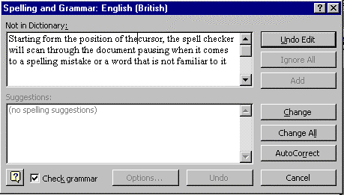

Make the required change
Click on Change The word will be changed in your document

Using the spell checker to create the AutoCorrect list
When Word 97 finds an incorrect spelling...

Click the correct suggestion (or type it in)
Click the AutoCorrect button The correction is added to the AutoCorrect list
and the change is made in your document

Spell checking a section

To spell-check a particular section of your document, select that section before choosing the Spelling option.

Check spelling while you Type

Checking your spelling as you type
As you type, Word is constantly checking your spelling. If it spots a word that is not in its dictionary, then it will put a red wavy line underneath it.

Click the red underlined word with the right mouse button, and select the correct spelling, or choose from one of the other options (see below)
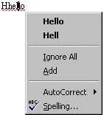

From the pull down list choose the correct spelling or one of the following

Ignore All | Will ignore all other occurrences of this word in the document
Add | Add the word to the Custom dictionary and will not spell check the document again
AutoCorrect | Add the misspelled word and its correct spelling to the list of words and phrases that are automatically corrected (see section, “AutoCorrect”)
Spelling | Display the Spelling Dialog box (see section, “Spell checking your document”)

Turning this feature on or off
Tools Menu - Options
Spelling and Grammar tab
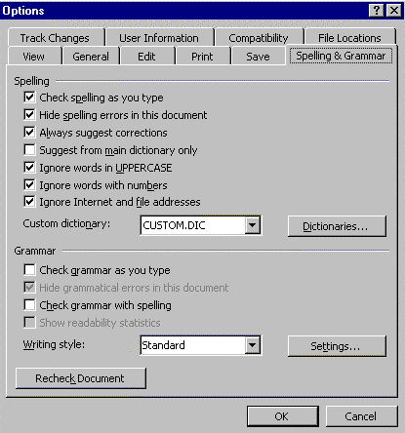

Untick or tick the ‘Check Spelling As You Type’ option
Using The Status Bar Indicator
As you type you’ll see the Automatic Spell Checking Icon change on the status bar at the bottom of the screen. If you see a red tick it means, that everything is spelt correctly so far. A red cross means that you have errors. To quickly highlight the spelling errors double-click the status bar icon. Word will take you to the next error, and will pop-up a menu to help you correct the spelling

Thesaurus: looking for similar words

Calling up the Thesaurus

Select word you want to look up
Press SHIFT + F7 to start the Thesaurus
or
Tools menu - Language - Thesaurus

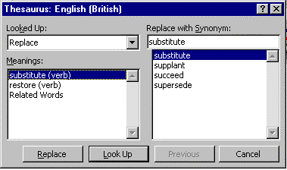

Click the synonym (word with a similar meaning) required from the list
Replace button

Word 97 will present you with:

Meanings: Several possible meanings of the current word
Replace With Synonyms: Alternatives which mean similar things to the word in the text (with the current meaning)
Replace With: Currently selected replacement word
If there is more than one meaning in the 'Meanings' list, then each one will have a different list of synonyms. Click on the meaning that you want and the appropriate synonyms will be displayed.
Cancel button to close the Thesaurus

Looking up alternatives to alternatives!

You can have hours of fun (!), looking into the alternatives to the suggested alternative, and so on and so on...
Click one of words in 'Replace With Synonyms' list
Click 'Look Up' A list of alternatives to the highlighted word
will then be displayed.

Grammar Checker
Microsoft Word 97 will even check your grammar if you so desire – but be warned, many people think this feature is more trouble than it is worth!

Starting the Grammar Checker
Tools menu - Spelling and Grammar

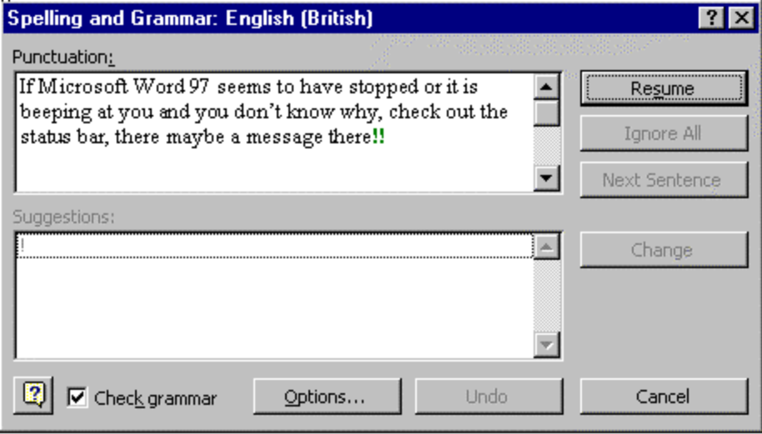

Ensure there is a tick in the box next to the option ‘Check grammar’

Starting from the position of the cursor, the grammar checker will scan through the document, pausing when it comes across a word or grammatical structure not in its dictionary or grammar database. You can choose one of the suggested alternatives by clicking on it and then clicking on Change, or you can choose one of the options listed below.

Grammar Options

Ignore Skips correcting the error in the selected sentence and other sentences with a similar error
Ignore All Skips correcting the error and any identical to this
Next Sentence Displays the next sentence for which Word has a suggested grammar correction
Cancel Close the Grammar and Spell Checker
Undo Undo the previous change made
Options Change settings for the Grammar and Spell Checker
Check Grammar A tick in this box enables the grammar-checker

What if the desired change isn’t suggested?
Put your cursor next to the word to be changed in the top half of the spell checker
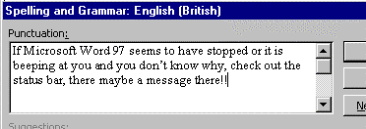

Make the required change
Change button The word will be changed in your document

Index

Index

Accents, 65
Alignment, 61
AutoComplete, 123
Autocomplete tips, 123
AutoCorrect, 126
AutoFormat
Document, 128
Without review, 130
Autoformat as You Type, 131
AutoFormatting
Tables, 114
Autoformatting Settings, 131
Automated Lists, 93
Automatic Numbered, 93
Autotext
Creating, 125
AutoText, 123
Deleting, 125
Bin, 36
Bold, 53
Borders
in tables, 114
Borders, 89
Bottom of Document (Go To), 24
Breaks, 104
Page, 104
Section, 104
Bullet Style - changing -, 93
Bullets & Paragraph Numbering, 92
Bullets Or Numbers As You Type, 92
Bullets To Existing Text, 92
capital letters, 21
Case
Changing, 63
Centre, 61
Changing
Text, 22
Click & Drag, 23
Closing documents, 34
Colour
text, 55
Columns, 102
Adjusting with ruler, 103
changing widths in a table, 112
deleting in tables, 110
in tables, 110
Copying
Formatting, 60
Copying File(s)
to the floppy disk, 37
Copying Files, 36
Copying Text
Cut & Paste, 66
Drag & Drop, 68
Correcting, 126
Correcting Mistakes, 22
Creating New Documents, 34
Cursor, 25
Date
Inserting, 62
Delete, 21
Deleting
Text, 22
Deleting Files, 36
Deletion
Keys, 22
Document
inserting the name, 87
Documents
closing, 34
Different views, 45
More Than One, 43
Opening, 33
Exiting Word, 9
Favourites, 37
Favourites folder, 37
Fields
Date & Time, 62
filename, 87
Files
copying, 36
deleting, 36
getting deleted files back, 36
managing, 35
Moving, 36
Renaming, 37
Searching for, 39
sorting, 36
Finding Files, 39
Finding Text, 99
Fitting columns on the page, 111
Font, 56
Dialog Box, 57
Fonts, 56
footer
inserting the filename, 87
Footers, 86
Foreign Characters
Accents, 65
Format Painter, 60
Full Screen
Defined, 46
Go To
A Page, 25
Grammar Checker, 138
Grid-Lines, 108
header
inserting the filename, 87
Headers, 86
Help, 7, 17
Highlighting Text, 54
icons, 11
Icons
In Manual, 6
Word's Toolbar, 11
Indent, 81
Hanging, 81
Indents
Examples, 82
Using, 76
With The Ruler, 82
Insert
v. Overtype, 20
inserting filename, 87
Insertion Point, 25
Internet, 37
Italic, 53
Justify Text
Centre, 61
Fully, 61
Left, 61
Right, 61
Keyboard, 21
Landscape, 74
Lists, 92
Lost Files, 39
Manual
How To Use It, 5
Margins
In Page Setup, 71
Setting With The Ruler, 72
Master Document View
Defined, 45
Maths
In a table, 120
Merging Cells, 118
Minutes, 97
Mistakes
Correcting, 22
Mouse, 23
Moving around, 24
Going to a page, 25
Keyboard, 24
quick ways, 27
scroll-bars, 24
Moving Files, 36
Moving Text
Cut & Paste, 66
Drag & Drop, 68
Multi Level List - Typing It, 95
Multi-Level Numbering, 95
Multiple Documents, 43
New documents, 34
new line, 21
Normal View, 47
Defined, 45
Numbering, 92
blank lines, 92
Outline, 95
Page, 84
Pages, 84
with different levels, 95
Numbering/Bullets - Removing, 94
Numbers As You Type, 92
Numbers To Existing Text, 92
Office Assistant, 17
Opening Documents, 33
Orientation, 74
Outline numbered, 95
Outline View, 47
Defined, 45
Overtype
v. insert, 20
Page, 84
Page Breaks, 84, 104
Page Layout View, 47
Defined, 45
Page Numbering, 84
Page Setup, 70
Paper Size, 70
Page views, 45
Pagination, 84
Paper Clip, 17
Paper Size
Setting, 74
Paper Source
Setting, 74
Portrait, 74
Print Preview, 41, 47
Print Preview View
Defined, 45
Printer Trays
Setting, 74
Printing, 42
Quick Ways to Move Around Within A Document, 27
Recycle bin, 36
Redo, 29
Renaming Files, 37
Replace
Search &, 99
Revising, 22
Rows
in tables, 110
Ruler
Columns, 103
Setting Measurements, 75
Using, 75
Saving, 30
Default Directory, 31
With New Name, 31
Screen, 10
Word, 10
Scroll Bars, 24
Search, 99
searching for files, 39
Searching for files
Advanced, 40
Searching for Files, 39
Section Breaks, 104
Select Browse Object, 27
Selecting
in tables, 108
Selecting Text
More Methods With Mouse, 52
With the Keyboard, 50
With The Mouse, 51
Shading, 89
in tables, 115
Shortcut
menus, 23
Size of Text, 56
Sorting Files, 36
Special Characters
Inserting, 64
Spell Checking, 132, 134
Spell-Check, 132
Spelling
Automatic, 134
Splitting Cells, 118
Starting
Word, 9
Status Bar, 10, 26
Sub-points, 95
Symbols
Inserting, 64
Tables, 106
adding up in, 119
aligning text, 118
Autofit, 111
borders, 114
Borders toolbar, 116
column widths, 112
converting text to, 121
deleting columns, 110
fitting columns on page, 111
inserting columns, 110
inserting rows, 110
layout of, 112
merging cells, 118
new columns, 110
new rows, 110
selection, 108
shading, 115
Shading toolbar, 117
sorting info in, 119
Special Features, 120
splitting cells, 118
Working With, 108
Tabs
Bar tabs, 80
Deleting, 77
Leaders, 79
moving, 77
setting your own, 77
Type Of, 78
Using, 76
TABs, 76
Templates
Buit-In, 100
Text
Bold, 53
Changing, 22
Changing Text. See hanging
Changing The Look Of, 53
colour, 55
coverting into a table, 121
Deleting, 22
Justification, 61
Selecting, 51
Thesaurus, 136
Time
Inserting, 62
Toolbar
Formatting, 13
icons, 11
Print Preview, 41
standard, 12
ToolTips, 14
Toolbars, 15
ToolTips, 14
Top of Document (Go To), 24
Typeface, 56
Typing, 20
Underlined, 53
Underlining
Different styles, 59
Undo, 29
View
Changing, 47
Views, 45
Web, 37
Wizards, 100
Word
Exiting, 9
Screen, 10
Strarting, 9
Zooming
In On Document, 44

